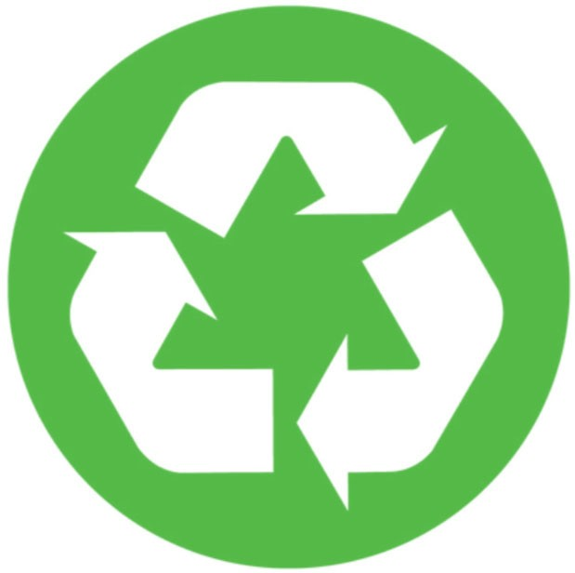
RECYCLING AT
*Insert your property name or logo and recycling program contact information here.

WHERE TO

RECYCLE?
*Insert details of where recycling and trash containers are located on your property here. Include a map on the back if necessary.

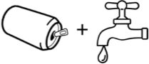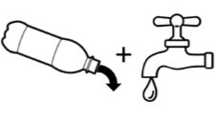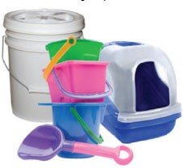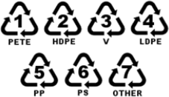WHAT TO
Metal Cans
Plastic Containers
Empty & Rinse

Plastic Food Trays Plastic Bottles, Jugs & Rigid Plastics & Cups Containers #1-7
(NO Styrofoam)

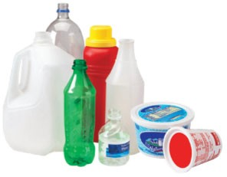
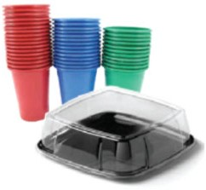
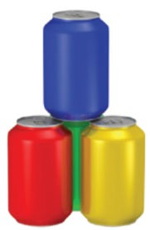
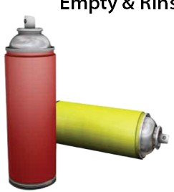
RECYCLE?
Empty & Rins
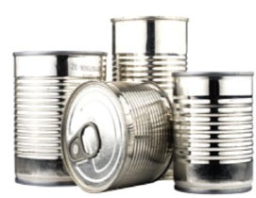

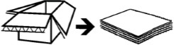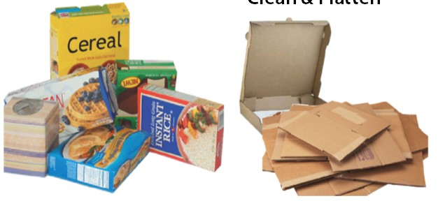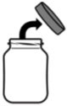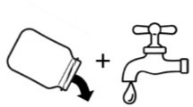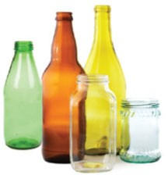
Cardboard & Pizza Boxes
Cereal & Food Boxes
Clean & Flatten
Cardboard
Paper
Clean, Empty & Rinse
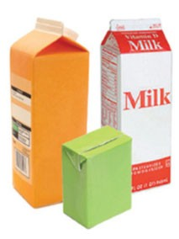
Milk & Juice Cartons Magazines, Junk Mail, Mixed & Juice Boxes Paperback Books, Paper, Paper Bags
& Catalogs & Newspaper
Glass Bottles & Jars
Empty & Rinse
Remove
Glass

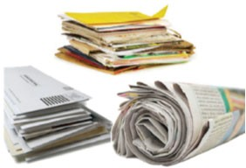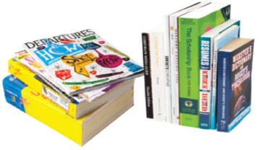KEEP IT OUT
OF RECYCLING

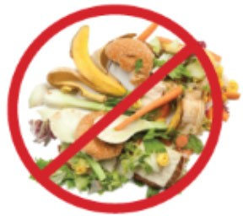
NO
FOOD
NO
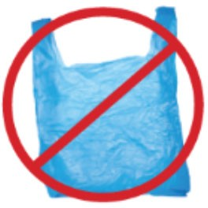
PLASTIC BAGS OR
SHRINK WRAP
NO
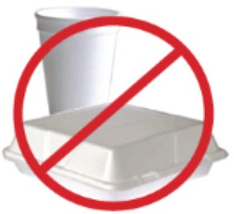
STYROFOAM

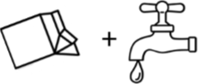

KEEP RECYCLING LOOSE, DON’T BAG IT.
If you have to bag your recycling due to collection methods you MUST use a clear or opaque bag. If possible, please empty bags into the recycling dumpster or you can get a large reusable bag from your leasing office.

