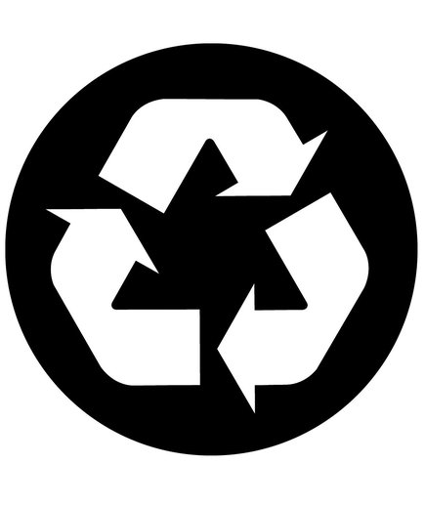
Recycling AT
*Insert your business name or logo and recycling program contact here.

What to
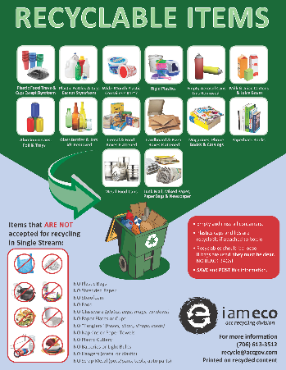
Recycle?
- All recycling collection is single stream, which means all acceptable recyclables can be collected and mixed together in one container, and collected by one truck.
- The Recyclable Items poster details what is recyclable in Athens.
- Janitorial staff is NOT expected to remove trash from recycling. But if you notice a consistent problem, please notify management.

Where is

Recycling?
- Recycling bins are blue or green with the chasing arrow symbol and labeled “Recycling”.
- Bins are located in: Customize locations for your business, include a map if necessary.

Offices
Breakroom
Work Room
Conference room
Gym
Kitchen
Mailroom
Warehouse
Storage room
Classroom
Training room
Locker room
Copy room
Hallway
Shipping/Receiving

• Please be sure to return all bins to their original location with labels facing outward.
• Recycling collected and placed loose in the outside recycling dumpster or recycling roll cart.

Rules for
Recycling
• Do NOT mix trash with recycling.
• Boxes should be broken down. Please remove any plastic wrap or Styrofoam and place in trash.
• Do not bag recycling, please keep it loose. If you have to bag your recycling due to collection methods you MUST use a clear bag. If possible, please empty bags into the recycling dumpster and dispose of the bag.
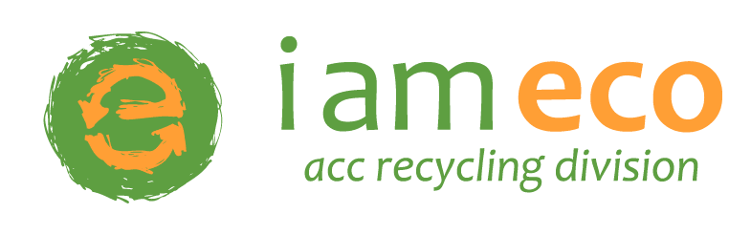
For recycling questions, contact the Athens-Clarke County Recycling Division:
706-613-3512 recycle@accgov.com www.accgov.com/recycle
For recycling questions, contact the Athens-Clarke County Recycling Division:
706-613-3512 recycle@accgov.com www.accgov.com/recycle
• Recycling bins are blue or green with the chasing arrow symbol and labeled “Recycling” .
• Bins are located in: Customize locations for your business, include a map if necessary.
• Please be sure to return all bins to their original location.
• Recycling collected and placed in the outside green recycling dumpster or recycling roll cart.
Rules for
Recycling
• Do NOT mix trash with recycling.
• Boxes should be broken down. Please remove any plastic wrap or Styrofoam and place in trash.
• Do not bag recycling, please keep it loose. If you have to bag your recycling due to collection methods you MUST use a clear or opaque bag. If possible, please empty bags into the recycling dumpster and trash the bag.

