Watershed Management Plan

Shoal Creek

The Unified Government of Athens-Clarke County
December 2014

Department of Transportation and Public Works
120 West Dougherty Street
Athens, GA 30603

Contents
Chapter 1 Introduction
1.1 Purpose of Shoal Creek Watershed Management Plan
1.2 Outline of Shoal Creek WMP
1.3 Snapshot of Shoal Creek
Chapter 2 Methodology
Chapter 3 Current Conditions in Shoal Creek
3.1 Physical Stream Assessment
3.1.1 Stream Walk Assessment Method and Scores
3.1.2 Shoal Creek Stream Bed, Banks, and Buffers
3.1.3 Potential Stressors Affecting Shoal Creek’s Stream Assessment Scores
3.2 Biological Stream Assessment
3.2.1 How Macroinvertebrates Are Indicators of Stream Health
3.2.2 Macroinvertebrate Collection, Scoring Method and Results
3.2.3 Biological Score Results for Shoal Creek
3.2.4 Potential Stressors Affecting Shoal Creek’s Biological Score
3.2.5 How Biofilms Indicate Stream Health
3.2.6 Biofilm Analysis Methods
3.2.7 Biofilm Analysis Results
3.2.8 Historical Impacts on Aquatic Habitat and Stream Health
3.3 Water Quality Data
3.3.1 Why Sample?
3.3.2 Water Quality Sampling Methods
3.3.3 Water Quality Data for Shoal Creek
3.3.4 Potential Stressors Affecting Shoal Creek’s Water Quality
3.4 Conceptual Model of Shoal Creek Conditions and Concerns
Chapter 4 Shoal Creek Watershed Management Plan
4.1 Summary of Management Needs
4. Shoal Creek Best Management Practices to Achieve Goals and Objectives
4.2.1 Stream Channel Restoration
4.2.2 Streambank/Riparian Area
4.2.3 Distributed BMPs
4.2.4 Sewer Line Maintenance/Replacement
4.2.5 Citizen Education
4.2.6 Other BMPs
4.3 Evaluation and Location of BMP Priority Areas
4.4 Estimated Load Reductions of Best Management Practices
4.4.1 Characteristics of the Management Plan Strategy
4.4.2 Modeling and Assessment Approach
4.4.3 Modeling Results
4.5 Implementation Cost and Schedule
4.6 Evaluation Methods for Measuring Success
4.6.1 Quantitative Evaluation Techniques
4.6.2 Qualitative Evaluation Techniques

Appendix of Charts and Data

Chapter 1: Introduction

1.1 Purpose of the Shoal Creek Watershed Management Plan

The Shoal Creek Watershed Management Plan (WMP) is part of a combined effort undertaken by Athens-Clarke County Stormwater to address stream health throughout the county. The primary purpose of the Shoal Creek Watershed Management Plan is to guide County staff, elected officials, community organizations, and the citizenry in protecting and, where needed, restoring the function and beauty of the watershed. The plan is intended to function as a practical tool with specific recommendations on practices to improve and sustain a healthy, productive environment. Shoal Creek is not currently listed on the federal 303(d) list of impaired streams released in 2012, but is, however, on the “Draft 2014 Integrated 305(b)/303(d) List” for impairment due to fecal coliform contamination. One of the major focuses of this plan is to mitigate the likelihood of further fecal coliform contamination, along with any other potential contaminants, and ultimately achieve permanent de-listing of this watershed from the federal 303(d) list of impaired waters.

1.2 Outline of Shoal Creek WMP

The plan consists of the following pieces:

- Chapter 1 provides an introduction including the purpose and an outline of the Shoal Creek WMP. It also provides a brief description of the watershed including its physical boundaries and landmarks found within the drainage area.
- Chapter 2 describes briefly the methodology that was used in assessing the watershed’s health.
- Chapter 3 presents the current conditions of Shoal Creek including its physical, biological, and water quality conditions. It describes the potential stressors effecting Shoal Creek.
- Chapter 4 explains the watershed management plan, a summary of the management needs, the BMPs to be used, estimated load reductions, an implementation schedule and cost assessment, and evaluation methods.
- Appendix provides the stream assessment data including physical, biological, and water quality data.

1.3 Snapshot of Shoal Creek

The Shoal Creek Drainage Basin (SHCDB), as shown in Figure 1.3.1, lies east of the center of Athens-Clarke County, and depicts, roughly, the shape of a rectangle with the short sides pointing to the north and south. It has a land area of over 16 square miles. Robert Hardeman, Morton and Belmont Roads form the majority of the eastern boundary of the watershed, while Barnett Shoals and Whit Davis Roads provide much of the boarder to the west. To the north, Moores Grove and Athens Roads provide an approximated boundary, and to the south, Bob Godfrey Road. The headwaters of Shoal Creek, as shown in Figure 1.3.2, are approximately a half mile to the south of the intersection of Spring Valley and Moore’s Grove Road. Shoal Creek discharges into the Oconee River south of the confluence of the North and Middle Oconee Rivers, near the end of Tribble Bottoms Road just beyond the boarder of Athens-Clarke County.

Figure 1.3.1: Location of Shoal Creek Drainage Basin in Athens-Clarke County

Figure 1.3.2 Aerial View of Shoal Creek Drainage Basin

Chapter 2: Methodology

Three different methods of data collection were used to provide an adequate representation of the current health of Shoal Creek. Each method will be described later in detail, as will the findings associated with the data and how they compare to the water quality standards of a “healthy” water body. First, a stream assessment was conducted. ACC Stormwater staff walked Shoal Creek and its larger tributaries with the intention of obtaining quantitative measurements of the stream bank, stream bed and stream buffer (Figure 2.1), as well as qualitative measurements of other factors like surrounding land use and stream crossings. A second assessment was used to determine the current biological status of the creek. In an effort to assess Shoal Creek’s biological health, University of Georgia School of Ecology collected macroinvertebrates (tiny aquatic bugs) living in the stream. The type and quantity of macroinvertebrates found is very useful for determining stream health. Some macroinvertebrates are more sensitive to pollution and stream bed silting than others, so by assessing what species are present, we can determine whether or not the stream’s ability to support life has been impacted. The third assessment method involved water quality data collection. Periodic data as well as long-term water quality data was collected in an effort to observe both real-time and long-term data trends. Some data was obtained via in-house sampling methods, approved by GAEPD, and others were gathered by GAEPD and other credible, local watershed groups.

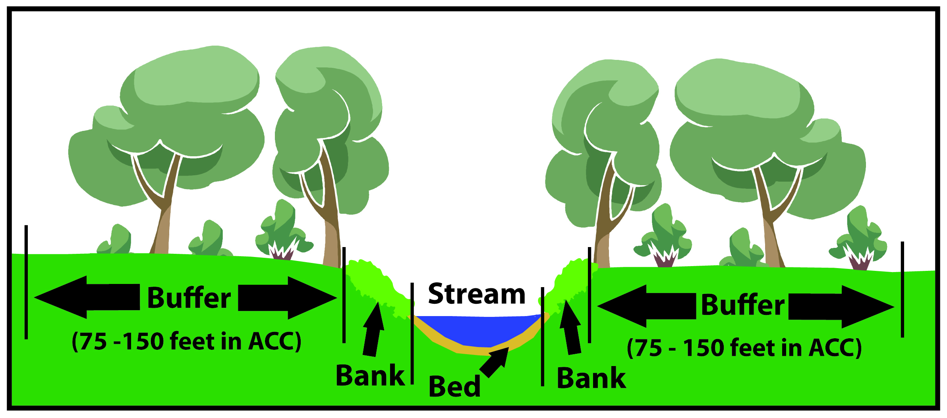
Figure 2.1: Cross Section of a Stream

The data collected using each of the aforementioned methods is analyzed in this report in a manner that provides a snapshot of the health of Shoal Creek. With this, potential “stressors” can be identified, possibly leading to the discovery and mitigation of the sources of pollution and impairment. The next section will focus on analyzing this data.

Chapter 3: Current Conditions in Shoal Creek

  - Physical Stream Assessment
3.1.1 Stream Walk Assessment Method and Scores

Stream walks were conducted in the Shoal Creek watershed in March of 2009 and 2011. The combined stream walk events evaluated 21 total sections, or reaches, of Shoal Creek and its major tributaries. ACC staff physically walked each reach and conducted an inventory of stream bed, stream bank, and stream buffer conditions. Figure 3.1.1.1 displays the reaches of SHCDB surveyed and the following photos (Figure 3.1.1.2 – 3.1.1.4) highlight a few representative areas within SHCDB. Reaches on the main stem of Shoal Creek are alphabetically named and the tributaries are numerically named.

Figure 3.1.1.1: Shoal Creek Stream Reaches

Map not available.

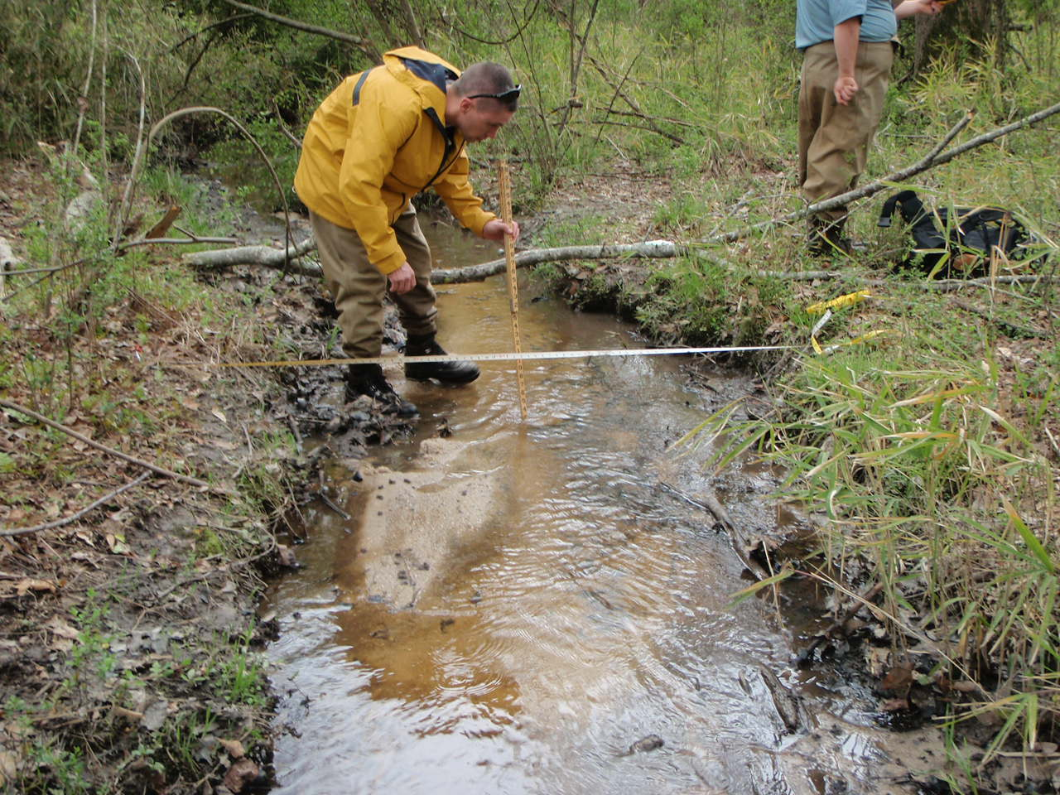
Figure 3.1.1.2: Stream Assessment of Shoal Creek – Taking Bed, Bank, and Buffer Measurements

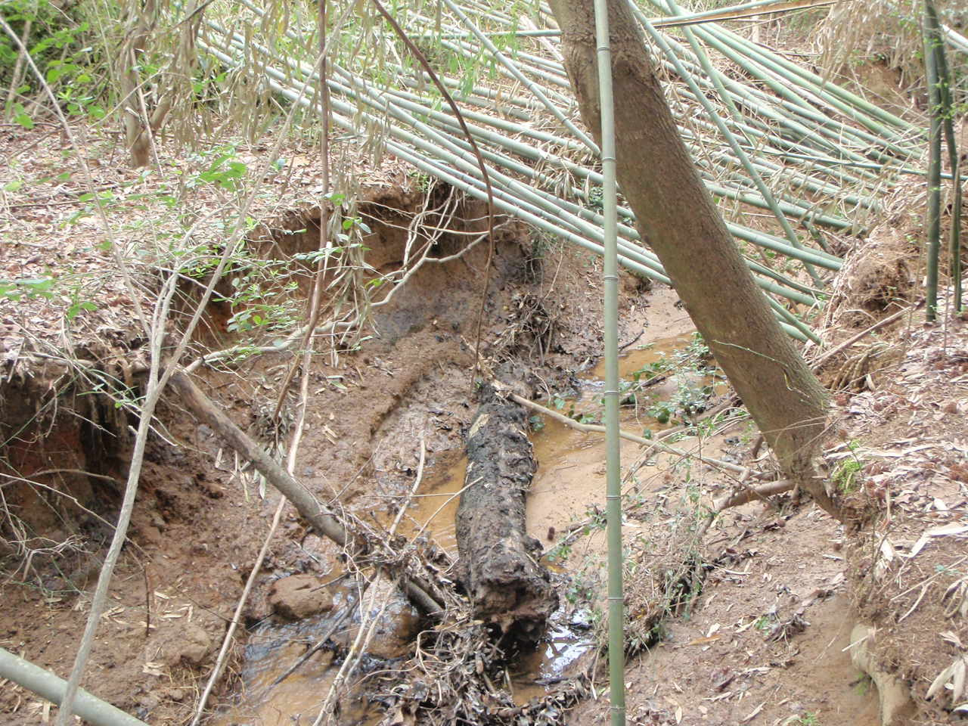
Figure 3.1.1.3: Stream Assessment of Shoal Creek –Bank Erosion and Invasive Species Presence

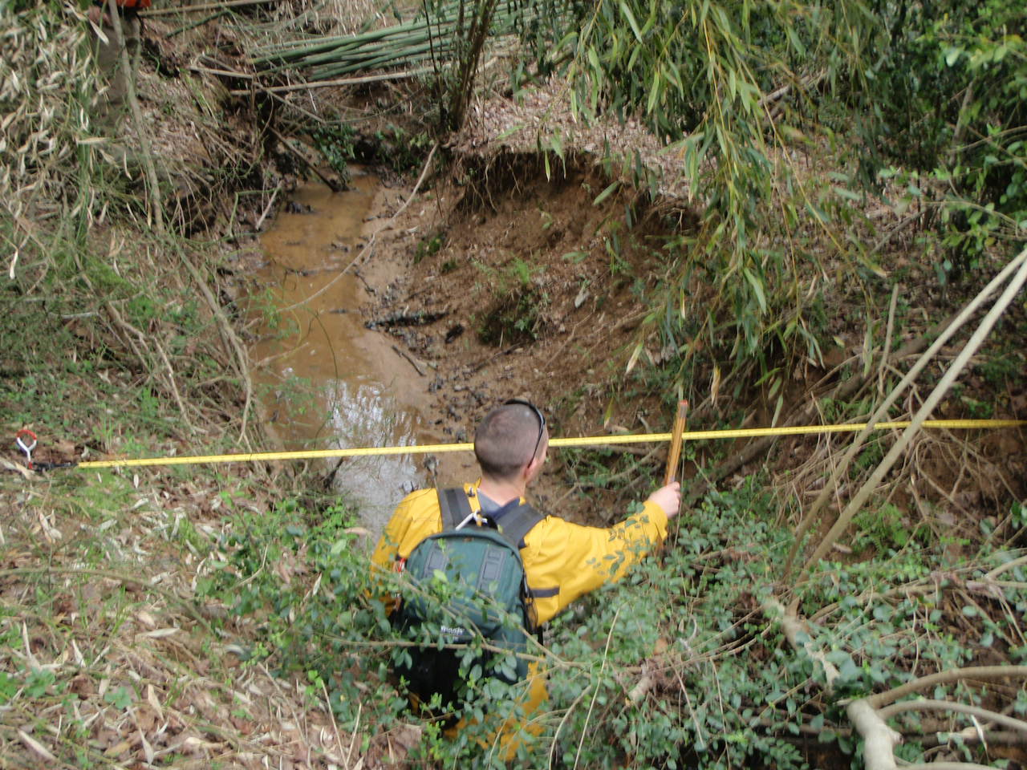
Figure 3.1.1.4: Stream Assessment of Shoal Creek – Obstructed Flow and Eroded Stream Bank

As a means of providing a qualitative data assessment of the physical condition of the Shoal Creek stream habitat, each reach was evaluated and rated based on a total reach score. As displayed in Table 3.1.1.1, in-stream habitat, vegetated buffer width, bank erosion, and floodplain connection were the components of the total reach score. Each component of the total reach score could receive a maximum of 20 points, with vegetated buffer width and bank erosion being the summation of the left and right stream bank scores. Therefore, the maximum total reach score is 80. The benchmark for a “healthy” reach is a total reach score of 63 or greater. If a reach exceeds a score of 63, it suggests that the reach has optimal bed, bank and buffer conditions for a healthy, functional stream ecosystem compliant with state and federal regulation. The range for reach assessment scores is as follows: (Poor: 0-23, Marginal: 24-40, Sub-Optimal: 41-63, Optimal: 64-80). Table 3.1.1.1 displays the combined results of the stream surveys conducted in March of 2009 and 2011. Lastly, the total reach scores for each stream segment were averaged to give an overall score representative of the physical health of the entire Shoal Creek waterway. The average score was 38, giving Shoal Creek and overall rating of “Marginal”. Each of the components of the stream assessment (In-stream Habitat, Vegetated Buffer Width, Bank Erosion Score and Floodplain Connection) were individually averaged and showed relatively low scores, indicating that the overall rating of “Marginal” for Shoal Creek is due to a low score in all areas of the assessment. Scoring particularly low were the floodplain connection and bank erosion scores throughout Shoal Creek.

Note: The location of reach SH-1j corresponds to the reach named SH-R1 by Tetra Tech. Also, reaches SH-1r through SH-1u were walked in 2009, while the rest were walked in 2011.

Table 3.1.1.1: Reach Scores of Shoal Creek
Reach | In-stream Habitat Score | Vegetated Buffer Width |  | Bank Erosion Score |  | Floodplain Connection | Total Reach Score | Percent Score
 |  | Left Bank | Right Bank | Left Bank | Right Bank
1a | 9 | 9 | 9 | 1 | 1 | 3 | 32 | 40%
1b | 17 | 9 | 9 | 6 | 6 | 12 | 59 | 74%
1c | 12 | 9 | 9 | 5 | 5 | 11 | 51 | 64%
1d | 10 | 8 | 4 | 5 | 5 | 9 | 41 | 51%
1e | 6 | 3 | 3 | 2 | 4 | 3 | 21 | 26%
1f | 7 | 8 | 8 | 3 | 2 | 3 | 31 | 39%
1g | 8 | 6 | 5 | 5 | 5 | 3 | 32 | 40%
1h | 8 | 8 | 9 | 5 | 5 | 4 | 39 | 49%
1i | 9 | 7 | 7 | 5 | 5 | 2 | 35 | 44%
1j | 5 | 1 | 1 | 1 | 1 | 6 | 15 | 19%
1k | 9 | 9 | 9 | 4 | 4 | 3 | 38 | 48%
1l | 9 | 8 | 9 | 4 | 4 | 3 | 37 | 46%
1m | 9 | 3 | 2 | 5 | 5 | 2 | 26 | 33%
1n | 9 | 2 | 2 | 6 | 5 | 2 | 26 | 33%
1o | 9 | 6 | 6 | 5 | 5 | 2 | 33 | 41%
1p | 11 | 7 | 6 | 3 | 3 | 2 | 32 | 40%
1q | 10 | 7 | 5 | 3 | 3 | 6 | 34 | 43%
1r | 11 | 9 | 9 | 7 | 7 | 15 | 58 | 73%
1s | 10 | 9 | 8 | 6 | 5 | 10 | 48 | 60%
1t | 7 | 8 | 7 | 9 | 9 | 19 | 59 | 74%
1u | 5 | 5 | 5 | 9 | 9 | 18 | 51 | 64%
Average | 9.0 | 6.7 | 6.3 | 4.7 | 4.7 | 6.6 | 38 | 48%
Percent | 45% | 67% | 63% | 47% | 47% | 33% | 48%
Table 3.1.1.1 shows the breakdown of the reach scores for each category of the stream assessment and the combined scores. An overall reach score of 38 was calculated for Shoal Creek, signifying “Marginal” watershed health.

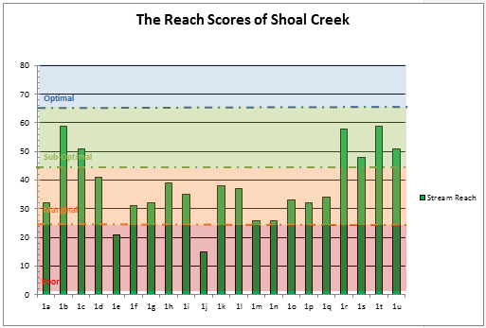
Figure 3.1.1.5: Reach Scores of Shoal Creek

The average reach score in SHCDB was 38, with reach SH1b and SH1t scoring the highest (59) and reach SH1j scoring the lowest (15).

Figure 3.1.1.6: Stream Assessment Scores and Their Reach Locations

3.1.2 Shoal Creek Stream Bed, Bank, and Buffer

According to Table 3.1.1.1, the in-stream habitat of Shoal Creek ranked an average of 9 out of 20 amongst all 21 reaches. Based on the reach assessment criteria used during stream walk evaluations, a ranking of 9 indicates “marginal” in-stream habitat health. A marginal ranking coincides with approximately a 20-40% mix of stable habitat, meaning adequate habitat is not readily available in many parts of the stream. Additionally, as noted in supplementary reach assessment data, Shoal Creek’s stream bed was observed to have a large amount of aggradation of sand and sediment. Bedrock and cobble, both being indicators of adequate macroinvertebrate habitat, were quite scarce, appearing in only about 20% of the 21 reaches listed in Table 3.1.1.1. The majority of Shoal Creek’s reaches contained silt/clay, sand, gravel or some combination of the three, confirming that aggradation is occurring in many portions of the streambed due to sediment being transported and deposited into the stream. As shown in Fig. 3.1.1.3 and Fig. 3.1.1.4 above, bank scouring and undercutting is a significant issue present in Shoal Creek. This effect is confirmed by the low scores in both the “bank erosion” and “floodplain connection” sections of the reach assessments summarized in Table 3.1.1.1. Such erosion is typically due to large rain events, leading to increases in volume and velocity of runoff, that ultimately cause the transportation of sediment to streams. Urbanization, specifically the construction of impervious surfaces such as parking lots and roofs, is typically a major contributor to increased runoff and aggradation of sediment in streams. However, according to Tetra Tech’s Management Strategy Analysis for Tanyard, Cedar, and Shoal Creeks, the major contributor of impairment in the Shoal Creek watershed is past agricultural land use. Therefore, while some sedimentation of the stream may have resulted from residential or commercial development, it is most likely to have occurred from land disturbance related to farming practices.

3.1.3 Potential Stressors Effecting Shoal Creek’s Stream Assessment Scores

The most telling evidence from the stream assessment data presented above is the relationship between the low scores in the in-stream habitat, bank erosion and floodplain connection assessment sections. Each of these sections resulted in a “marginal” score, indicating less than ideal conditions in the watershed in terms of stream bank and stream bed health. As mentioned before, typical reasons for low scores in these sections are due to increased runoff volume and velocity typically seen in urbanized and commercialized areas. While this type of development is not prevalent in the Shoal Creek drainage basin, past and present agricultural uses could certainly play a role in the culmination of such conditions. Mass clearing and crop rotation, practices very common in agriculture, can lead to disturbance of soils, making transport of sediment during rain events highly probable. This loose soil and sediment is then likely to be deposited in the streambed, leading to aggradation and decreased in-stream habitat availability. Additionally, clearing of pastureland leads to reduction in overhead tree cover, and consequently, reduction in the initial abstraction of rainfall by the tree canopy. As a result, more rainfall reaches the soil in shorter periods of time, leading to increased runoff. Such increases in runoff, both in volume and velocity, contribute to the transport of sediment, further channelization and bank erosion, and as a result, loss of floodplain connection – all of which were observed impacts on Shoal Creek.

Additionally, it should be noted that one area of Shoal Creek in particular was identified by Tetra Tech, an environmental consulting firm contracted by Athens-Clarke County, to have an inadequate riparian buffer and water quality impairment due to uncontrolled access to stream by cattle. However, according to Table 3.1.1.1, both the left and right bank of Shoal Creek ranked in the “sub-optimal” category with an average reach score of 6.5. This indicates that the buffer is typically 25-50 feet wide on either bank and has been minimally impacted by human activities throughout the majority of the watershed. However, given the agricultural nature of the majority of the Shoal Creek watershed, it is possible that a specific area may be severely impacted by buffer loss and livestock, even if the overall assessment doesn’t indicate it. The Shoal Creek watershed is scheduled to reappear on the 2014 303d listing of impaired streams for fecal coliform. One probable cause for this elevated level of fecal coliform may be unrestricted access to Shoal Creek by livestock, an issue that will be discussed later in this report.

3.2 Biological Stream Assessment

3.2.1 How Macroinvertebrates Are Indicators of Stream Health

As mentioned earlier, macroinvertebrates are small bugs that can be seen with the human eye that live in the beds of streams. Since different species of macroinvertebrates are more sensitive to pollution and other impairments than others, the number and diversity of macroinvertebrates that are found in a stream can tell us a lot about water quality and stream health.

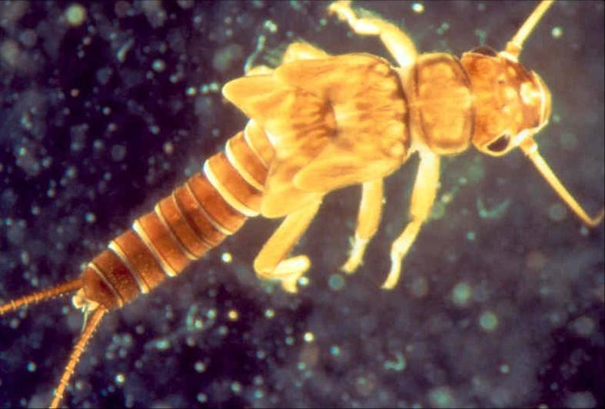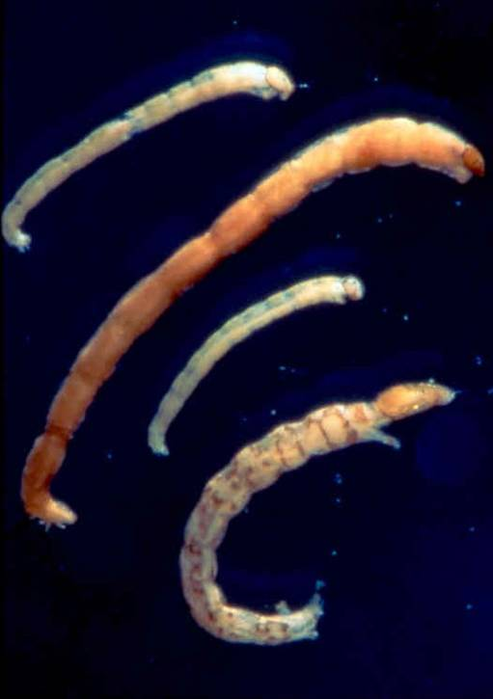

Figure 3.2.1.1: Macroinvertebrates

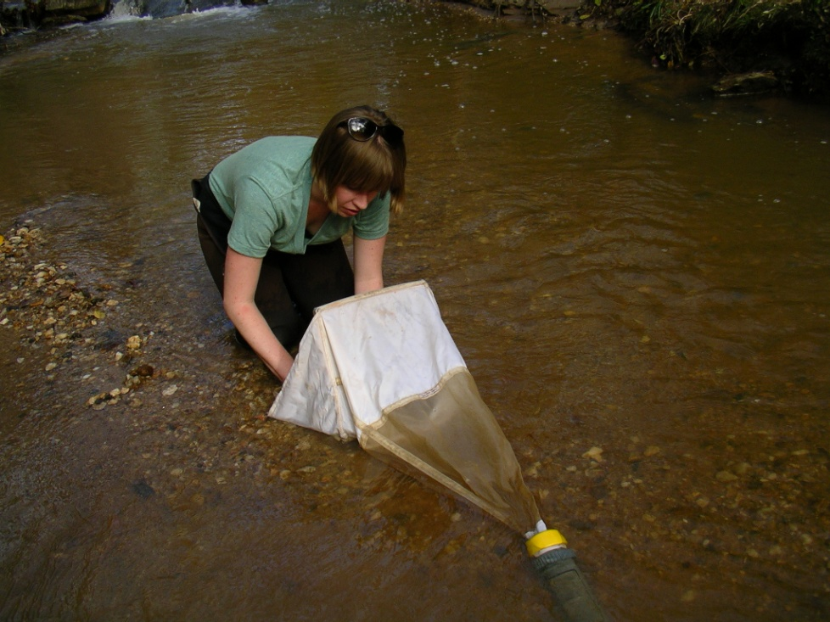

Figure 3.2.1.2: Macroinvertebrate Sampling

3.2.2 Macroinvertebrate Collection and Scoring Methods

Macroinvertebrate samples from Shoal Creek were collected and evaluated by the University Of Georgia School Of Ecology. Three sites (SH1, SH2, and SH3) were sampled in February or March of 2012 and 2013, while SH1 was also sampled in 2009. The health of Shoal Creek was evaluated using three methods: the Family-level Biotic Index (FBI), percent Ephemeroptera, Plecoptera, and Trichoptera (%EPT), and the Save Our Streams (SOS) Program. Multiple macroinvertebrate ranking systems can provide different viewpoints on aquatic ecosystems, giving a more complete assessment of a stream’s health. The three methods are usually in agreement, but SOS rankings can sometimes be elevated.

The Family-level Biotic Index (FBI) was used to evaluate the health of in-stream macroinvertebrates, which can then be correlated with the overall health of the stream itself. Macroinvertebrates were collected and then identified to the Family taxonomic level. Tolerance values were assigned to each taxon using the Family-level Biotic Index (Hilsenhoff 1988). This system assigns macroinvertebrate families a value of 0-10 based on their sensitivity to organic pollution (Excellent = 0.00 – 3.75; Very Good = 3.76 – 4.25; Good = 4.26–5.00; Fair = 5.01 – 5.75; Fairly poor = 5.76 – 6.50; Poor = 6.51 – 7.25; Very poor = 7.26 –10.00). Thus, the higher an FBI score, the more degraded a stream is.

% EPT is the percent of individuals (and families) of the orders Ephemeroptera (mayflies),
Plecoptera (stoneflies), and Trichoptera (caddisflies). These taxa are generally considered pollution-sensitive and their presence or absence can be a reliable indicator of stream degradation. Thus, a lower %EPT indicates stream degradation.

The Save Our Streams (SOS) Program of the Izaak Walton League of America is based on the presence or absence of “sensitive,” “somewhat sensitive,” and “tolerant” types of macroinvertebrates. This method is used by the Georgia Adopt-a-Stream program. Numerical scores were used to indicate water quality (excellent > 22, good = 17-21, fair = 11-16, poor < 11). Thus, the higher an SOS score, the more healthy a stream is.

3.2.3 Macroinvertebrate Score Results for Shoal Creek

Table 3.2.3.1 below summarizes the macroinvertebrate findings for each sampling site. Sampling locations coincide with those used in water quality sampling. Please refer to Figure 3.3.2.1 to see where each sampling site is located in the Shoal Creek drainage basin.

Table 3.2.3.1 Macroinvertebrate Scores

Sample Site | Number of Individuals | Number of EPT Individuals | %EPT | Number of Families | FBI Score | Rank | SOS Score | Rank | Percent Impervious Surface
SH1 (2009) | ND | ND | ND | ND | 5.86 | Fairly Poor | 24 | Excellent | 4
SH1 | 203 | 76 | 37.4 | 23 | 3.92 | Very Good | 27 | Excellent | 4
SH2 | 675 | 69 | 10.2 | 22 | 5.67 | Fair | 21 | Good | 5.5
SH3 | 197 | 37 | 18.2 | 17 | 5.39 | Fair | 21 | Good | 5.5
ND- No data collected

The FBI for SH1 was reported as “fairly poor” in 2009, but “very good” in 2013. This could indicate an improvement in the quality of the stream around SH1 or be the result of different researchers. However, the SOS score was “excellent” for SH1 in 2009 and 2013. The disagreement between FBI and SOS scores in 2009 could mean that a specific type of macroinvertebrate that is considered more sensitive by the SOS method than the FBI method is common in Shoal Creek. Both SH2 and SH3 had “fair” FBI scores and “good” SOS scores. The 2013 results coincide with statements made previously about Shoal Creek’s in-stream habitat. Most reaches of the stream scored in the “marginal” and “sub-optimal” range (see Figure 3.1.1.5), with only two reaches ranked “poor”. These reaches might be damaging macroinvertebrate habitat downstream through sedimentation and erosion, explaining the lower scores for SH2 and SH3. %EPT scores agreed with FBI scores. Sites with a higher %EPT also had a lower FBI, indicating more sensitive species were found.

3.2.4 Potential Stressors Affecting Shoal Creek’s Macroinvertebrate Scores

Impaired aquatic life in a stream is most often directly a result of degraded aquatic habitat. According to the data collected during the stream walks, the stream bed of Shoal Creek was found to have fairly significant sedimentation and aggradation. Many macroinvertebrate taxa live in riffle areas created by water moving over the stream bed material while others live in sandy pools. Therefore, a wide range in bed sediment sizes provides a variety of habitat for different aquatic organisms. As mentioned in Section 3.1.2, the majority of the sediment in the streambed of Shoal Creek is smaller, fine sandy/silt sediment. The presence of these more fine particles may provide significant habitat for some aquatic organisms, however, without the presence of larger rock and cobble, many of the riffle areas and other features required by other macroinvertebrates are not present.

While we found Shoal Creek to have a higher “vegetated buffer” score when compared to other areas of the stream assessment, the rating is still considered to be “suboptimal”, indicating some areas of buffer disturbance (see Table 3.1.1.1). Reduced vegetated buffers decrease shading, typically resulting in increased stream temperatures. This may inhibit the proliferation of some macroinvertebrate taxa that are sensitive to high water temperatures. More importantly, reduction in vegetated buffers may decrease the amount of leaves, wood and other organic material being delivered to the stream, reducing important food and habitat sources for macroinvertebrates.

Additionally, as discussed before, Shoal Creek is more than likely impacted by increased runoff volumes and velocities due to some residential and commercial development and, more significantly, by land disturbances associated with farming practices of both past and present. Such increases in stormwater runoff can lead to bank scouring, floodplain disconnection and sediment aggradation in the stream – each of which was seen in Shoal Creek’s stream walk assessments. In addition to scouring the stream, this increased stormwater flow may deliver harmful pollutants to the stream in a more rapid and concentrated manner, exacerbating Shoal Creek’s impairment. Most macroinvertebrates are sensitive to water quality and several studies have shown a positive relationship between macroinvertebrate abundance and diversity and water quality (Komnoski et al. 2007, Roy et al. 2003). Conductivity, a measure of dissolved ions in the water, is a good indicator of pollution from non-specific sources. Two of the three sample sites (SH2 and SH3) measured for high conductivity (>80 µS/cm; see Section III), on average, indicating potential presence of pollutants. These sites also had the worst macroinvertebrate scores. According to the Environmental Protection Agency, an elevated level of stream conductivity may be an indicator of sewage discharges into the waterway due to the high levels of anions such as chloride, phosphate and nitrate present in such waste streams.

Figures 3.2.3.1 and 3.2.3.2 provide a comparison between good and poor stream habitat. In Figure 3.2.3.1, cobble is present in the bed and there is leaf litter that provides habitat and food for macroinvertebrates. In Figure 3.2.3.2, the bed is choked by sand and debris from an invasive bamboo species and the stream bank is eroded, reducing the likelihood of viable macroinvertebrate habitat.

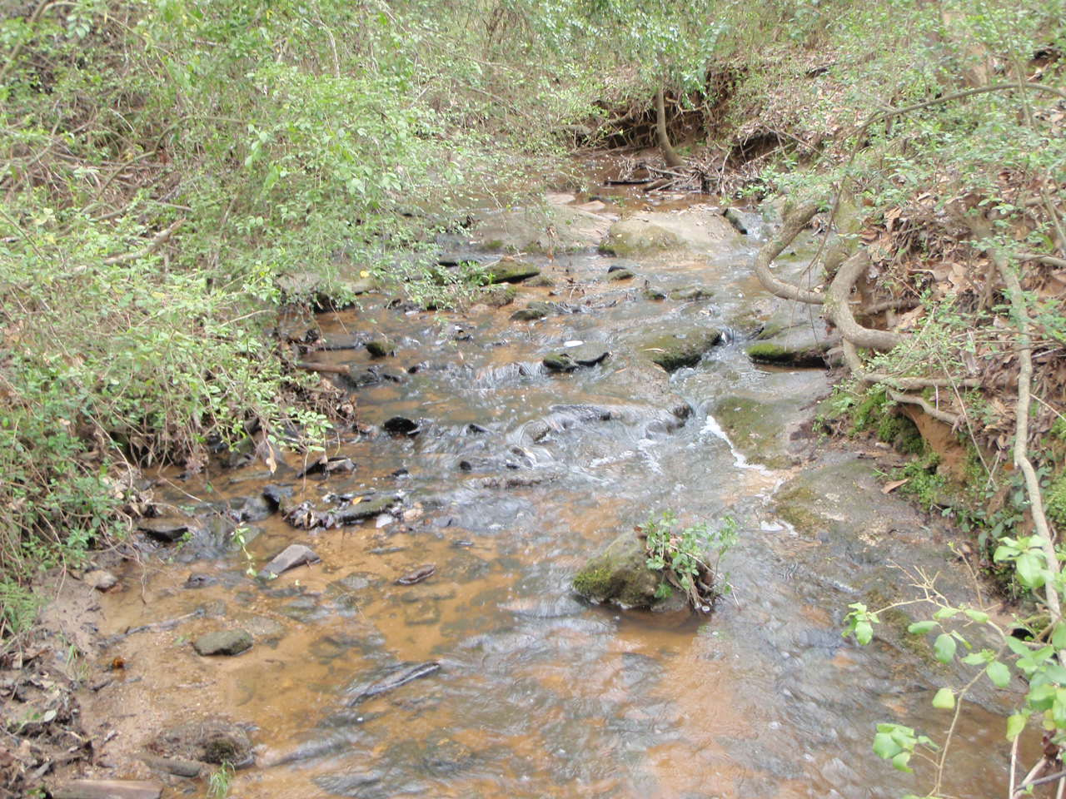
Figure 3.2.4.1: Shoal Creek - Good Stream Habitat

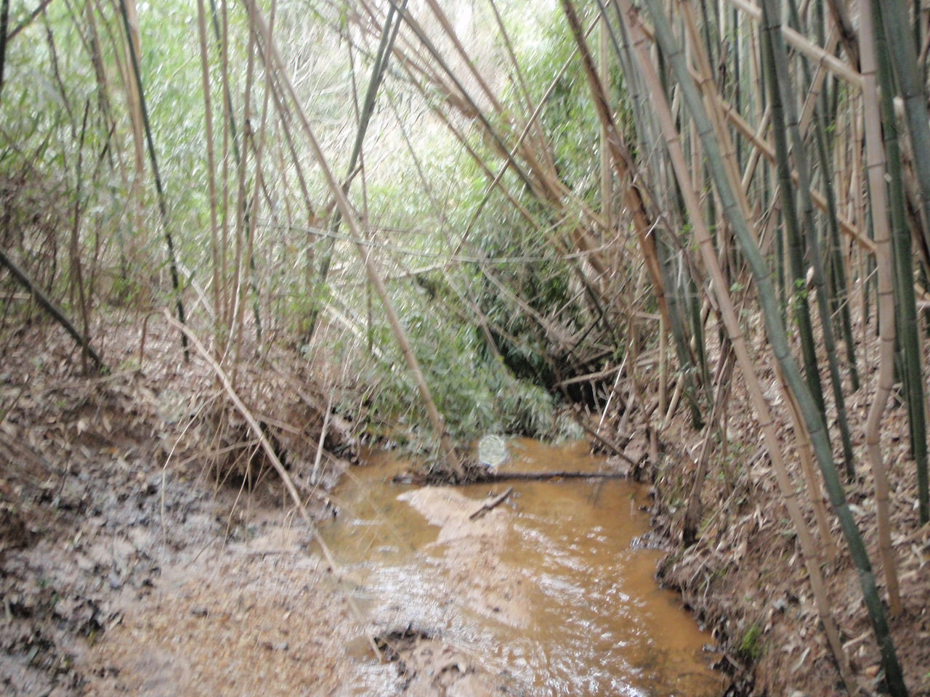
Figure 3.2.4.2: Shoal Creek - Poor Stream Habitat

3.2.5 How Biofilms Can Indicate Stream Health

Biofilms are the algae, microorganisms and organic matter on the bottoms of streams. Analysis of biofilms can reveal a lot about stream condition. Increased biofilm mass could indicate high nutrient levels or increased light from a lack of riparian zone. Decreased biofilm mass could be the result of altered stream hydrology caused by high peak flows, erosion, and sedimentation in areas with impervious surfaces. Biofilm nutrient content may increase due to nutrients available in stream water and sources of nitrogen (N) can be traced by detecting isotopic signatures of N in biofilms. Biofilms are a food source for macroinvertebrates and fish as well as an important site for the uptake and storage of nutrients (Hoellein et al 2011).

3.2.6 Biofilm Analysis Methods

Biofilm samples from Shoal Creek were collected and evaluated by the University Of Georgia School Of Ecology. Three sites (SH1, SH2, and SH3) were sampled in February or March of 2012 and 2013, and SH1 was also sampled in 2009. Analysis looked at chlorophyll a, biofilm ash-free dry mass (AFDM), biofilm carbon:nitrogen (C:N) ratio, and the δ¹⁵N isotopic signature of biofilms. Chlorophyll a is a measure of the algal component of biofilm mass while AFDM is the total mass of organic matter that makes up the biofilm. These values were measured for both hard (rocks) and soft (sand and organic material) substrates. Hard substrates are tightly attached and tend to have higher chlorophyll a levels, while soft substrates are more loosely bound and have higher AFDM (Sterling 2012). Low AFDM in soft substrates could indicate disturbed hydrology that scours away the soft substrates. Undesirable conditions in streams are likely best characterized by high algal biomass (high chlorophyll a) and loss of retention of organic material (low AFDM). A decrease in the C:N would indicate an increase in Nitrogen levels and a possible nutrient input to the stream. The δ¹⁵N isotopic signature of biofilms can be used to determine if human activities such as sewage or pet waste are a source of N (Chang et al. 2002, Ulseth and Hershfy 2005, Diebel and Vander Zanden 2009, Pastor et al. 2014).

3.2.7 Biofilm Analysis Results

Table 3.2.7.1 Biofilm Scores

Sample Site | Chlorophyll a (mg/m²) |  | AFDM (g/m²) |  | C:N | δ¹⁵N
 | Hard | Soft | Hard | Soft
SH1 (2009) | *94.6 ±13.3 | 13.7 ±5.2 | 3.08 ±0.19 | 2.567 ±1.19 | ND | ND
SH1 | *64 ±20.5 | 19 ±6.7 | 16.9 ±4.5 | 162.0 ±60.1 | 10.1 | 4.1
SH2 | *144 ±37.9 | 5 ±0.6 | 54.2 ±7.2 | 44.4 ±14.3 | 10.9 | 7.0
SH3 | 20 ±2.6 | 14 ±5.0 | 25.2 ±4.5 | 131.7 ±15.5 | 11.0 | 7.2
* indicates chlorophyll a concentrations exceeding or approaching 100 mg/m² based on ±SE (standard error), which is considered excessive
ND- No data was collected

Hard-substrate Chlorophyll a values were elevated at both SH1 and SH2 sites, indicating a possible need for nutrient reduction efforts. Low soft-substrate concentrations of AFDM at site SH2 could be the result of disturbed hydrology. Soft substrates are mobilized and scoured to a greater extent than hard substrates, and are therefore more affected by peak flows, erosion, and sedimentation. SH2 is the site of most concern due to its high hard-substrate chlorophyll a concentrations and low soft-substrate AFDM concentrations. This fits with Shoal Creek’s stream walk data that found the middle section of the stream to have the lowest reach scores. Also, elevated δ¹⁵N in SH2 and SH3 suggest that human activity could be a major source of N for the lower sections of Shoal Creek. Chlorophyll a results from the 2009 study of SH1 agree with 2013 findings; however AFDM readings are significantly lower. This could be the result of different sampling or analysis methods or indicate an increase in AFDM in Shoal Creek as a whole over time. Understanding how nutrient concentrations stimulate algal growth in Shoal Creek is important in managing the nutrient inputs and further studies are needed to fully investigate the implications of these results.

3.2.8 Historical Impacts on Aquatic Habitat

Since excess sediment in the stream is the main cause of the stream bed aggradation and, ultimately, loss of aquatic habitat, it’s important to determine where that extra sediment might be coming from. When considering the impacts of sediment, we need to look not only at what is happening in Shoal Creek right now, but also at what went on in the Shoal Creek basin regarding land use in the past. Historic maps of Shoal Creek were not available at the time of this report, so a complete historic analysis is yet to be undertaken.

As mentioned previously, Shoal Creek is historically agricultural and the majority of the area in the watershed is still used for agricultural purposes. Agriculture affects streams in several ways. First, clear cutting trees for cropland is a primary reason for much of the riparian buffer depletion in Shoal Creek. Removal of stream buffers and land clearing can increase runoff and sediment entering the stream systems. Agricultural activities can also increase the amount of nutrients delivered to a waterway. These nutrients can come from the improper application of fertilizers that are therefore transported to a stream via stormwater runoff, or the nutrients can come from livestock manure, potentially delivering nutrients and harmful pathogens to a stream during rain events.

Figure 3.2.4.1: Shoal Creek: 1938

Map not available.

Figure 3.2.4.2: Shoal Creek: 1951

Map not available.

Figure 3.4.2.3: Shoal Creek: 1960

Map not available.

Figure 3.4.2.4: Shoal Creek: 2008

Map not available.

3.3 Water Quality Data

3.3.1 Why Sample?

Water quality data are used to characterize waters, identify trends over time, identify emerging problems, determine whether pollution control programs are working, help direct pollution control efforts to where they are most needed, and respond to emergencies such as floods and spills (EPA, Monitoring and Assessing Water Quality). Water quality sample results are compared to a set of water quality benchmarks created by combining both regulatory standards (Georgia Water Quality Standards) and previous research. These benchmarks represent measures of healthy streams. Collecting and testing water quality samples over time gives us a better picture of what pollutants might be traversing our local waterways like Shoal Creek.

3.3.2 Two Water Quality Sampling Methods

Two sampling methods were used to collect water quality data for Shoal Creek. First, monthly sampling was conducted at three sampling sites in the watershed. These grab samples cover a wide range of parameters that indicate water quality. We can compare variation in monthly water quality data with stream walks, biological data, and other watershed activities that have happened during the same timeframe to identify potential sources of pollution. Another method we use is in-situ water sampling using data collection units called Datasondes. These data collection units are left in-stream to give us continuous trend-identifying water quality data as indicated by measures of pH, dissolve oxygen, conductivity, turbidity, and temperature. The continuous data is used to identify changes to basic stream chemistry over time and seasonally. The data can also identify significant changes to stream chemistry over time.

Monthly Sampling

Monthly water quality data was collected via the grab sampling method, meaning samples were collected from all sample sites at the same time. This method is in compliance with Athens-Clarke County’s EPA-approved Quality Assurance Protection Plan (QAPP) that ensures accuracy of results by standardizing sampling procedures. The criteria sampled were water temperature, pH, dissolved oxygen, conductivity, fecal coliform bacteria, total suspended solids, and nutrients. Each criterion is an indicator for a potential type of water pollution. Analysis is conducted by several different labs including the Athens-Clarke County Public Utilities Water Treatment Lab and the University of Georgia Analytical Chemistry Laboratory. The labs follow methods taken from the Standard Methods for the Examination of Water and Wastewater as developed by the American Public Health Association, the American Water Works Association, and the Water Environment Federation (APHA). Figure 3.3.2.1 includes the water quality sampling sites in Shoal Creek as well as the land use in the Shoal Creek Basin. Sample data is provided in Appendix Section II.1.

In-Situ Water Sampling Using Datasondes

The Datasonde has multiple probes that sense the following water quality indicators: dissolved oxygen, pH, temperature, conductivity and turbidity. It is able to store these measurements until a staff member retrieves the unit from the stream and downloads the data. Datasondes collect real-time continuous data without having to be present. The Datasondes are calibrated and checked after each data collection before being returned to the stream. Sample data is provided in Appendix Section II.3.
Figure 3.3.2.1: Shoal Creek Water Quality Sampling Sites and Land Cover Use

3.3.3 Water Quality Data for Shoal Creek

Georgia’s water quality standards are set by the State of Georgia Environmental Protection Division (GAEPD). According to the State, the “healthy” range for a number of criteria depends on the designated use of the stream as made by GAEPD. A stream designated for fishing has a higher water quality criterion than one that is just used for outdoor recreation since the fish might be consumed by people. For this project, water quality health is determined using a set of benchmarks defined both by the state water quality standards and previous research. Previous research included a literature review focused on instream, baseflow measurements within the Georgia piedmont. Table 3.3.3.1 shows the benchmarks and monthly averages for all water quality data used in this project, with the bolded benchmarks having regulatory implications. Shoal Creek is designated by the Georgia EPD as a stream used for fishing. Based on available water quality data, the primary constituents of concern related to the benchmarks in Table 3.3.3.1 for Shoal Creek are Fecal Coliform, Nutrients (specifically NO3), and TSS. To view all sampling results, refer to the charts in Section II.1 in the Appendix where samples scoring outside of the designated “healthy” range are highlighted yellow.

Table 3.3.3.1: Water Quality Benchmarks and Monthly Average Values

Parameter | Benchmark* | SH1 | SH2 | SH3
Temperature | < 30 deg C | 14.05 | 15.48 | 15.88
pH | 6.0 to 8.5 | 6.36 | 6.86 | 6.71
Dissolved Oxygen (DO) | > 5 mg/L | 8.76 | 9.32 | 9.68
Conductivity | 0 - 1.5 mS/cm | 0.06 | 0.09 | 0.14
Fecal Coliform | < 500 col | 546.11 | 686.33 | 222.56
NH4 | 0.01 – 1 mg/L | 0.033 | 0.005 | 0.002
PO4 | 0.002 – 0.1 mg/L | 0.001 | 0.003 | 0.001

Bold = Regulatory standard as defined by Georgia State Water Quality Standards (2009). Non-bold items are parameters that were also measured. Values in exceedance are not a violation of water quality standards, but indicate poor stream health.
*Benchmarks are for streams under normal flow conditions.

3.3.4 Potential Stressors Effecting Shoal’s Water Quality Scores

If a water quality indicator is not within the acceptable range as designated by GAEPD, then the waterbody is in violation of regulatory standards and is typically classified as “impaired” if the trend persists. When a benchmark is exceeded, this indicates that stressors on stream health are present but no regulatory implications exist. When a water quality criterion is in exceedance of either a benchmark or regulatory standard, we then look at what might be causing that criterion to be out of range and the associated impacts on water quality. In Shoal Creek, monthly averages for two of three sample sites exceed the EPD regulatory standard for fecal coliform of 500 colonies or less. This trend is consistent with EPD’s placement of Shoal Creek on its “Draft 2014 Integrated 305(b)/303(d) List” for fecal coliform impairment. Additionally, total suspended solids and nutrient scores for NO3 were out of acceptable range for one sample site (SH1), but no identifiable trends were noticed and, therefore, more sampling efforts should be made for SH2 and SH3 to gather a more conclusive data set.

Looking at monthly sampling data for Shoal Creek, samples with fecal coliform results exceeding the EPD standard of 500 colonies/100 mL occurred 16 times across the three sample sites over the period of January 2009 to May 2012. On a month-to-month basis, no identifiable trends were noticed. However, when looking at each sample site’s data set as a whole, SH2’s fecal average coliform levels proved to be significantly higher than both the other two sample sites and the regulatory standard. While, fluctuation across the sampling period does not suggest an ongoing source of fecal coliform contamination, it is apparent that there are significant non-point source contributors to this impairment. Figure 3.3.4.1 contains box plots of fecal coliform data from three sample sites. SH1 and SH2 both show elevated levels of fecal coliform contamination, leading one to believe that the impairment is due to stressors introduced in the upper portion of the watershed, with significant dilution occurring downstream at SH3.

Figure 3.3.4.1: Box Plot of Fecal Coliform Sampling

Fecal coliform can come from leaking septic systems or sewer lines, businesses that have permits to put water back into a stream after an industrial process, and from animal waste. There are 2,431 septic systems in the Shoal Creek basin, more than any other basin in the county. Most of these systems are relatively new but could be a major contamination issue in the future if they are not properly maintained. Some of the northern section of Shoal Creek drainage basin is served by county maintained sewer lines, but a large majority of the basin is not served by this utility. Between November 1997 and December 2009 there were XX sewer spills within the Shoal Creek Basin reported by the Athens-Clarke County Public Utilities Department.

Moreover, as stated previously, the primary land usage of the Shoal basin was historically agricultural, and much of these practices still exist today. Many agricultural practices involve the presence of livestock that can contribute to elevated fecal coliform levels as well as nutrient delivery to surface waters. Fecal coliform is an indicator that fecal matter has been introduced to a waterway and implies that other harmful pathogens from feces may also be present. One site in particular was identified by Tetra Tech, a county-contracted environmental consultancy, as a probable source of fecal coliform introduction to Shoal Creek. This potential source of impairment and recommended best management practices for mitigation will be further discussed in later sections of this report.

Total suspended solids are the amount of sediment suspended in the water of the stream. The amount of suspended sediment can be increased by bank erosion and bed scouring caused by the increased runoff and water velocities entering a stream as discussed in earlier sections of this report (see sections 3.1.2: Shoal Creek Stream Bed, Bank and Buffer and 3.1.3: Potential Stressors Effecting Shoal Creek’s Stream Assessment Scores). According to Table 3.3.3.1, the average score for total suspended solids was elevated for the one sample site (SH1) for which data was collected. It is important to note, however, that the benchmarks are meant to represent a healthy stream in dry weather conditions. With that being said, considerations involving rain events as well as a more complete data set, including TSS data from SH2 and SH3, are needed to further assess the potential for suspended solids impairment.

3.4 Conceptual Model of Shoal Creek Conditions and Concerns

In order to understand the health of Shoal Creek watershed, we utilized three main methods of data collect that provide us with information on stream health: conducting a physical stream assessment, collecting biological scores, and collecting water quality data. A conceptual model (Figure 3.4.1) was created to trace these indicators back to their likely sources and identify areas of particular concern in Shoal Creek. Additional work is needed to identify and locate sources.

Indicators

The three indicators for this study are Water Quality Data, Biological Scores, and Stream Assessment Scores. Water Quality Data come from two sources: monthly grab sampling and datasonde long-term monitoring instruments. This data is then compared to water quality benchmarks created using the Georgia Water Quality Standards and comparable studies of water quality. Biological Scores were obtained by collecting and analyzing macroinvertebrate and algae data. Stream health cannot be solely defined by water quality alone. That is why it is important to conduct physical stream assessments as well. Stream walks were used to gain an understanding of Shoal Creek’s physical health from the headwaters to the confluence with the Oconee River.

Impacts

Moving up the model, we looked at the local impacts that lead to the indicators mentioned above. These are the “evidence” that a stream is suffering from some type of water pollution. These indicators include specific impacts with a direct correlation to Water Quality Data like regulatory standards violations and missed benchmarks stemming from algal growth and decreased water quality. Degraded aquatic habitat and impaired aquatic life affect biological scores. In the physical assessment of the stream, we focused on the bed, banks, and buffers and noted the particular impact of deposition, aggradation, and degraded riparian habitat in Shoal Creek.

Stressors

A variety of more broad stressors cover some of the larger issues of water quality. These stressors include nutrients, pathogens, and chemicals—all important contaminants to be mindful of in stream studies. More importantly in Shoal Creek, these stressors include some evidence of increased peak flow and runoff volumes, riparian disturbance, and increased pathogens and sediment, which upon analysis are likely the most important contributors to the declining health of the watershed.

Sources/Sub-Sources

Finally, more global sources of stream degradation include human activity and other sources of water pollution. In this study of Shoal Creek, it is evident that a majority of the issues in this watershed stem from human sources, particularly historical and current agricultural and some urban development. Other sources of water pollution also contribute to poor water quality, but the data does not suggest that the impacts are as great as human activity.

Summary

Overall, as mentioned, the driving factor on the condition of Shoal Creek Drainage Basin is human activity. We can point to three key stressors as having impacts on aquatic life, hydrologic function, and water quality. These stressors are sedimentation, hydromodification (both due to development and agricultural practices), and fecal coliform contamination. SHCDB is one of the largest and most agriculturally influenced watersheds in ACC which has resulted in increased storm flows as mentioned before. These increased storm flows have resulted in high flow velocities which “blew out” the stream channel in the upper reaches causing increased sedimentation, incised channels, and channels aggraded with sediment downstream. The combination of sediment and increased flows also decreases the habitat for macroinvertebrates. Fecal coliform contamination has recently resulted in the stream being listed on the GAEPD’s “Draft 2014 Integrated 305(b)/303(d) List”. However, the sources of contamination are uncertain at this time and the data shows no signs of a continuous source. Further source identification is needed. The lack of stormwater BMPs in the SHCDB is likely the reason for the impairment currently observed. Chapter 4 will discuss one specific BMP method projected to reduce fecal coliform impairment and further stream sedimentation.

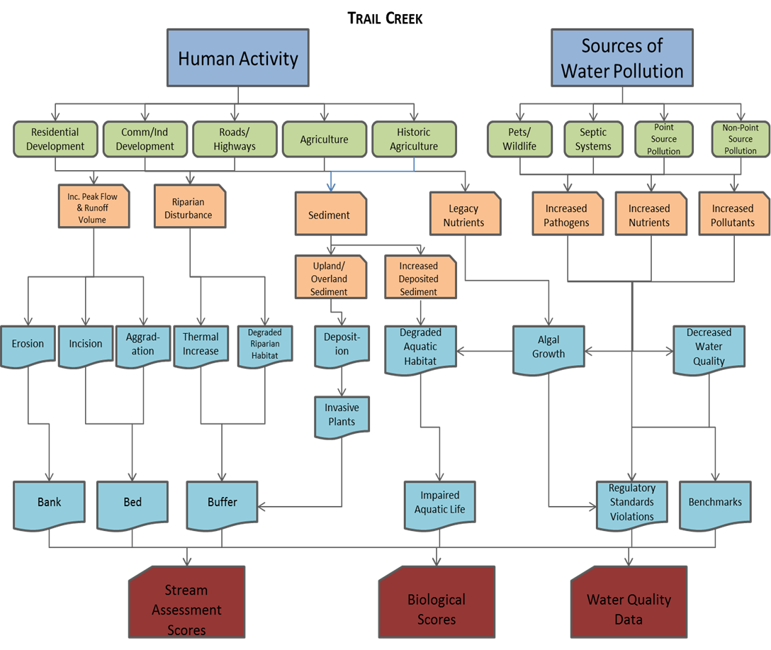

Sources/
Sub-Sources

Stressors

Impacts

Indicators

Figure 3.4.1 Conceptual Model of Human Impacts on Streams

Chapter 4: Identification of Management Needs

4.1 Summary of Management Needs

Agricultural practices, both past a present, have had the most significant impact on the Shoal Creek watershed. Most reaches along Shoal Creek were in relatively good health aside from those in agricultural areas. The most important steps in the Shoal Creek watershed improvement strategy will be preservation, agricultural BMPs, and stream restoration. All of these actions will be in the effort to decrease livestock impacts and nutrient loading as well as improve and/or maintain aquatic habitats. One reach in particular that is of highest concern runs through a pasture on private farmland where cattle have access to the stream. This has caused damage to the riparian buffer at the site and also poses a concern for bacterial contamination. Riparian buffers are critical in controlling flow into the stream and therefore impact stream bank erosion, sedimentation, and the overall health of the stream. This reach is located near the intersection of Old Lexington and Morton roads. While Tetra Tech has labeled it SH-R1, its location actually corresponds to the reach named SH-1j by ACC staff during stream walks, as discussed in Chapter 3. Table 3.1.1.1 and Figure 3.1.1.5 show that reach SH-1j has the lowest scores, which corresponds with Tetra Tech’s assessment that BMPs should be focused there. Aside from this section of Shoal Creek, flow volume and peak flow is not an issue for the watershed. Water quality data has shown that the overall health of the stream has not been significantly impacted. Centralized and distributed BMPs are only necessary in agricultural areas of Shoal Creek in order to treat pasture runoff. Pasture runoff contributes to nutrient loading through fertilizer runoff, sedimentation through soil erosion, and bacterial concerns if livestock feces are transported into the river. Key to this strategy will also be bacterial source tracking in order to select management options that are most effective in preventing fecal coliform contamination. Ensuring that new development and redevelopment projects have adequate flow and water quality BMPs, such as LID (Low Impact Development) will also help prevent any damage to the watershed in the future.

4.2 Best Management Practices to Be Utilized in Shoal Creek Watershed

4.2.1 Streambank/Riparian Area BMPs

4.2.1.1 Priority Streambank/Riparian Area BMPs

Pasture BMPs limiting cattle access to streams

This BMP involves using fencing to block cattle access to streams. Alternative water sources would need to be provided to the cattle. This practice typically involves restoration of the fenced riparian buffer. This BMP along with other agricultural BMPs should be the priority effort for Shoal Creek. They should be implemented along the reach of Shoal Creek that runs through open pasture.

Streambank stabilization

Streambank stabilization involves adding natural materials or structures to banks to reduce erosion and provide stability. Natural, less structural materials are preferred, but riprap and similar materials may be required along severely unstable reaches.

Streambank restoration

Streambank restoration involves the conversion of vertical banks to gradually sloping banks, which are then stabilized and vegetated.

4.2.1.1 Secondary Streambank/Riparian Area BMPs

Riparian buffer revegetation

Riparian buffer revegetation, or restoration, involves the re-establishment of natural vegetation along streams where it has previously been removed or destroyed. This activity is usually part of a stream restoration project.

Riparian buffer preservation (education and conservation easements)

This activity involves preventing the future disturbance of vegetation along streams by purchasing property rights, either through a conservation easement or fee simple purchase.

Preservation of beaver ponds and wetlands

This activity involves preventing the future disturbance of beaver ponds or wetlands by purchasing property rights, either through a conservation easement or fee simple purchase.

4.2.2 Stream Channel Restoration

Stream channel restoration objectives and practices vary depending on watershed needs, goals, and site constraints. In general, restoration concepts include channel morphology, floodplain structure, hydrologic and hydraulic analysis, in-stream structures, habitats and vegetation, site and watershed conditions, monitoring, maintenance, and education. Priority 1 restorations include raising the channel to the existing valley and constructing a new meandering channel. Priority 2 restorations include excavating a lower floodplain and constructing a new meandering channel. Priority 3 restorations include the excavation of narrow floodplain benches in confined systems. Priority 1 restorations are recommended for Shoal Creek.

Characteristics may include:
- Producing more gradually sloping banks
- Reconnecting a stream to the floodplain
- Converting a stream from a
- straight to a meandering channel
- Restoration of riffles (shallow areas where flow passes over a gravel bed)
- Restoration of pools (deeper,
- more slow-flowing areas)
- Rock or wood structures that promote natural stream flow patterns (see above photo)
- Revegetation of banks
- Maintenance and monitoring
Instream grade control

Instream grade control is a type of restoration that alters the existing channels and adds structures to the channels that reduce velocity and downstream erosion.

4.2.3 Distributed BMPs

Distributed BMPs are BMPs for smaller land areas than centralized BMPs, and may be spread throughout the watershed. Both centralized and distributed BMPs are meant to control peak flow spikes that might bring large amounts of pollutants with it. However, according to the water quality data gathered, Shoal Creek does not have significant peak flow pollution problems, so these BMPs are not a priority. It is suggested that bioretention be used in the area with open pasture to capture agricultural runoff. We will consider both priority and secondary distributed BMPs. Priority BMPs are somewhat easier and more cost effective and should be considered first when establishing management practices to be used.

4.2.3.1 Priority Distributed BMPs

Bioretention

Bioretention areas are depressions filled with 2 to 4 feet of sandy soil and planted with drought and flood tolerant plants. Stormwater drains into the surface of the bioretention area and, as the water infiltrates through the sandy soil, the soil and plants remove a portion of pollutants. In areas with sandy loam or other highly permeable soils, the water treated by the bioretention cell will infiltrate into the native soil. In areas that have soils with low permeability (typically clay-dominated soils), a gravel layer and underdrain pipe are placed below the sandy soil layer. Once the stormwater infiltrates through the treatment cell’s sandy soil, it is drained out of the device through the underdrain pipe. Most bioretention areas are designed so that up to a foot of water can pond in the cell during a rain event. A weir is included in the bioretention area to bypass excess water above the ponding depth. Since bioretention areas use mulch and a variety of shrubs and small trees, they can be easily incorporated into existing landscaping.

Rainwater harvesting

Rainwater harvesting reduces runoff during a storm event by retaining a portion of the runoff for future use. This can be accomplished by using storage tanks called cisterns or rain barrels. Cisterns are tanks that hold rainwater for irrigation and other uses. The cistern pictured to the right can hold over 200 cubic feet of water. These BMPs can be pre-manufactured or constructed onsite. They also can be incorporated inconspicuously into the side of a building. Rain barrels typically hold less water than cisterns, about 8 cubic feet per rain barrel. If these devices are designed properly and if water is reused frequently, they can be used to control stormwater runoff, reduce stormwater flow, and remove some pollutants.

Disconnect downspouts

This practice involves reducing the amount of concentrated stormwater runoff leaving a site by disconnecting roof downspouts from drainage systems. Some houses or other buildings may not be directly connected to the municipal storm sewer system, but still may have an onsite drainage system or diffused runoff that could be disconnected. The roof runoff is diffused and directed into natural areas, gardens, bioretention cells, etc.

Retrofit of parking areas to disconnect impervious surfaces

This strategy involves the re-design of a parking lot so that runoff is captured and treated in distributed stormwater BMPs like bioretention. Grass swales may be employed as a conveyance to the bioretention, providing additional pollutant removal.

Permeable pavement

Permeable pavement differs from conventional asphalt and concrete in that it allows for infiltration of water during a rainfall event. Permeable pavement types include porous asphalt, porous concrete and paving stones interspersed with sandy soil or other porous fill. These types of pavement vary in vehicular traffic capacity. Grass parking lots, reinforced with plastic rings, are typically used for overflow parking, while some permeable pavement can be designed to handle more frequent traffic.

4.2.3.2 Secondary Distributed BMPs

Swales

A grass swale is a grass-lined channel with sloped banks. Culverts are used to pass stormwater under driveways and streets. Unlike water quality swales, grass swales do not have a sandy soil layer or gravel underdrains. Grass swales are used to convey stormwater runoff and slow stormwater flow. They are an alternative to storm sewer pipes, which produce higher stormwater flows than grass swales, especially for smaller storm events. Grass swales also remove some sediment if the stormwater flow is controlled.

4.2.4 Sewer Line Maintenance/Replacement/Study

Enhanced CIP for sewer pipe maintenance and replacement (potential enhancement of current programs)

A capital improvement plan/program (CIP) includes an enhanced schedule for routine sewer pipe maintenance and replacement of leaking pipes.

Conduct enhanced bacteria study

A field study designed to observe indicators of bacteria loading can help identify the major sources of bacteria in a watershed and lead to more successful management efforts.

4.2.5 Citizen Education

Citizen Education Efforts

Citizen education is an extremely important method for improving stream health. Several different methods would be used for educating citizens, as outlined below. Many of these strategies would be utilized county-wide, not just in Shoal Creek. They are an important part of this WMP however. Each strategy includes:

- Program Description
- Target Audience
- Goals of Program (Broad)
- Expected Outcome (Quantitative)
Stream Clean-Ups
- Residents remove trash and tires from the stream bed, banks, and buffer. Volunteers may also be recruited using Community Connection’s network of volunteers. Partner with the Solid Waste Department in order to have access to roll-off containers for disposal of trash.
- Residents living in the target basin, residents living or owning property near streams.
- To improve stream habitat, connect residents to their local environment, and to gain resident investment in the larger Watershed Improvement Program.
- 500 feet of stream cleaned up and involvement of 15 residents per basin. Also measure the tons of garbage removed from the stream and buffer.
Fertilizer Reduction Program
- Residents are taught how to test the soil to determine how much fertilizers they need. They are taught how and when to fertilize properly, using a fertilizer with nitrogen/phosphorous/potassium ratios recommended by UGA Cooperative Extension Office. Residents can be engaged during the neighborhood meetings but will also be mailed test kits. How many kits are sent in by residents to be tested is a measure of some behavior change. Residents will be asked to create a “no fertilizer and no mowing zone” within x feet from the stream, and the change in buffer width over time can be a measurement of behavior change. The landscaping businesses currently used by basin residents will also be engaged and asked to use only what fertilizers are necessary as prescribed by UGA Cooperative Extension. Residents will be asked to show the soil testing results to their landscapers and request that only the necessary amounts of fertilizers are applied during the appropriate season. Signs may be posted that can be changed to give residents a “green” or a “red” light for fertilizing based on when the next rain event is likely to occur.
- Home owners in target basins, approach by neighborhood or even a collection of streets.
- Overarching goal is to reduce improper fertilizer application and therefore to reduce nutrient levels in the stream. The stream will be sampled before, during, and after the implementation of the program. During the program complimentary media will run on local media outlets.
- Outcomes could include:
  - Enlist at least 50% of households in a residential neighborhood to sign a pledge to eliminate or reduce fertilizer application to once per year. (Follow up periodically to confirm ongoing adoption.)
  - Have 25 number of residents send in soil testing kits per year.
  - Change in buffer width over time.
  - Fertilizer levels in water before and after program implementation.
Other Desired Behavior Change
- Reduction of soaps and detergents in runoff
  - Give residents car clings that remind them to wash their car on the lawn.
  - Offer coupons for local car washes. Can track how many coupons are redeemed.
- Reduction of pet waste in runoff
  - Give out free doggie bags
  - Have residents and their children do “poop patrol,” putting flags in pet waste left on the ground. Repeat 6 months later and measure the change in the number of flags distributed for the same area.
- Reduction of leaf and lawn litter that enter the stormwater system
  - Leave door hangers explaining the harm done by lawn debris on area houses.
    - Do a visual assessment of lawn debris and leaves in the gutters and stormdrains before and then 6 months after program implementation.
Businesses
- Engage businesses in the Stream Savers Program. This program is still in development but includes business participation in the following types of activities. An “ACC Green Business Award” program might also be effective, and would involve participating in education and behavior change activities designed by ACC Stormwater, Keep Athens-Clarke County Beautiful, ACC Water Conservation, and ACC Recycling.
- Hosting a rain barrel workshop for the general public
- Installing a rain barrel with educational signage on the business property
- Having a “Stream Saver Special” food item or product for sale
- Completing a stormwater audit of the business grounds
- Organizing a team of business employees to take part in a stream clean-up or other environmental service day
- Adopting a stream or highway
- Hosting a visit from the Stormwater mascot, Tortooga
- Completing a water conservation audit
- Watching a stormwater or water quality related DVD during a staff meeting
- Converting to non-toxic cleaners for cleaning the workplace
- Participating in a lunch-n-learn lecture hosted by ACC Stormwater
- Making stormwater education materials available for customers

Complementary Media

Complementary media campaigns will be run on local media outlets to increase awareness of and advertise for the programs themselves, as well as to educate ACC citizens in general about ways they can protect the health of their watersheds. Advertising for localized neighborhood programs to the larger general audience will help to build awareness of the watershed improvement programs ACC Stormwater will offer and hopefully increase attendance at future public meetings and workshops. Staff should create a media campaign approach that speaks to the interests of the Athens population, but should also draw from resources that already exist from national stormwater pollution reduction campaigns.

4.2.6 Other BMPs

Waterfowl management

It is generally desirable to have waterfowl habitat within a watershed ecosystem. However, waterfowl can be a significant source of bacteria and nutrients in waterbodies, and a number of management strategies are available to control their populations. The following strategies can be used to discourage the overuse of waterbodies by waterfowl, particularly Canadian geese:

- Install devices that repel waterfowl from a waterbody without causing harm to the birds or other wildlife (custom windmills, eagle-shaped kites, flashing lights, etc.)
- Reduce or eliminate fertilization and irrigation near waterbodies.
- Replace lawn areas along waterbodies with shrubs, yucca plants, or other vegetation that is less attractive to waterfowl.
- Build in trees, shrubs, rocks and other natural obstructions that provide habitat for predators.

These strategies should also be used to prevent BMP retrofits, especially pond retrofits and stormwater wetlands, from being accessed by waterfowl.

4.3 Evaluation and Location of BMP Priority Areas

The BMPs above were further evaluated to select the most promising BMPs for detailed modeling and assessment by individual catchment. Tetra Tech, the environmental consultant used on this project, used available observed and simulated data to designate which catchments presented the greatest management needs, including
- Catchment Loading: estimated total loading from overland runoff in the watershed, including Total Nitrogen (TN); Total Phosphorus (TP); Total Suspended Solids (TSS). These estimates are from the LSPC watershed model results of existing conditions.
- Observed Monitoring Data: measured water quality data including TN, TP, TSS, Dissolved Oxygen (DO), Fecal Coliform (FC), Biological Oxygen Demand (BOD), and Turbidity (as discussed in Section 3.3.3).
- Flashiness Index: a measure of the peak flow of streams. These estimates are from Tetra Tech’s modeling of existing conditions using the project’s LSPC watershed model.
- Aquatic Habitat Score: indicators of overall stream health from the project characterization reports.
- Total Stream Segment Score: an indicator of overall stream condition from the project’s characterization reports.
As noted above, all of the BMPs in the previous section are recommended for the watershed improvement strategy. However, different combinations of BMPs were selected for different catchments. The BMPs were screened for their potential effectiveness and implementation feasibility based on each catchment’s (1) management needs, and (2) existing types and intensities of land cover. Each strategy included a number of distributed engineering BMPs, streambank and riparian area management, and citizen education. The BMPs selected for more detailed catchment assessment were considered the most promising BMPs; however, other BMPs options on the menu could be effective as well in a given catchment and should also be considered in the future.

Priority reaches for restoration and preservation were selected according to which reaches were rated as moderately degraded during ACC’s field assessment (Section 3.1). Sites were evaluated to ensure that selected reaches exhibited moderate bank erosion, channelization, etc., and selected reaches did not have conditions that would cause major constraints, like unusually high banks or existing structures.
The following figure (Figure 4.3.1) shows overall management needs and high priority BMPs, by catchment. The figure also highlights secondary management needs that should be addressed as resources become available, and the associated secondary BMPs. Figure 4.3.2 shows that there is really only one reach (SH-R1) of Shoal Creek that is currently of most concern.

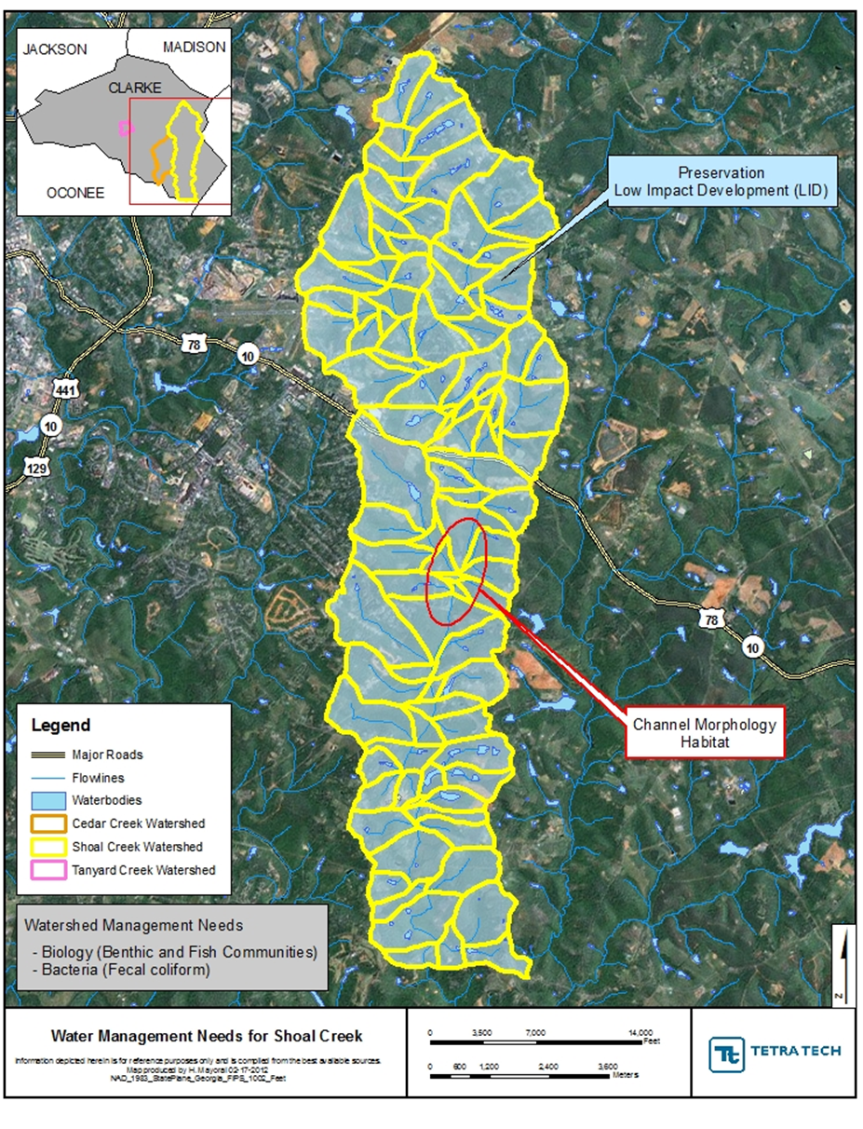
Figure 4.3.1 Shoal Creek Management Needs
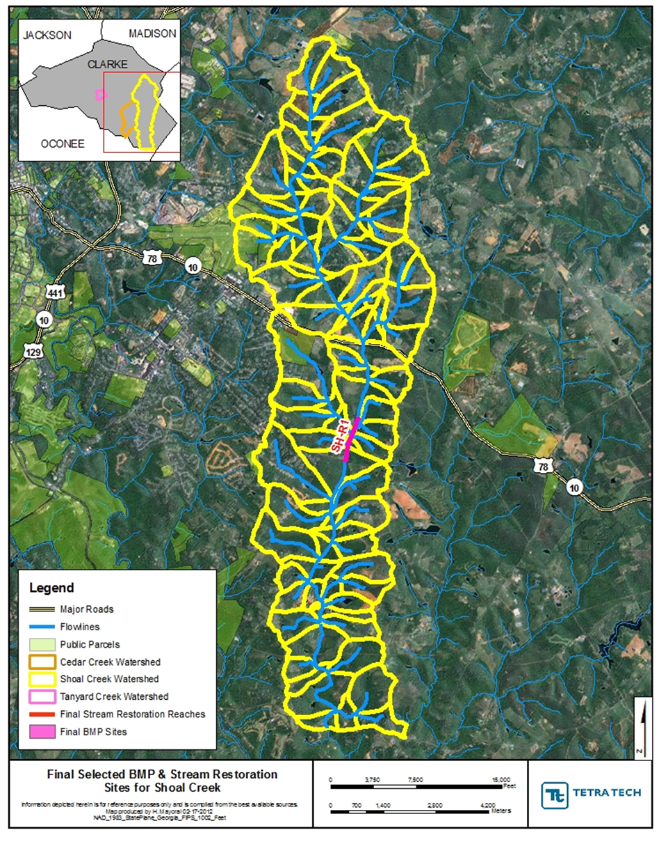
Figure 4.3.2 Shoal Creek Selected BMP and Stream Restoration Site

4.4 Estimated Load Reductions of Best Management Practices

BMP modeling was not performed for the Shoal Creek watershed because there are no structural BMPs recommended at this time. Hydrology and water quality modeling was conducted in order to provide more reasonable annual average concentrations and pollutant loads than those calculated from measured data. The models used for each watershed have been calibrated based on measured data in the watershed, and are based on continuous simulation modeling.

In the Shoal Creek watershed, the BMP strategy focuses on a singular BMP site. It employs a Priority 1 stream restoration to raise the streambed to original floodplain levels as well as streambank stabilization, in-stream natural channel design structures, and buffer enhancements. Agricultural BMPs and bioretention basins are recommended to reduce non-point source pollution and peak runoff volumes. LIDs, education efforts, and other BMP methods are included in the BMP because they are key for the future preservation of Shoal Creek.

4.4.1 Characteristics of the Management Plan Strategy

The management plan strategy has a number of key characteristics to achieve:

- 75 percent of problem pastureland with livestock is targeted for streambank restoration, fencing, and alternative water sourcing
- 50 percent of the unvegetated stream buffers are restored in the targeted catchments.
- 50 percent of the good candidate streambank/channel restoration or instream grade control sites are implemented.

4.5 Implementation Cost

Implementing this plan will require significant amounts of funding to achieve the load reductions mentioned in the previous section. These reductions will also not occur rapidly and therefore a long-term strategy for both cost and implementation is necessary. Table 4.5.1 provides a breakdown of the costs for each BMP over the course of 20 years.

Table 4.5.1 WMP Cost Breakdown

Strategy | Land Ownership | Aggressive Strategy
Strategy | Land Ownership | Land Acquisition | Construction | Design | Annual O&M | 20-Year O&M | Total 20-Year Cost
Citizen Education Efforts | NA | $0 | $0 | $10,000 | $2,000 | $40,000 | $50,000
Enhanced Bacteria Study | NA | $0 | $20,000 | $0 | $0 | $0 | $20,000
Stream Restoration | Private | $30,583 | $954,300 | $143,145 | $4,771 | $95,430 | $1,223,458
Agricultural BMPs | Private | $0 | $35,210 | $10,563 | $704 | $14,084 | $59,857
Total | NA | $30,583 | $1,009,510 | $163,708 | $7,475 | $149,514 | $1,353,315

4.6 Evaluation Methods for Measuring Success

In order to ensure the success of the management measures outlined in this plan, an adaptive management approach is necessary. Continued evaluation, both quantitative and qualitative, will help determine the effectiveness of the variety of BMPs used. All BMPs will be monitored upon implementation, but specific evaluations will take place at 5 year intervals. At this time, if necessary, revisions will be made to this plan in order to improve its effectiveness at enhancing watershed health.

4.6.1 Quantitative Evaluation Techniques

In assessing the current conditions in Shoal Creek, we have a baseline of data to compare the expected BMPs’ improvements against. In order to assess what improvements have been made, follow-up monitoring and physical assessment will be conducted 5 and 10 years after adoption of this plan. This will include the following activities and goals:

- Streamwalks
  - Activities:
    - Shoal Creek will again be walked and the same stream reaches will be scored using the same system.
  - Goals:
    - 5-year: 3 of 10 reaches score at least Sub-Optimal (currently 0 of 10)
    - 10-year: 6 of 10 reaches score at least Sub-Optimal, with at least 1 scoring Optimal
- Water Quality Sampling
  - Activities:
    - Quarterly Monitoring: Conduct quarterly grab sampling for parameters of concern including fecal coliform, nutrients (TN, NO₃, NH₄, TP, PO₄), and turbidity (for TSS).
    - Delisting Sampling: Conduct delisting sampling, four samples over a 30-day period, for fecal coliform as described in TMDL implementation plan for Shoal Creek.
  - Goals:
    - 5-year: 20 percent reduction in TN and TP, and a 10 percent reduction in TSS
    - 10-year: 40 percent reduction in TN and TP, and a 20 percent reduction in TSS
    - Delisting of Shoal Creek from the 303(d) list for fecal coliform contamination.
- Biological Monitoring
  - Activities:
    - Macroinvertebrate analysis will be conducted at the current sampling locations and scored using the same system.
  - Goals:
    - 5-year: All sites will improve to a “fair” score.
    - 10-year: All sites will score either “good” or “excellent”.
At 5 years after adoption of this plan, mostly lower cost BMPs such as citizen education and an enhanced bacteria study should be completed, while funding sources are identified for the more expensive BMPs and programs.

4.6.2 Qualitative Evaluation Techniques

A set of qualitative evaluation criteria can be used to determine whether pollutant loading reductions are being achieved over time and whether substantial progress is being made towards attaining water quality standards in the watershed. Conversely, the criteria can be used for determining whether this Watershed Management Plan needs to be revised at a future time in order to meet standards. A summary (Table 4.6.2.1) of the methods provides an indication of how these programs might be measured and monitored to evaluate success in both the short and the long term. By evaluating the effectiveness of these programs, communities and agencies will be better informed about public response and success of the programs, how to improve the programs and which programs to continue. Although these methods of measuring progress are not tied directly to measurements in Shoal Creek, it is fair to assume that the success of these actions and programs, collectively and over time, will impact positively on the instream conditions and measurements of the watershed.

Evaluation Method | Program/Project | What is Measured | Pros and Cons | Implementation
Public Surveys | Public Education or involvement program/project | Awareness; Knowledge; Behaviors; Attitudes; Concerns | Moderate cost.  Low response rate. | Pre- and post- surveys recommended. By mail, telephone, or group setting. Repetition on regular basis can show trends.
Written Evaluations | Public meeting or group education or involvement project | Awareness;  Knowledge | Good response rate. Low cost | Post-event participants complete brief evaluations that ask what was learned, what was missing, what could be done better. Evaluations completed on-site.
Visual Documentation | Structural and vegetative BMP installations, retrofits | Aesthetics. Pre- and post- conditions. | Easy to implement. Low cost. Good, but limited form of communication. | Provides visual evidence. Photographs can be used in public communication materials.
Phone Call/ Complaint records (Stormwater Hotline) | Education efforts, advertising of contact number for complaints/ concerns | Number and types of concerns of public. Location of problem areas. | Subjective information from limited number of people. | Answer phone, letter, emails and track nature of calls and concerns
Participation Tracking | Public involvement and education projects | Number of people participating. Geographic distribution of participants. Amount of waste collected, e.g. stream cleanup waste collection | Low cost. Easy to track and understand. | Track participation by counting people, materials collected and having sign-in/ evaluation sheets.
Focus Groups | Information and education programs | Awareness; Knowledge; Perceptions; Behaviors | Medium to high cost to do well. Instant identification of motivators and barriers to behavior change. | Select random sample of population as participants. 6-8 people per group. Plan questions, facilitate. Record and transcribe discussion.
Adapted from Lower Huron River Watershed Management Plan

Appendix of Charts and Data

Section I – Stream Reach Scores by Parameter

Note: The location of reach SH-1j corresponds to the reach named SH-R1 by Tetra Tech. Also, reaches SH-1r through SH-1u were walked in 2009, while the rest were walked in 2011.

Section II – Water Quality Data

II.1 – Monthly Grab Sampling Results

NR = Non-recorded data (due to equipment failure or sampling methods were changed and therefore this data was not recorded)
ND = Non-detectable data (the amount was non-detectable by the sampling method)
Values exceeding benchmark levels are highlighted in yellow

Sample Site SH1
Date | Time | Temp (Deg. C) | pH | DO (mg/L) | Conductivity (mS/cm) | Fecal Coliform (#Col/100 mL)
1/8/09 | 8:05 AM | 9.56 | 5.83 | 9.31 | 0.028 | 1493
2/5/09 | 7:30 AM | 2.21 | 6.59 | 9.74 | 0.022 | 273
3/19/09 | 7:40 AM | 10.08 | 6.13 | 9.20 | 0.035 | 154
4/14/09 | 7:25 AM | 14.18 | 6.54 | 7.73 | 0.038 | 255
5/12/09 | 7:15 AM | 15.72 | 6.64 | 6.74 | 0.046 | 1402
6/9/09 | 7:50 AM | 19.31 | 6.75 | 6.73 | 0.052 | 195
7/1/09 | 7:45 AM | 19.41 | 6.55 | 5.94 | 0.049 | 124
8/4/09 | 7:20 AM | 21.22 | 6.98 | 5.55 | 0.057 | 2848
9/1/09 | 7:45 AM | 19.73 | 6.24 | 4.84 | 0.081 | 179
9/29/09 | 7:30 AM | 16.95 | 6.99 | 6.61 | 0.068 | 1414
10/21/09 | 7:58 AM | 13.55 | 6.31 | 8.65 | 0.065 | 72
11/18/09 | 7:30 AM | 14.94 | 6.28 | 7.56 | 0.109 | 119
12/16/09 | 7:28 AM | 9.48 | 6.42 | 6.56 | 0.154 | 67
1/13/10 | 7:35 AM | 4.08 | 5.89 | 12.97 | 0.091 | 649
2/10/10 | 7:30 AM | 5.76 | 5.50 | 10.46 | 0.128
6/14/11 | 7:25 AM | 19.57 | 6.53 | 7.56 | 0.052 | 1553.1
7/12/11 | 7:30 AM | 22.37 | 6.89 | 6.65 | 0.054 | 125.9
8/9/11 | 8:24 AM | 23.3 | 6.49 | 5.63 | 0.056 | 517.2
9/20/11 | 7:10 AM | 17.34 | 6.63 | N/A | 0.061 | 410.6
10/4/11 | 7:20 AM | 11.71 | 6.89 | 13.92 | 0.053 | 135.4
11/8/11 | 7:15 AM | 10.96 | 6.57 | 6.66 | 0.044 | 137.6
12/6/11 | 7:20 AM | 12.99 | 5.98 | 10.47 | 0.049 | 111.2
1/10/12 | 6:55 AM | 12.38 |  | 10.2 | 0.044 | 579.4
2/7/12 | 7:11 AM | 8.96 | 5.72 | 15.79 | 0.041 | 547.5
3/6/12 | 7:05 AM | 8.25 | 5.81 | 8.51 | 0.035 | 410.6
4/3/12 | 7:30 AM | 17.4 | 6.96 | 11.63 | 0.049 | 135.4
5/1/12 | 7:20 AM | 17.94 | 5.32 | 12.05 | 0.048 | 290.9

Sample Site SH1 (continued)

Date | NO3-N (ppm) | NH4-N (ppm) | TN (ppm) | PO4-P (ppb) | TP (ppb) | TSS
1/8/09 | 0.1330 | 0.2591 | 0.5530 | ND | ND | 18
2/5/09 | 0.8900 | 0.2284 | 1.1990 | 0.3028 | 0.3484 | 3
3/19/09 | 0.5770 | ND | 0.8970 | 0.3772 | 0.2958 | 5
4/14/09 | 0.321 | ND | 1.001 | 0.3602 | ND | 10
5/12/09 | 0.5770 | ND | 1.3880 | 0.2451 | ND | 7
6/9/09 | 0.4733 | 0.0444 | 0.98946 | ND | 0.07344 | 11
7/1/09 | 1.1443 | 0.02215 | 1.32876 | ND | 0.00819 | 17
8/4/09 | 0.6017 | 0.0067 | 0.64044 | ND | ND | 195
9/1/09 | 0.6783 | 0.0226 | 0.77776 | ND | 0.028587 | 11
9/29/09 | 0.3606 | 0.0377 | 0.819 | 0.0071 | 0.04522 | 8
10/21/09 | 0.0922 | 0.0182 | 0.616896 | ND | 0.0168 | 9
11/18/09 | 0.3937 | ND | 1.008 | ND | 0.00714 | 10
12/16/09 | 0.4102 | 0.0487 | 0.74551194 | ND | 0.039728 | 2
1/13/10 | 0.5657 | ND | 1.03567452 | 0.0031 | 0.031847 | 4
2/10/10 | NR | NR | NR | NR | NR | NR
6/14/11 | NR | 0.007 | NR | 4.219 | NR | NR
7/12/11 | NR | 0.018 | NR | 1.416 | NR | NR
8/9/11 | NR | 0.004 | NR | 0 | NR | NR
9/20/11 | NR | 0.001 | NR | 1.053 | NR | NR
10/4/11 | NR | 0.001 | NR | 6.169 | NR | NR
11/8/11 | NR | 0.005 | NR | 0 | NR | NR
12/6/11 | NR | NR | NR | NR | NR | NR
1/10/12 | NR | NR | NR | NR | NR | NR
2/7/12 | NR | NR | NR | NR | NR | NR
3/6/12 | NR | NR | NR | NR | NR | NR
4/3/12 | NR | NR | NR | NR | NR | NR
5/1/12 | NR | NR | NR | NR | NR | NR

Sample Site SH2

Date | Time | Temp (Deg. C) | pH | DO (mg/L) | Conductivity (mS/cm) | Fecal Coliform (#Col/100 mL) | NO3-N (ppm) | NH4-N (ppm) | TN (ppm) | PO4-P (ppb)
6/14/11 | 7:45 | 20.27 | 6.83 | 7.15 | 0.098 | 816.4 | NR | 0 | NR | 1.909
7/12/11 | 8:35 | 23.58 | 7.12 | 5.53 | 0.113 | 248.1 | NR | 0.005 | NR | 1.779
8/9/11 | 9:49 | 24.19 | 7.13 | 4.88 | 0.125 | 461.1 | NR | 0.002 | NR | 0
9/20/11 | 8:04 | 17.95 | 7.03 | N/A | 0.118 | 686.7 | NR | 0.018 | NR | 15.09
10/4/11 | 8:05 | 12.3 | 7.14 | 13.47 | 0.106 | 410.6 | NR | 0 | NR | 1.973
11/8/11 | 8:05 | 9.98 | 6.98 | 7.41 | 0.085 | 1732.9 | NR | 0.007 | NR | 0
12/6/11 | 8:20 | 12.58 | 6.6 | 11.43 | 0.093 | 387.3 | NR | NR | NR | NR
1/10/12 | 7:50 | 11.87 |  | 10.29 | 0.069 | 686.7 | NR | NR | NR | NR
2/7/12 | 7:56 | 8.95 | 6.42 | 9.98 | 0.058 | 549.3 | NR | NR | NR | NR
3/6/12 | 7:50 | 7.85 | 6.38 | 8.36 | 0.053 | 1299.7 | NR | NR | NR | NR
4/3/12 | 8:26 | 17.83 | 7.71 | 10.54 | 0.086 | 613.1 | NR | NR | NR | NR
5/1/12 | 8:15 | 18.42 | 6.13 | 13.5 | 0.09 | 344.1 | NR | NR | NR | NR

Sample Site SH3

Date | Time | Temp (Deg. C) | pH | DO (mg/L) | Conductivity (mS/cm) | Fecal Coliform (#Col/100 mL) | NO3-N (ppm) | NH4-N (ppm) | TN (ppm) | PO4-P (ppb)
6/14/11 | 8:10 | 21.42 | 6.96 | 6.99 | 0.088 | 73.3 | NR | 0.003 | NR | 0
7/12/11 | 8:15 | 24.57 | 6.94 | 5.12 | 0.093 | 167 | NR | 0.002 | NR | 0
8/9/11 | 9:27 | 24.27 | 6.96 | 5.38 | 0.1 | 248.1 | NR | 0.001 | NR | 0
9/20/11 | 7:45 | 18.21 | 6.75 | N/A | 0.87 | 275.5 | NR | 0 | NR | 3.407
10/4/11 | 7:52 | 13.14 | 6.88 | 8.91 | 0.091 | 161.6 | NR | 0 | NR | 3.382
11/8/11 | 7:46 | 10.37 | 6.88 | 7.5 | 0.071 | 116.9 | NR | 0.004 | NR | 0
12/6/11 | 8:01 | 12.51 | 6.52 | 11.95 | 0.071 | 115.3 | NR | NR | NR | NR
1/10/12 | 7:36 | 11.74 |  | 11.11 | 0.059 | 235.9 | NR | NR | NR | NR
2/7/12 | 7:45 | 8.71 | 6.16 | 17.37 | 0.056 | 148.3 | NR | NR | NR | NR
3/6/12 | 7:33 | 8.07 | 6.15 | 8.73 | 0.046 | 410.6 | NR | NR | NR | NR
4/3/12 | 8:10 | 18.63 | 7.54 | 10.87 | 0.075 | 307.6 | NR | NR | NR | NR
5/1/12 | 7:55 | 18.9 | 6.05 | 12.6 | 0.077 | 410.6 | NR | NR | NR | NR

Grab Sampling Results Graphically Represented by Indicator. Spaces in the data represent either there was no data available or data was below detection limits. Shading is explained below.

= Benchmark Range = Level of Concern

II.2 In-Situ Water Sampling Using Datasondes
Gaps in data are due to equipment malfunction and subsequent repair times.

Datasonde Sample Site SH1

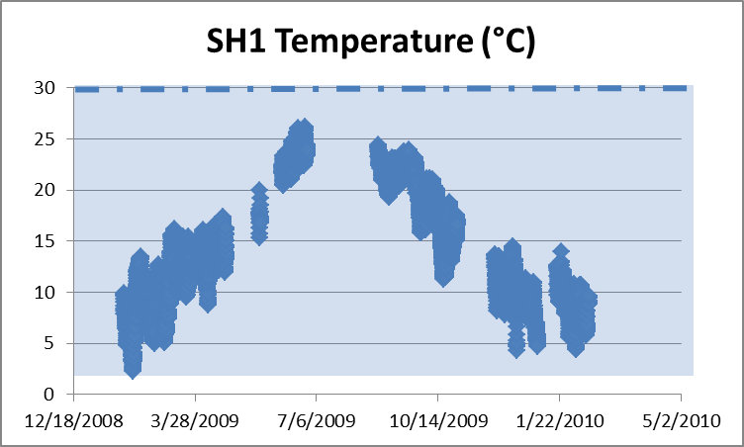

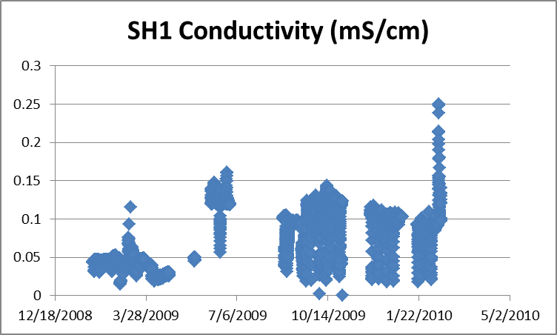

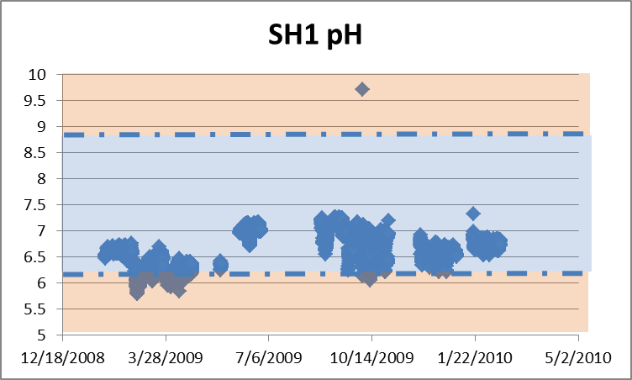

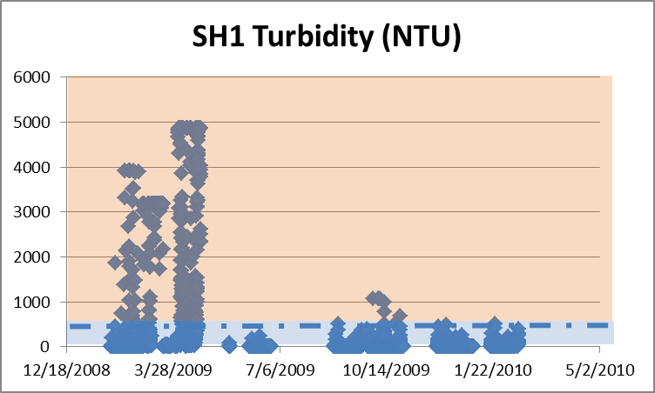

Section III – Baseline Indicators (as of 2010)

Land Cover Data for Shoal Creek
Land Cover Type | Area (acres) | %
Barren Land | 55.6 | 0.53
Cultivated Crops | 15.6 | 0.15
Deciduous Forest | 3356.2 | 32.05
Developed, High Intensity | 18.9 | 0.18
Developed, Low Intensity | 723.2 | 6.91
Developed, Medium Intensity | 128.1 | 1.22
Developed, Open Space | 1959.5 | 18.72
Evergreen Forest | 845.3 | 8.07
Hay/Pasture | 2198.4 | 21.00
Herbaceuous | 612.0 | 5.85
Mixed Forest | 122.1 | 1.17
Open Water | 87.0 | 0.83
Shrub/Scrub | 45.8 | 0.44
Woody Wetlands | 302.7 | 2.89
Total | 10470.3 | 100.00

Selected References

American Public Health Association (APHA) , the American Water Works Association (AWWA), and the Water Environment Federation (WEF). Standard Methods for the Examination of Water and Wastewater. http://www.standardmethods.org . December 3, 2009.

Environmental Protection Agency (EPA). Monitoring and Assessing Water Quality. http://www.epa.gov/owow/monitoring. October 20, 2009.

MacTammany, Matthew E. Recovery of Southern Appalachian Streams from Historical Agriculture. Virginia Polytechnic Institute and State University, Blacksburg, VA: 2004.

WA Department of Ecology. A Citizen’s Guide to Understanding and Monitoring Lakes and Streams. http://www.ecy.wa.gov/Programs/wq/plants/management/joysmanual/streamnutrients.html. 2009.
GA DNR/EPD. 2007. Macroinvertebrate Reference Data Piedmont Ecoregion (45), Southern Outer Piedmont -- 45b Data. GA Department of Natural Resources, Environmental Protection Division. Accessed May 2009. http://www.gaepd.org/Documents/WPB_Macroinvertebrate_SOP.html
City of Griffin. 2008. Water quality reference station in Meriwether County; data collected by City of Griffin (2005-2008).
CWP. 2003. Impacts of Impervious Cover on Aquatic Systems. Center for Watershed Protection. Watershed Protection Research Monograph No. 1. Ellicott City, MD.
CWP. 2005. Unified Stream Assessment: A Users Manual. Version 2. Center for Watershed Protection. Urban Subwatershed Restoration Manual Series. Ellicott City, MD.
Fox and Absher. 2002. The ABCs of Water-Quality Assessment in Georgia. Stormwater, March-April 2002. Accessed April 2009. http://www.stormh2o.com/march-april-2002/water-quality-assessment.aspx
GA DNR. 2007. Total Maximum Daily Load Evaluation for Two Stream Segments in the Oconee River Basin for Sediment (Biota Impacted). Submitted to the U.S. Environmental Protection Agency, Region 4, Atlanta, GA. Submitted by the GA Department of Natural Resources Environmental protection Divsions, Atlanta, GA. Accessed March 2009. http://www.gaepd.org/Files_PDF/techguide/wpb/TMDL/Oconee/EPD_Final_Oconee_Sediment_TMDL_2007.pdf
Gore, J.A., J.R. Olsen, D.L. Hughes, and P.M. Brossett. 2005. Reference conditions for wadeable stream in Georgia with a multimetric index for the bioassessment and discrimination of reference and impaired streams. Phase II. Final Report. Columbus State University, Columbus, GA.
Hoellein, T. J., C. P. Arango, and Y. Zak. 2011. Spatial variability in nutrient concentration and
biofilm nutrient limitation in an urban watershed. Biogeochemistry 106:265-280.
Meyer, J. L., M. J. Paul, and W. K. Taulbee. 2005. Stream ecosystem function in urbanizing landscapes. Journal of the North American Benthological Society. Vol. 24(3):602-612.
Paul, M. J., J. L. Meyer, C. A. Couch. 2006. Leaf Breakdown in Streams Differing in Catchment Land Use. Freshwater Biology. Vol. 51:1684-1695. Blackwell Publishing Ltd.
Pitt, R. E. 2000. Water Quality Conditions in the Cahaba River and Likely Pollutant Sources. University of Alabama at Birmingham Department of Civil and Environmental Engineering. Accessed March 2009. http://unix.eng.ua.edu/~rpitt/Publications/MonitoringandStormwater/Cahaba%20problems%20and%20sources.PDF
Roy, A.H., A. D. Rosemond, M. J. Paul, D. S. Leigh, and J. B. Wallace. 2003. Stream Macroinvertebrate Response to Catchment Urbanization. Freshwater Biology 48:329-346. Blackwell Publishing Ltd.
Schoonover, J. E., B. G. Lockaby, S. Pan. 2005. Changes in chemical and physical properties of stream water across and urban-rural gradient in western Georgia. Urban Ecosystems. Vol. 8:107-124. Springer Science + Business Media, Inc.
State of Georgia. 2009. 391-3-6-.03 Water Use Classifications and Water Quality Standards. State of Georgia, Office of the Secretary of State. Accessed March 2009. http://rules.sos.state.ga.us/cgi-bin/page.cgi?g=GEORGIA_DEPARTMENT_OF_NATURAL_RESOURCES/ENVIRONMENTAL_PROTECTION/WATER_QUALITY_CONTROL/index.html&d=1
State of Georgia. 2009. 391-3-6-.03 Water Use Classifications and Water Quality Standards. State of Georgia, Office of the Secretary of State. Accessed March 2009. http://rules.sos.state.ga.us/cgi-bin/page.cgi?g=GEORGIA_DEPARTMENT_OF_NATURAL_RESOURCES/ENVIRONMENTAL_PROTECTION/WATER_QUALITY_CONTROL/index.html&d=1
Tetra Tech. 2006. Baseline Biological and Water Quality Conditions for Selected Streams in Dekalb and Fulton Counties, Georgia. Prepared by Tetra Tech, Inc. Prepared for US Army Corps of Engineers, Mobile District.
USEPA. 2000. Ambient Water Quality Criteria Recommendations: Rivers and Streams in Nutrient Ecoregion IX. US Environmental Protection Agency, Office of Water. EPA 822-B-00-019. Accessed April 2009. http://www.epa.gov/waterscience/criteria/nutrient/ecoregions/rivers/rivers_9.pdf

