Watershed Management Plan

Cedar Creek

The Unified Government of Athens-Clarke County

July 22, 2011

Department of Transportation and Public Works
120 West Dougherty Street
Athens, GA 30603

Contents

Chapter 1 Introduction
1.1 Purpose of Cedar Creek Watershed Management Plan
1.2 Outline of Cedar WMP
1.3 Snapshot of Cedar Creek
Chapter 2 Methodology
Chapter 3 Current Conditions in Cedar Creek
3.1 Physical Stream Assessment
3.1.1 Stream Walk Assessment Method and Scores
3.1.2 Cedar Creek Stream Bed, Banks, and Buffers
3.1.3 Potential Stressors Affecting Cedar Creek’s Stream Assessment Scores
3.2 Biological Stream Assessment
3.2.1 How Macroinvertebrates Are Indicators of Stream Health
3.2.2 Macroinvertebrate Collection and Scoring Method
3.2.3 Macroinvertebrate Score Results for Cedar Creek
3.2.4 Potential Stressors Affecting Cedar Creek’s Macroinvertebrate Score
3.2.5 How Biofilms Indicate Stream Health
3.2.6 Biofilm Analysis Methods
3.2.7 Biofilm Analysis Results
3.2.8 Historical Impacts on Aquatic Habitat and Stream Health
3.3 Water Quality Data
3.3.1 Why Sample?
3.3.2 Two Water Quality Sampling Methods
3.3.3 Water Quality Data for Cedar Creek
3.3.4 Potential Stressors Affecting Cedar Creek’s Water Quality
3.4 Conceptual Model of Cedar Creek Conditions and Concerns
Chapter 4 Cedar Creek Watershed Management Plan
4.1 Summary of Management Needs
4.2 Cedar Creek Best Management Practices to Achieve Goals and Objectives
4.2.1 Centralized BMPs
4.2.2 Distributed BMPs
4.2.3 Stream Channel Restoration
4.2.4 Sewer Line Maintenance/Replacement
4.2.5 Streambank/Riparian Area
4.2.6 Citizen Education
4.2.7 Other BMPs
4.3 Evaluation and Location of BMP Priority Areas
4.4 Estimated Load Reductions of Best Management Practices
4.4.1 Characteristics of the Management Plan Strategy
4.4.2 Modeling and Assessment Approach
4.4.3 Modeling Results
4.5 Implementation Cost and Schedule
4.6 Evaluation Methods for Measuring Success
4.6.1 Quantitative Evaluation Techniques
4.6.2 Qualitative Evaluation Techniques
Appendix of Charts and Data

Chapter 1: Introduction

1.1 Purpose of the Cedar Creek Watershed Management Plan

The Cedar Creek Watershed Management Plan (WMP) is part of an effort undertaken by Athens-Clarke County Stormwater to address stream health throughout the county. The primary purpose of the Cedar Creek Watershed Management Plan is to guide County staff, elected officials, community organizations, and the citizenry to protect and where needed restore the beauty and function of the watershed. The plan is intended to be a practical tool with specific recommendations on practices to improve and sustain a healthy, productive environment. Cedar Creek is listed on the federal 303(d) list of impaired streams due to fecal coliform contamination and thus some of the management strategies in this plan will seek to address this concern and ultimately allow for removal of the stream from the 303(d) list.

1.2 Outline of Cedar Creek WMP

The plan consists of the following pieces:

- Chapter 1 provides an introduction including the purpose and an outline of the Cedar Creek WMP. It also provides a brief description of the watershed including its physical boundaries and landmarks found within the drainage area.
- Chapter 2 describes briefly the methodology that was used in assessing the watershed’s health.
- Chapter 3 presents the current conditions of Cedar Creek including its physical, biological, and water quality conditions. It describes the potential stressors effecting Cedar Creek.
- Chapter 4 explains the watershed management plan, a summary of the management needs, the BMPs to be used, estimated load reductions, an implementation schedule and cost assessment, and evaluation methods.
- Appendix provides the stream assessment data including physical, biological, and water quality data.
1.3 Snapshot of Cedar Creek

The Cedar Creek Drainage Basin (CEDB), as shown in Figure 1.3.1, lies outside of Loop 10 in the eastern part of the County. Its headwaters lie just north of Lexington Road and its confluence with the Middle Oconee is at the border between Clarke and Oconee Counties. Most of the land in this drainage basin consists of residential properties with some commercial property in and around the headwaters. There are three schools in the watershed, including Cedar Shoals High School, Barnett Shoals Elementary, and Athens Montessori School. All of the land in this area drains into the Middle Oconee River.

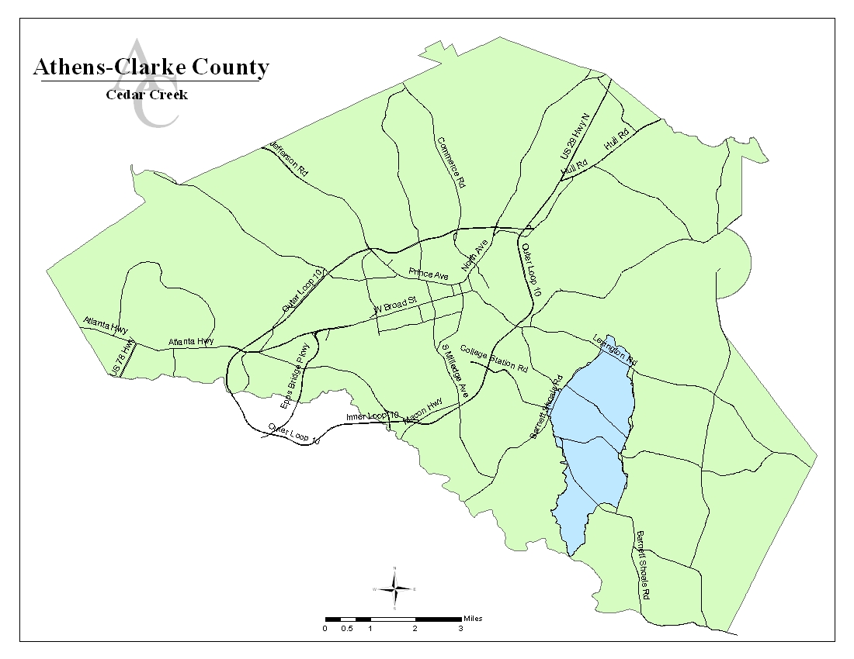
Figure 1.3.1: Location of Cedar Creek Drainage Basin in Athens-Clarke County

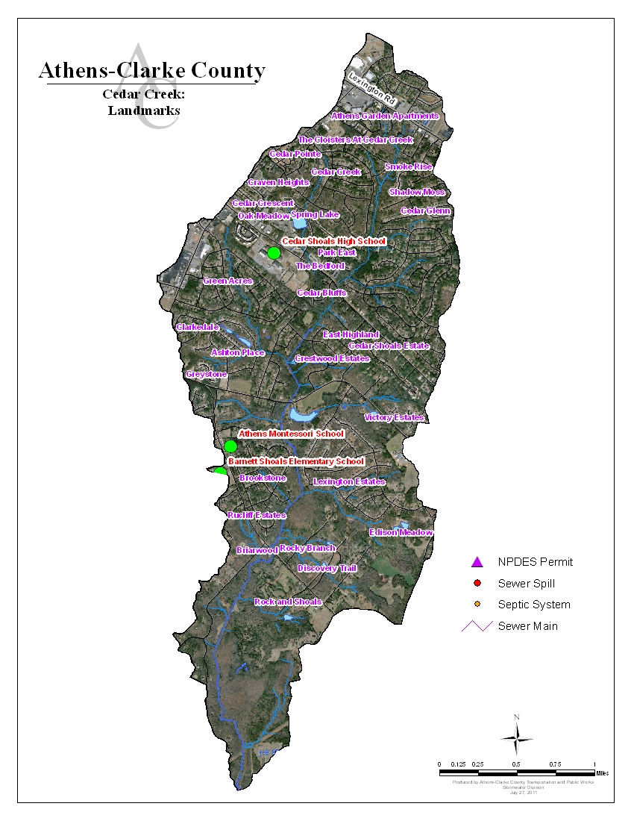
Figure 1.3.3: Landmarks in Cedar Creek Drainage Basin

Chapter 2: Methodology

We used three different methods of data collection to gain a full picture of the current health of Cedar Creek. Each data collection method will be described in detail, as will our findings and how they compare to “healthy” water quality standards. First, we conducted a stream assessment. ACC Stormwater staff walked Cedar Creek and its larger tributaries to take physical measurements of the stream bank, stream bed, and stream buffer (Figure 2.1), as well as qualitative measurements of other factors like surrounding land use and stream crossings. A second assessment method was to determine current biological status of the creek. UGA collected macroinvertebrates (tiny aquatic bugs) living in the stream. The type and quantity of macroinvertebrates found is very useful for determining how healthy the stream is through the organisms’ adaptability and survival capabilities. Some macroinvertebrates are more sensitive to pollution and stream bed silting than others, so by assessing what species are present, we can determine whether the stream’s ability to support life has been impacted. The third assessment method was to collect water quality data. We have collected both periodic and long-term water quality data, and we used data collected by GAEPD and local watershed groups that have been sampling and recording water quality data for many years.

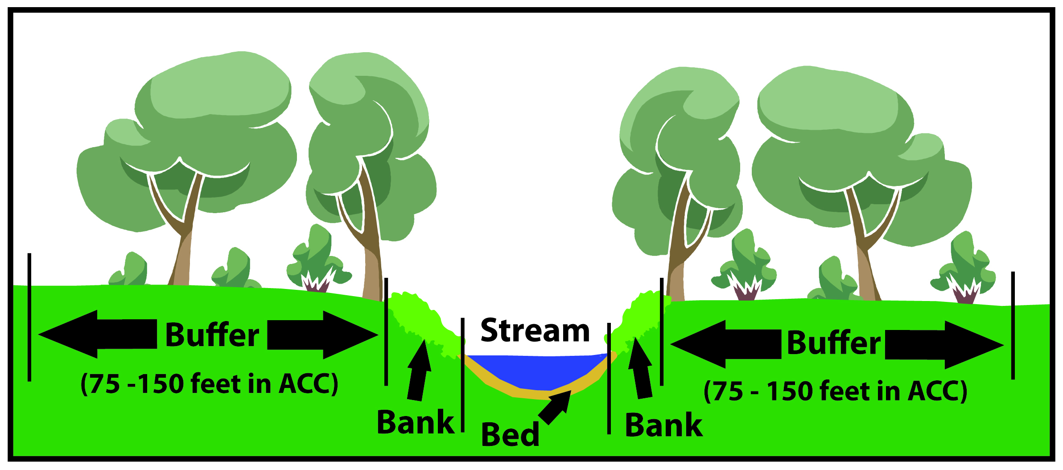
Figure 2.1: Cross Section of a Stream

The data from all of these methods is combined to give us a picture of how healthy Cedar Creek is at this moment in time, and it guides us towards discovering potential watershed “stressors,” which are sources of pollution and impairment. Let’s look at the data collected through each method and consider what could be stressing the health of Cedar Creek.

Chapter 3: Current Conditions in Cedar Creek

  - Physical Stream Assessment
3.1.1 Stream Walk Assessment Method and Scores

Stream walks were conducted in the Cedar Creek watershed in February of 2010. The stream was divided into sections, and each section is called a “reach.” ACC Stormwater Staff physically walked each reach and conducted an inventory of stream bed, stream bank, and stream buffer condition. (A stream buffer is the vegetated strip of land along either side of the stream.) Figure 3.1.1.1 shows the reaches surveyed in CEDB and the following photos highlight some of the areas in CEDB (Photos 3.1.1.1 – 3.1.1.5). Reaches are named alphabetically on the main stem of Cedar Creek and the tributaries are named numerically.

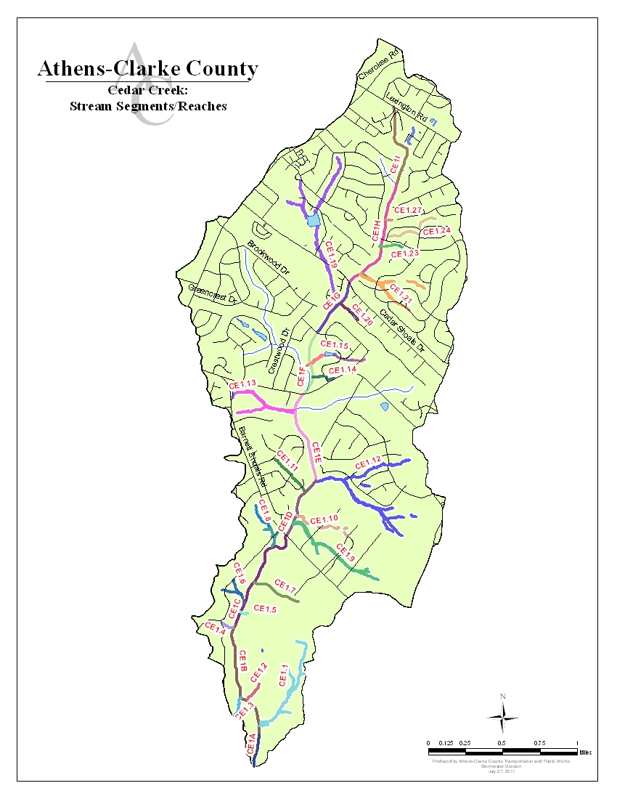 Figure 3.1.1.1: Cedar Creek Stream Reaches

Photo 3.1.1.1: Stream Assessment of Cedar Creek – Taking Bed, Bank, and Buffer Measurements
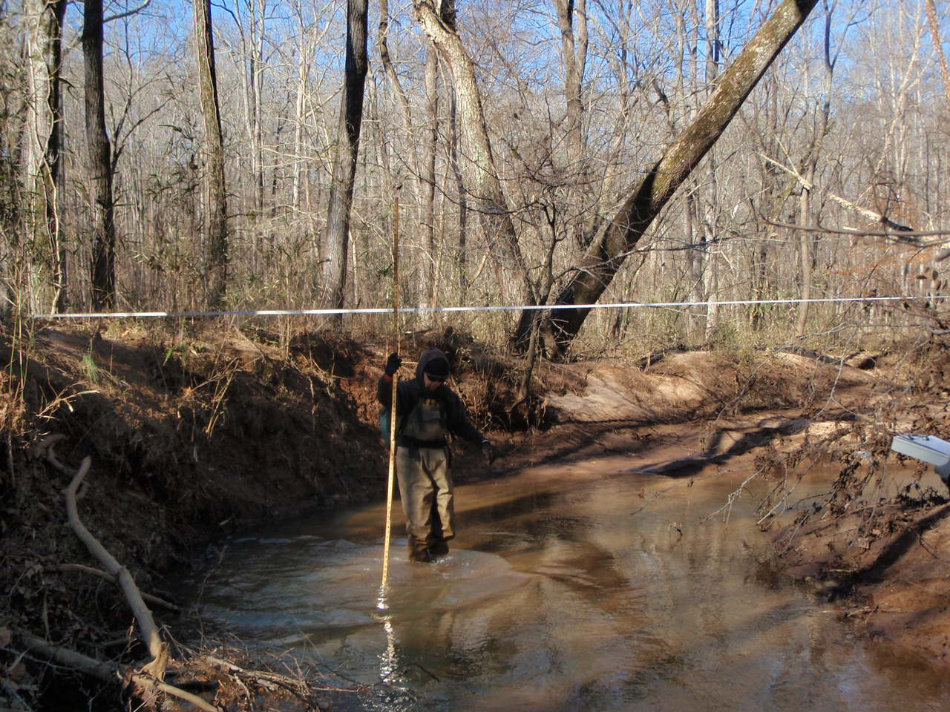
A cross section in Reach CE-1b

Photo 3.1.1.2: Stream Assessment of Cedar Creek – Road Crossing
.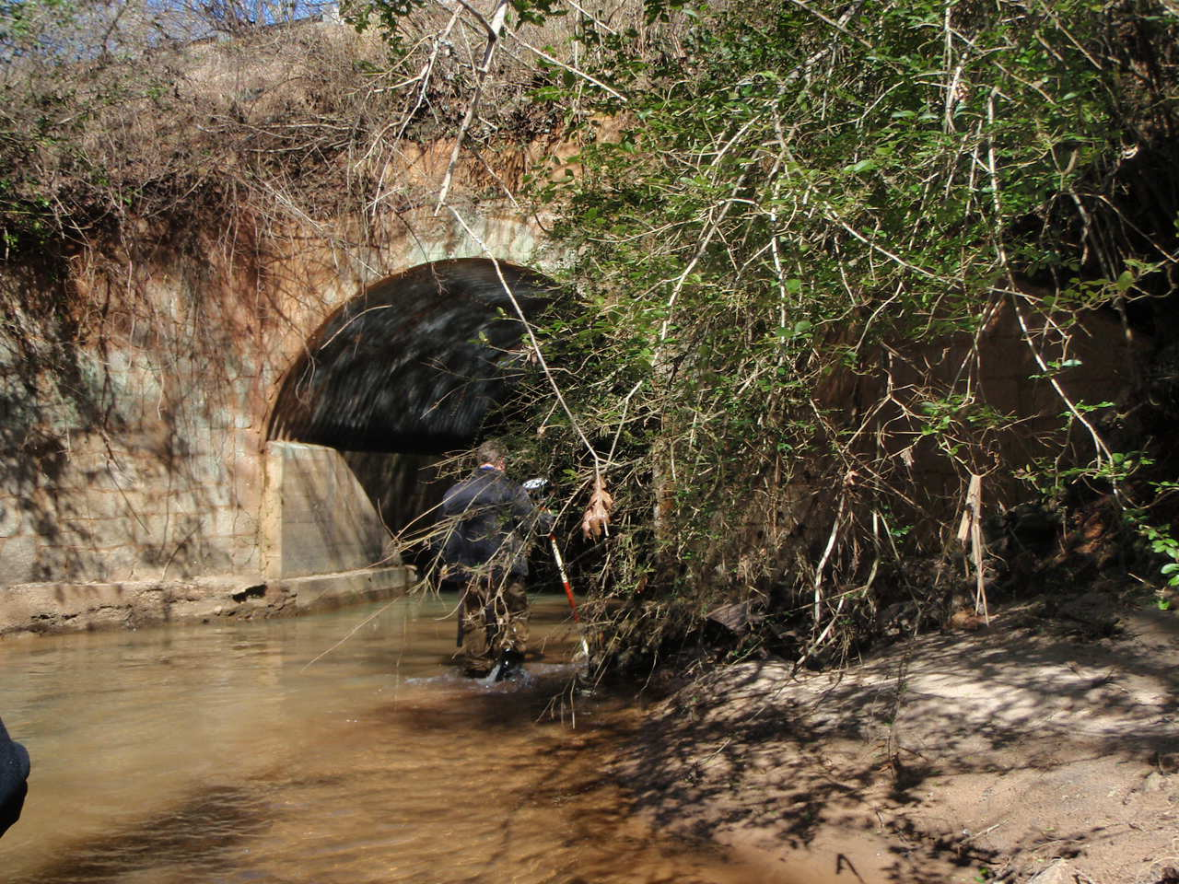
Culvert at Barnett Shoals Road

Photo 3.1.1.3: Stream Assessment of Cedar Creek – Grade Change
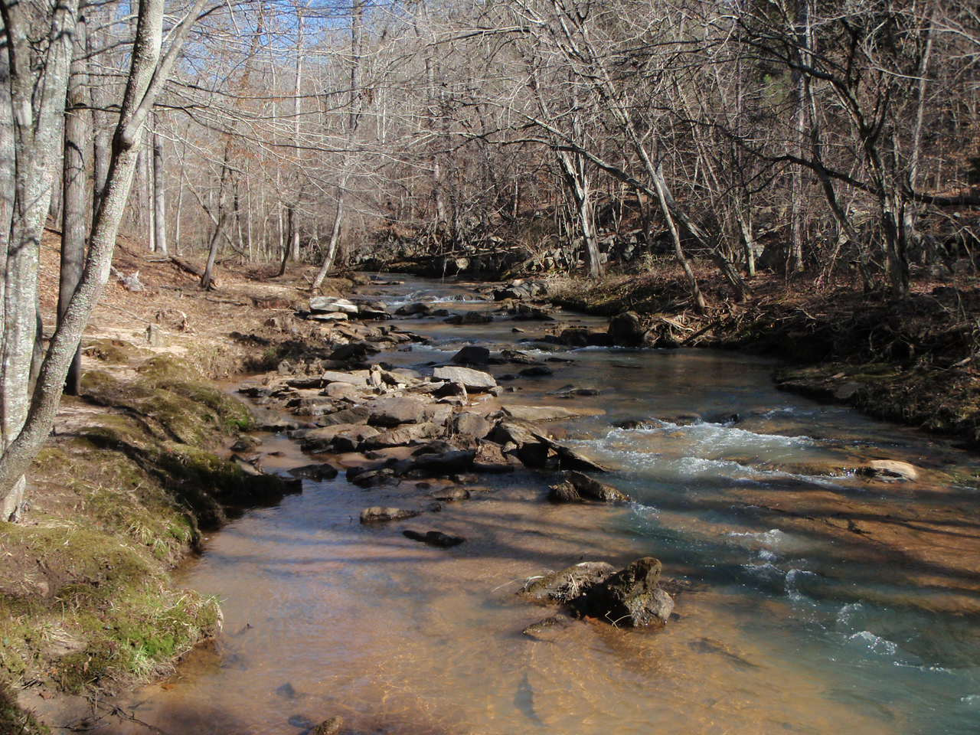
A grade change with cobble, boulders, and bedrock

Photo 3.1.1.4: Stream Assessment of Cedar Creek – Backyard Section
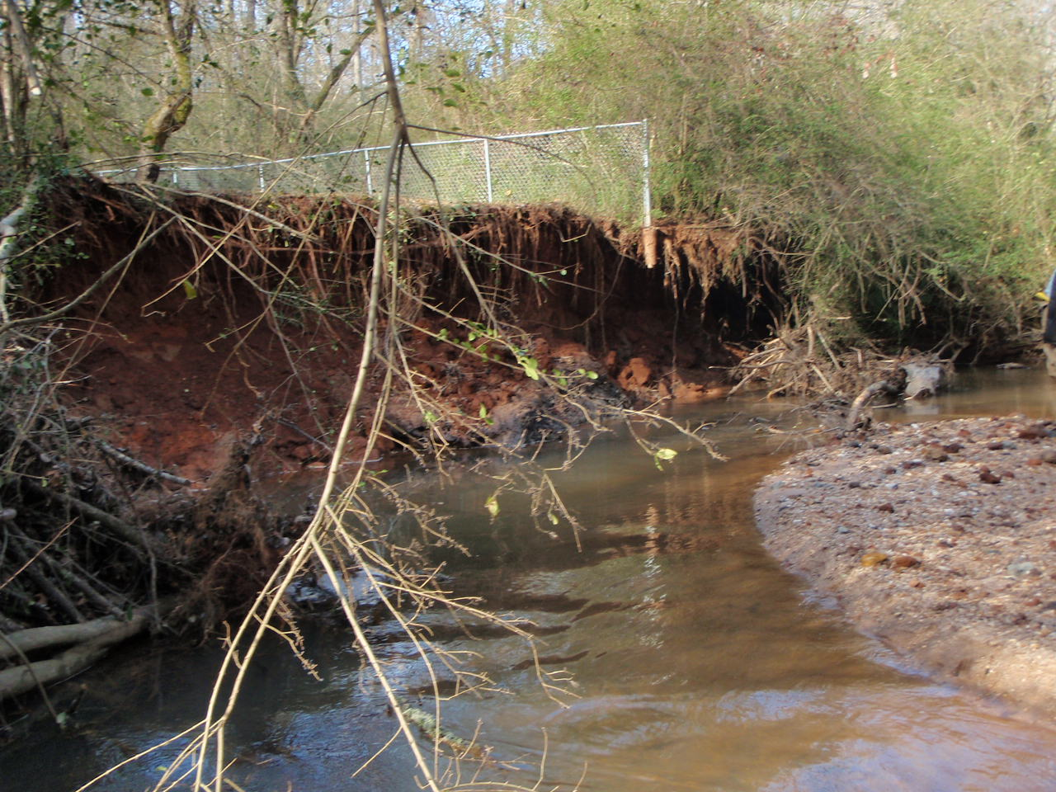
An eroded bank with an exposed fence post where the stream is in a backyard

Photo 3.1.1.5: Stream Assessment of Cedar Creek – Headwaters
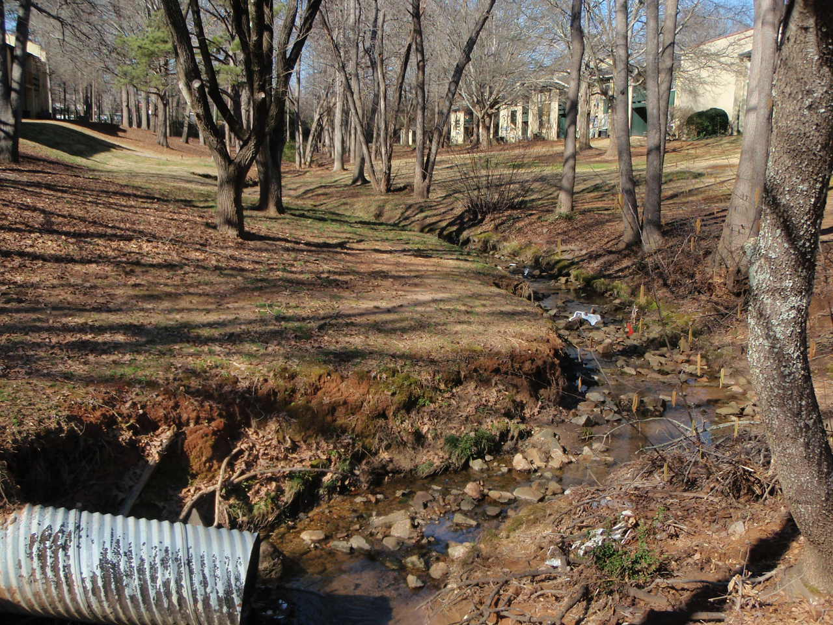
An urbanized segment near the headwaters of Cedar Creek between apartment buildings

Each reach was rated by the average of the data collected there. The in-stream habitat, vegetated buffer width, bank erosion, and floodplain connection were also evaluated in each reach and assigned a score. Each category could receive a maximum of 20 points, with vegetated buffer width and bank erosion scores allowed 10 points for each bank. A reach’s maximum score is 80. The benchmark set for a “healthy” rating is a score of 63 or above. A score of 63 or greater suggests that a stream has optimal bed, bank, and buffer conditions for a healthy functional stream ecosystem compliant with state and federal regulation. The range for the stream assessment scores is: (Poor: 0-23, Marginal: 24-40, Sub-Optimal: 41-63, Optimal: 64 – 80). Table 3.1.1.1 shows the results of the stream survey, while Figure 3.1.1.2 shows the reach scores and their locations. The Cedar Creek Watershed’s overall stream condition is rated as “Marginal,” with an average score of 33 points. Driving this marginal score is impairment of the bed, banks, and buffer of the stream. Figure 3.1.1.3 shows the reach scores and their locations.

Table 3.1.1.1: Reach Scores of Cedar Creek
Reach | In-Stream Habitat Score | Vegetated Buffer Width Scores |  | Bank Erosion Score |  | Floodplain Connection | Total Reach Score | Percent Score
 |  | Left Bank | Right Bank | Left Bank | Right Bank
1a | 6 | 5 | 2 | 2 | 2 | 12 | 29 | 36.3%
1b | 5 | 5 | 9 | 2 | 2 | 13 | 36 | 45.0%
1c | 8 | 6 | 5 | 5 | 5 | 13 | 42 | 52.5%
1d | 5 | 4 | 8 | 4 | 4 | 9 | 34 | 42.5%
1e | 6 | 3 | 5 | 2 | 2 | 5 | 23 | 28.8%
1f | 7 | 7 | 3 | 2 | 2 | 8 | 29 | 36.3%
1g | 8 | 7 | 5 | 3 | 3 | 5 | 31 | 38.8%
1h | 10 | 7 | 2 | 5 | 2 | 6 | 32 | 40.0%
1i | 11 | 7 | 4 | 3 | 3 | 9 | 37 | 46.3%
Averages | 7.3 | 5.7 | 4.8 | 3.1 | 2.8 | 8.9 | 33 | 40.7%
Percent | 36.7% | 56.7% | 47.8% | 31.1% | 27.8% | 44.4% | 40.7%
Table 3.1.1.1 shows the breakdown of the reach assessment scores and the combined scores, as well as the average score of 33

Figure 3.1.1.2 Reach Scores of Cedar Creek

The average reach score in CEDB was 33, with reach CE-1c scoring the highest (42) and reach CE-1e scoring the lowest (23).

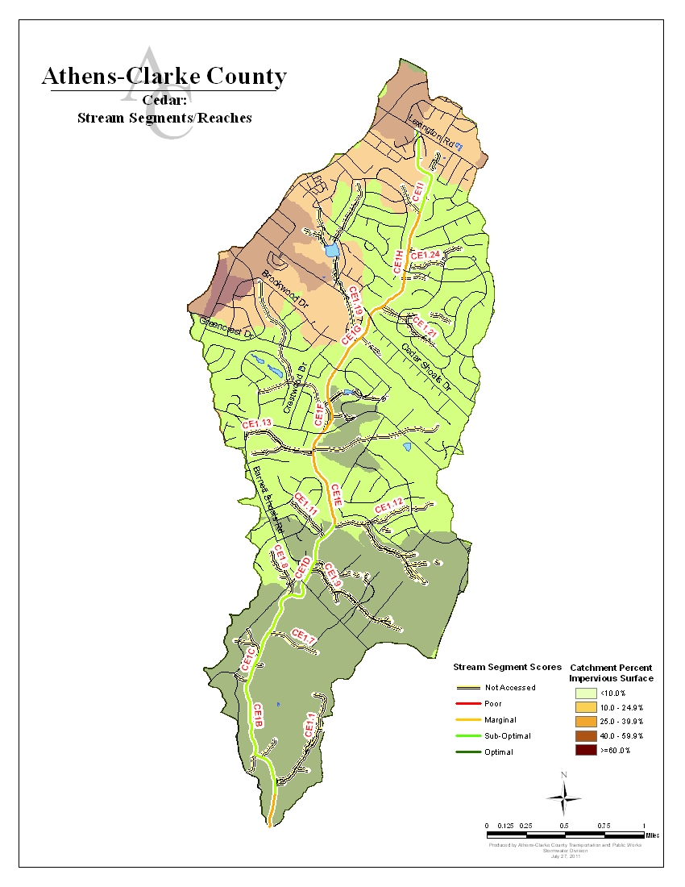
Figure 3.1.1.3: Stream Assessment Scores and Their Reach Locations
3.1.2 Cedar Creek Bed, Banks, and Buffers

The stream bed of Cedar Creek is heavily aggraded and choked with sand and sediment for all but two reaches walked during the field survey. This is largely the result of past agricultural use combined with current suburban and commercial development in the north half of Cedar Creek. The increased impervious surfaces increased peak flow, causing erosion and sedimentation for the entire stream. Stream bank erosion is a major issue for Cedar Creek, as evidence by the bank erosion scores of 3.1 and 2.8 out of ten for the left and right bank respectively.

The bank erosion is one likely source of the sand and sediment in the bed of the stream. Other possible sources of excess sediment found in streams include sediment from previous agricultural land use and sediment that has runoff from construction or development sites. Erosion is harmful to the health of a stream because it impacts the ecosystem. Macroinvertebrates and other wildlife can’t survive if their habitat has been eroded and destroyed by sediment. If the creatures at the bottom of the food chain are unable to survive in an eroded stream, they will never exist in large enough numbers to support wildlife higher up in the food chain like fish and birds.

A stream buffer is the strip of stream bank closest to a stream that should contain trees, shrubs, and other plants. In Athens, the buffer is protected by state law for 25 feet from the stream, and local ordinance protects the buffer for additional 50 feet for a total protected buffer of 75 feet. This means that it is unlawful to remove trees and other vegetation for 75 feet to either side of the stream. The plants in this protected strip of land surrounding streams shade the stream, reducing water temperatures. The plants also protect stream banks from erosion, filter pollutants like oil and sediment out of runoff entering the stream, and provide habitat for fish and other wildlife. An intact buffer stabilizes the stream banks while providing a multitude of benefits for plant and animals that live in and around the stream. Development and construction has occurred in Athens for over a century prior to the 75 foot buffer ordinance, and many stream buffers were removed to make way for agriculture, residential homes, commercials areas, and transportation corridors during this period.

Also contributing to buffer removal is the fact that many current residents are unaware of the importance of a buffer and remove it for aesthetic landscaping purposes. In the Cedar Creek drainage basin, the stream buffer along all survey reaches is largely disturbed by residential and commercial uses as well as roadway and railroad encroachments. Residential disturbances include landscaping and lawn maintenance inside the 75 foot protected buffer. Other residential disturbances include trash and debris placement in the buffer zone, which could lead to water quality concerns. As shown in Table 3.1.1.1 the CEDB averaged a 5.7 and 4.8 points out of 10 possible points for the left and right bank respectively. These scores reflect the current conditions and the result of severe buffer disturbance throughout the creek lowering the overall health score of the stream.

All the development in the CEDB has created a large amount of impervious area. Impervious areas are spaces in which water cannot penetrate to the soil such as buildings, roads and parking lots. Rainwater that falls on these surfaces cannot soak into the soil but instead collects into stormwater runoff when it rains. The larger the impervious area the higher speeds at which stormwater runoff enter streams and subsequently the greater impact a rain fall event will have.

Development in the northern half of CEDB has created a large amount of impervious area. Impervious areas are spaces in which water cannot penetrate to the soil such as buildings, roads and parking lots. Rainwater that falls on these surfaces cannot soak into the soil but instead collects into stormwater runoff when it rains. The larger the impervious area the higher speeds at which stormwater runoff enter streams and subsequently the greater impact a rain fall event will have. Percent impervious is calculated by dividing the total impervious surface of a catchment by the total catchment area. Increase in impervious area can decrease water quality and habitat. Increased impervious surface area leads to increased flow, which is a direct cause of scouring of banks and buffers, but also moves sediment through the system much faster.

3.1.3 Potential Stressors Effecting Cedar Creek’s Stream Assessment Scores

Now that we’ve collected data and compiled what we’ve seen going on in Cedar Creek, we look at the data to try and identify what could be contributing to both the good and bad conditions found in the stream. It is important to remember that we’re working with just one data set, which is just one glimpse of stream conditions at one point in time. It can be compared to a doctor trying to diagnose a chronic condition in a patient by only seeing him once; the patient may have been having a good day or a bad day, and we won’t know what’s really going on until we collect repeated data in the future. This first round of findings does still give us enough information to make some general conclusions about what is impacting Cedar Creek and what is not. The greatest piece of evidence we found is the urbanization and human influence on Cedar Creek, especially the northern half.

The northern half of Cedar Creek has been highly developed, primarily for residential purposes. Residential development creates high levels of impervious surfaces like roads, sidewalks, and buildings. Remember that all rain water that cannot soak into the ground is routed directly into the nearest stream via the stormwater system. The more water there is entering the stream and the faster it is moving, the more the stream banks and bed are scoured away. Erosion increases, and once the stream flow slows down this eroded sediment is dropped onto the stream bed where it impacts the stream’s ability to sustain wildlife. This increased runoff flow and volume is caused by an increase in the amount of impervious surface in a drainage basin. When there are more roads, parking lots, and buildings with impervious surfaces, less rain water can soak naturally into the ground. More runoff must be directed into the stormwater system to prevent flooding. When it rains, this increased water volume doesn’t gradually flow into our rivers and streams unless stormwater controls are in place to slow the runoff down. So, a heavy rain in an area with a high percentage of impervious surfaces and insufficient stormwater controls means that a lot of water is traveling very fast into a nearby stream. Nineteen percent (19%) of the Cedar watershed is covered in impervious area with most drainage areas between 40 and 60 percent impervious area (see Figure 4.4). There is a correlation between increased residential, commercial, and roadway development with erosion, incision, and aggradation in streams.
The stream buffer along Cedar Creek scored an average of 10.5% out of a scale of 100%, putting it well in the “Poor” range. The reason it scored poorly is because the buffer is narrow or non-existent in most reaches. Buffer loss is almost entirely a man-made problem. As mentioned before, the buffer was removed by development done prior to buffer protection ordinances. In residential areas stream buffers are sometimes removed by property owners during landscaping. Some bank support (such as riprap and various types of retaining walls) has been added along private property in the residential areas of the watershed. When applied properly, this type of bank stabilization can be very effective. Unfortunately, it appears as though some of these measures were taken haphazardly in the past and much of the riprap, etc has just ended up in the bed of the stream. Also, many residents dump lawn clippings and other yard debris into the stream or the stream buffer and this does not help in stabilization. Yard debris can have multiple affects on the stream, including using up oxygen which is needed by fish and other stream inhabitants. Dissolved oxygen levels collected were within the benchmark range, and do not indicate this as being a concern in CEDB. However, yard debris can carry fertilizers or pesticides from yards directly to the stream.

Also noted during the streamwalks were a number sewer lines with potential for breaks or future problems.

3.2 Biological Stream Assessment

3.2.1 How Macroinvertebrates Are Indicators of Stream Health

As mentioned earlier, macroinvertebrates are small bugs that can be seen with the human eye that live in the beds of streams. Since different species of macroinvertebrates are more sensitive to pollution and other impairments than others, the number and diversity of macroinvertebrates that are found in a stream can tell us a lot about water quality and stream health.

Photo 3.2.1.1: Macroinvertebrates

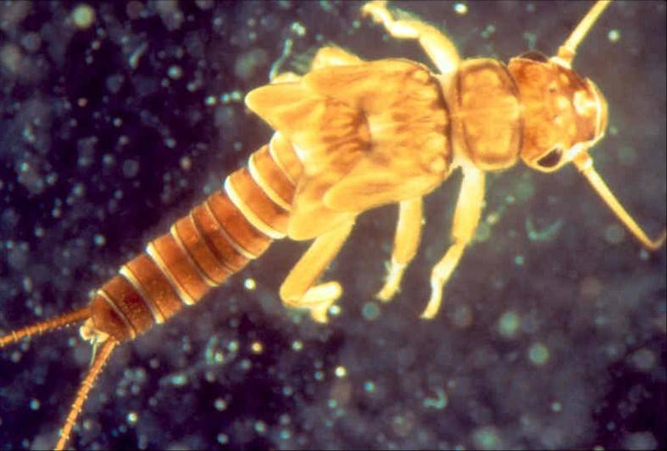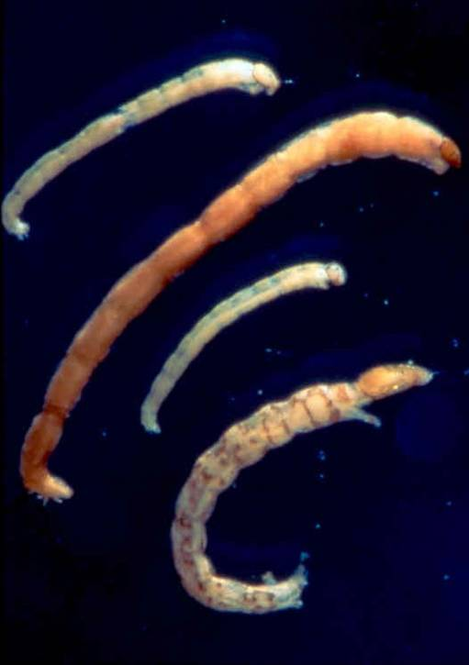

Photo 3.2.1.2: Macroinvertebrate Sampling

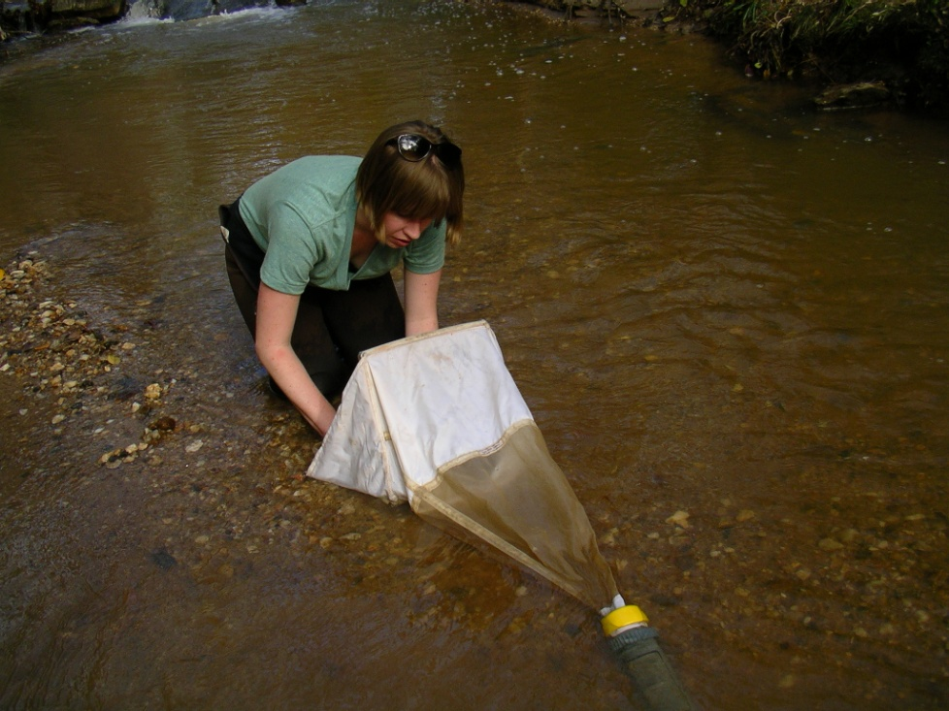

3.2.2 Macroinvertebrate Collection and Scoring Method

Macroinvertebrates were collected at two stream sites in Cedar Creek, shown in Figure 3.3.2.1, in February 2011. The results from the sampling sites were scored using two methods. The Save Our Streams (SOS) Program of the Izaak Walton League of America, which is based on the presence or absence of “sensitive,” “somewhat sensitive,” and “tolerant” types of macroinvertebrates. Numerical scores were used to indicate water quality (excellent > 22, good = 17-21, fair = 11-16, poor < 11).

The Family-level Biotic Index (FBI) was used to evaluate the health of in-stream macroinvertebrates, which can then be correlated with the overall health of the stream itself. Macroinvertebrates were collected and then identified to the Family taxonomic level. Tolerance values were assigned to each taxon using the Family-level Biotic Index (Hilsenhoff 1988). This system assigns macroinvertebrate families a value of 0-10 based on their sensitivity to organic pollution (Excellent = 0.00 – 3.75; Very Good = 3.76 – 4.25; Good = 4.26–5.00; Fair = 5.01 – 5.75; Fairly poor = 5.76 – 6.50; Poor = 6.51 – 7.25; Very poor = 7.26 –10.00). Thus, the higher an FBI score, the more degraded a stream is.
3.2.3 Biological Score Results for Cedar Creek

Table 3.2.3.1 below lists the biological scores for both the FBI and SOS methods at each sampling site. Please refer to the map in Figure 3.3.2.1 to see where each sampling site is located in the Cedar Creek drainage basin.

Table 3.2.3.1 Macroinvertebrate Scores

Sample Site | FBI Score | Ranking | SOS Score | Ranking
CE1 | 5.57 | Fair | 17 | Good
CE2 | 5.57 | Fair | 16 | Fair

FBI scores were reported as “fair” for both CE1 and CE2. SOS scores were “good” for CE1 and “fair” for CE2, though they only differed by one point. Scores from both of these methods indicate a generally acceptable macroinvertebrate environment throughout Cedar Creek. This does not coincide with statements made previously about Cedar Creek. The poor overall reach scores throughout the creek would lead one to expect worse macroinvertebrate scores. Also, the residential development in the upper section is in stark contrast to the less developed lower section, yet CE1 and CE2 have very similar FBI and SOS scores.

3.2.4 Potential Stressors Effecting Cedar Creek’s Macroinvertebrate Scores

Impaired aquatic life in a stream is most often directly a result of degraded aquatic habitat. According to the data collected during the stream walks, the stream bed of Cedar Creek was found to have some problems including sedimentation and aggradation. Many macroinvertebrate taxa live in riffle areas created by water moving over the stream bed material while others live in sandy pools. A wide range in bed sediment sizes provides a variety of habitat for different aquatic organisms that have different life history characteristics. Increased sedimentation caused by erosion and stormflow affects the stream bed, covering up pebbles and other rocks that normally provide habitat for macroinvertebrates.

Reduced vegetated buffers decrease shading, resulting in increased stream temperatures. This may inhibit some macroinvertebrate taxa that are sensitive to high water temperatures. Benchmarks for temperature were set at 30°C (Table 3.3.3.1), and no temperatures exceeded this during the sampling period in Cedar Creek. Thermal pollution is not a likely source of decreased macroinvertebrate scores. A reduction in vegetated buffers may, more importantly, decrease the amount of leaves and wood being delivered to the stream, important food and habitat sources for macroinvertebrates.

Other data points to high flows washing away leaf matter and other in-stream habitat for macroinvertebrates, making the stream much less hospitable. There is a high amount of impervious surface in the Cedar Creek watershed, and this increases the amount of stormwater being delivered to the stream. In addition to scouring the stream, this increased stormflow may deliver harmful pollutants to the stream, decreasing water quality. Most macroinvertebrates are sensitive to water quality and several studies have shown a positive relationship between macroinvertebrate abundance and diversity and water quality (Komnoski et al. 2007, Roy et al. 2003). Sampling sites were selected for optimal conditions, so the poor scores are likely due to flow or pollution when sediment is not present at the site.

Photo 3.2.4.1 Example Stream Habitat in CEDB

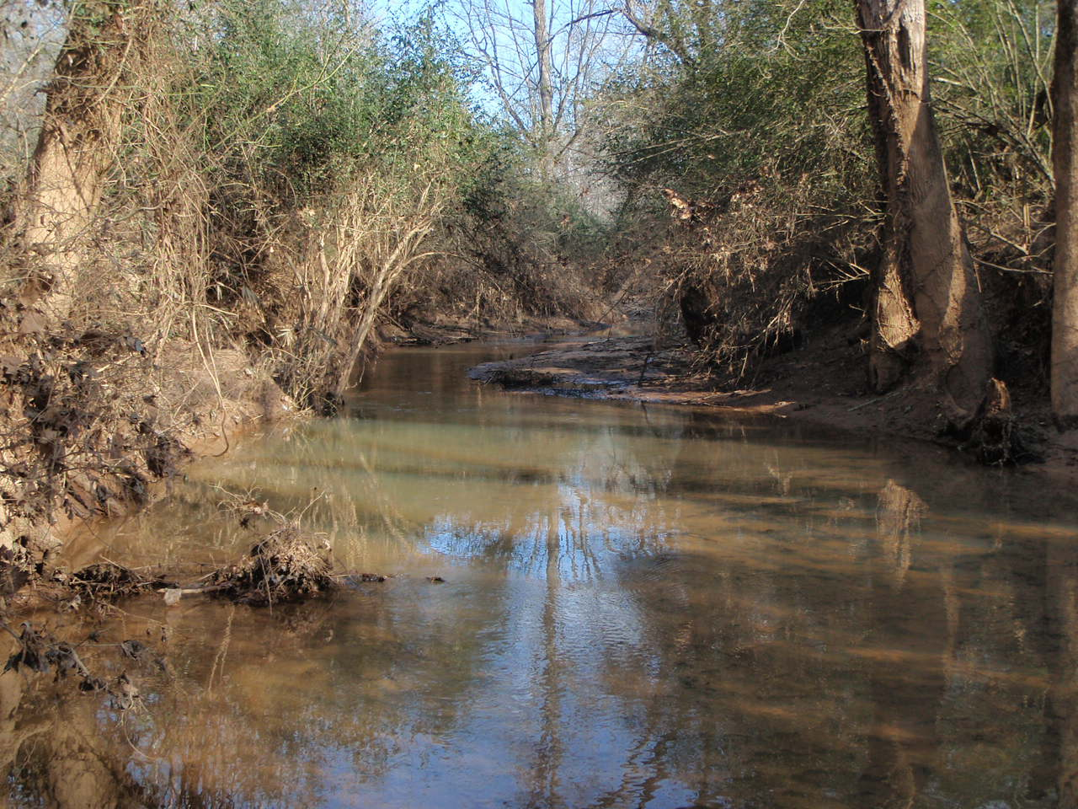

3.2.5 How Biofilms Can Indicate Stream Health

Biofilms are the algae, microorganisms and organic matter on the bottoms of streams. Analysis of biofilms can reveal a lot about stream condition. Increased biofilm mass could indicate high nutrient levels or increased light from a lack of riparian zone. Decreased biofilm mass could be the result of altered stream hydrology caused by high peak flows, erosion, and sedimentation in areas with impervious surfaces. Biofilm nutrient content may increase due to nutrients available in stream water and sources of nitrogen (N) can be traced by detecting isotopic signatures of N in biofilms. Biofilms are a food source for macroinvertebrates and fish as well as an important site for the uptake and storage of nutrients (Hoellein et al 2011).

3.2.6 Biofilm Analysis Methods

Biofilm samples from Cedar Creek were collected and evaluated by the University Of Georgia School Of Ecology. Two sites (CED1 and CED2) were sampled in March 2012. Analysis looked at chlorophyll a and biofilm ash-free dry mass (AFDM) of both hard and soft substrates. Chlorophyll a is a measure of the algal component of biofilm mass while AFDM is the total mass of organic matter that makes up the biofilm. These values were measured for both hard (rocks) and soft (sand and organic material) substrates. Hard substrates are tightly attached and tend to have higher chlorophyll a levels, while soft substrates are more loosely bound and have higher AFDM (Sterling 2012). Low AFDM in soft substrates could indicate disturbed hydrology causing peak flows that scour away the soft substrates. Undesirable conditions in streams are likely best characterized by high algal biomass (high chlorophyll a) and loss of retention of organic material (low AFDM).

3.2.7 Biofilm Analysis Results

Table 3.2.7.1 Biofilm Scores

Sample Site | Chlorophyll a (mg/m²) |  | AFDM (g/m²)
 | Hard | Soft | Hard | Soft
CED1 | 80.0 ±17.6 | 45.1 ±18.5 | 3.874 ±2.02 | 7.02 ±4.64
CED2 | 24.0 ±3.6 | 18.4 ±3.6 | 0.54 ±0.241 | 1.32 ±0.47

Biofilm levels at CED2 were significantly lower than CED1. This fits with Cedar Creek’s stream walk data that found decreased reach scores in the northern section of Cedar Creek, where the CED2 sampling site is located. This section is also much more developed, with increased impervious surface and decreased buffers, both of which decrease biofilm levels. The expectation of higher levels of chlorophyll a in hard substrates and AFDM in soft substrates held for both sampling locations. AFDM readings reported in 2011 are significantly lower than those found in other ACC streams reported in 2013. This could be the result of different sampling or analysis methods. Understanding how nutrient concentrations stimulate algal growth in Cedar Creek is important in managing the nutrient inputs, however further studies are needed to fully investigate the implications of these results.

3.2.8 Historical Impacts on Aquatic Habitat and Stream Health

Since excess sediment in the stream is the main cause of the stream bed aggradation, it’s important to determine where that extra sediment might be coming from. When considering the impacts of sediment, we need to look not only at what is happening in Cedar Creek right now, but also at what went on in the Cedar Creek basin regarding land use in the past. Review of historical aerial photography (Figures 3.2.4.1 through 3.2.4.5) shows that the Cedar Creek basin area has been urbanized as far back as the 1930s, and was likely used for agriculture even before that. The effects of past agricultural use on the land often continue to impact local streams even 50 to 100 years after agricultural practices have been abandoned, manifesting as physical and chemical problems in streams (MacTammany, 2004). Refer to the following historical maps to see how land use has changed over time in Cedar Creek.

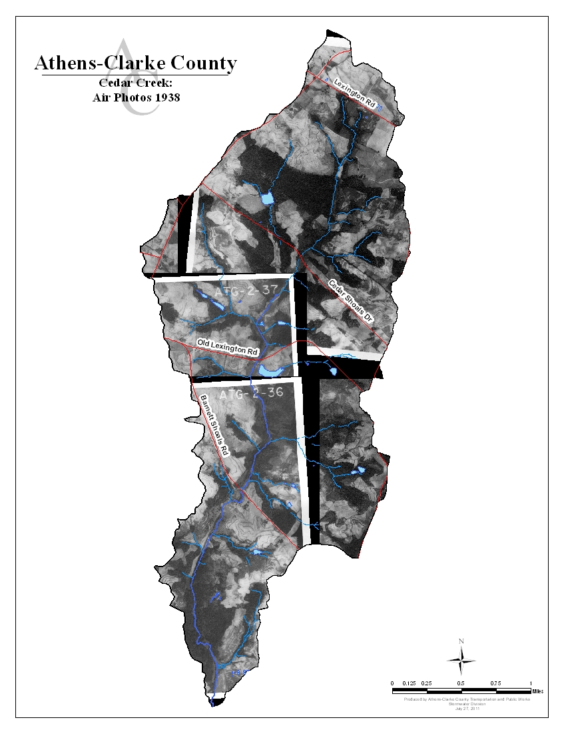
Figure 3.2.4.1 Cedar Creek: 1938

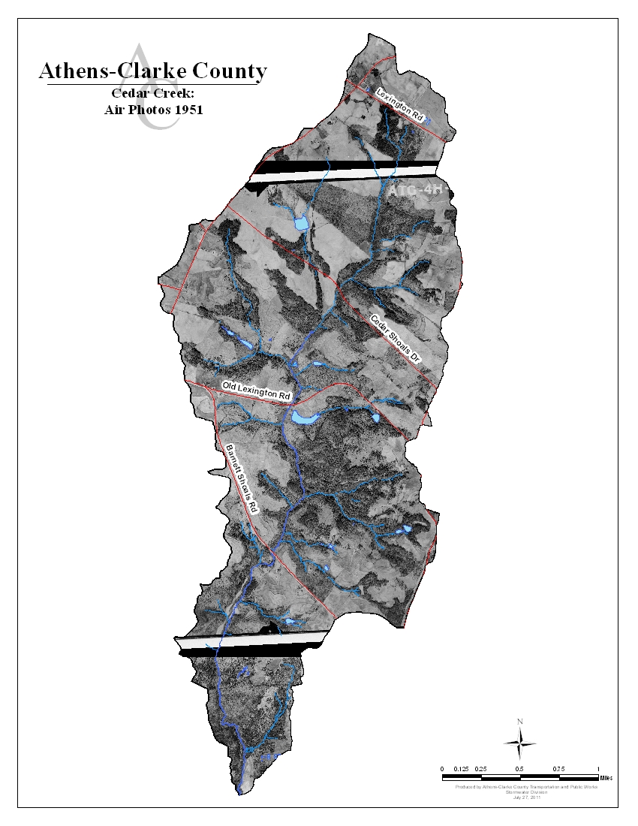
Figure 3.2.4.2 Cedar Creek: 1951

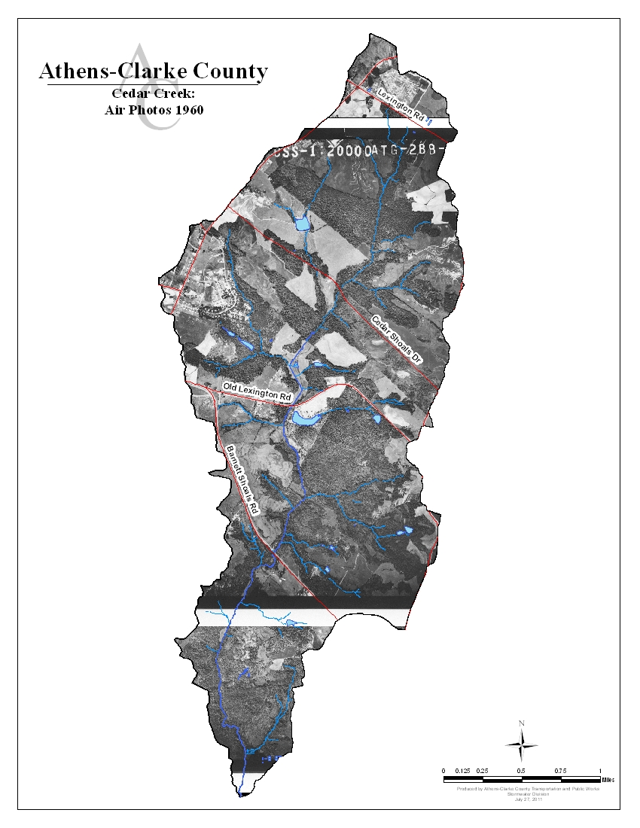
Figure 3.2.4.3 Cedar Creek: 1960

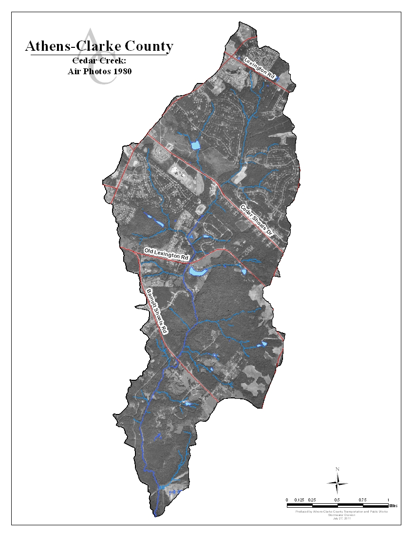 Figure 3.2.4.4 Cedar Creek: 1980
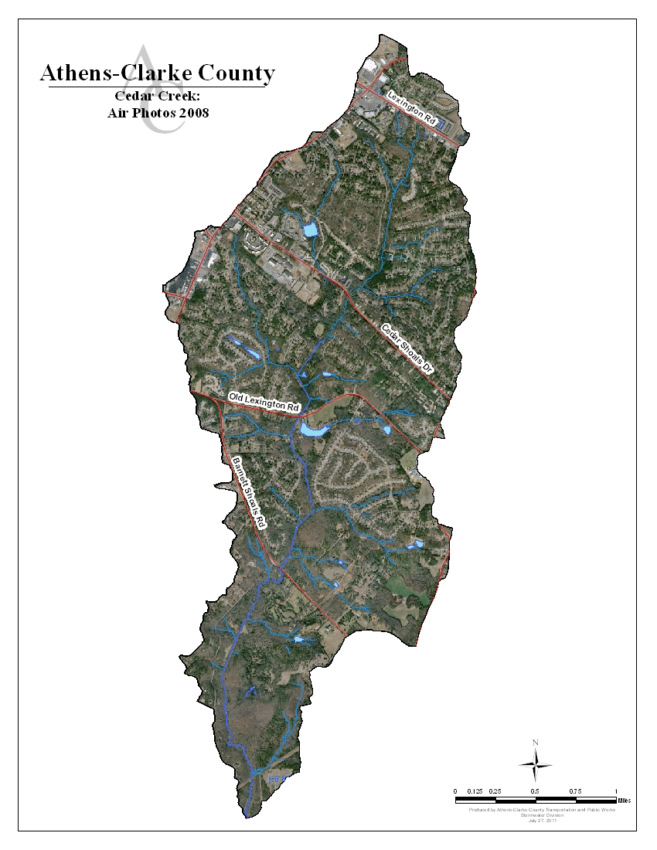
Figure 3.2.4.5 Cedar Creek: 2008

Agriculture affects streams in several ways. First, clear cutting trees to make way for cropland destroyed much of the stream buffers in the Cedar Creek area. Removal of stream buffers and land clearing can increase runoff and sediment entering the stream systems. The wood debris and leaves produced by trees falls into streams and provides food for macroinvertebrates. As trees disappear so does the primary food source of macroinvertebrates. Agricultural periods can also increase the amount of nutrients present in the stream system. These nutrients can come from fertilizers put on crops that get washed into a stream during a rainstorm, or the nutrients can come from manure, so if livestock are raised on the farmland nutrient s and bacteria may wash into the stream. Finally, sediment may leave farmland via runoff as well. Sediment that enters a waterway from agriculture may take a long time to move out of the stream since the sediment is suspended in the water when it is stirred up, but settles and deposits at different points in the stream network. This process of transportation and deposition must be repeated many times before the sediment finally makes its way to a larger river.

The history of stormwater controls also has an impact on the amount of suitable macroinvertebrate habitat found in streams. Prior to the early 1980s, there were no stormwater design requirements for new development projects. This means that stormwater controls like detention ponds, filtration systems, catch basins, and underground piped systems that collect, filter, and slow down runoff were never installed. Even now, there are very few of these types of best management practices (BMPs) in place in CEDB. Runoff leaving sites without stormwater controls often enters streams at a higher velocity and volume that it does when it leaves a site that does employ stormwater controls. The increased velocity can cause stream bank scouring and erosion when the runoff enters a stream, and it also flushes the stream system of suitable habitat as well as macroinvertebrates.

In Cedar Creek our data tells us that water temperatures are in the normal range, but that buffer damage and sedimentation has reduced macroinvertebrate habitat along all but one (CE-1i) of the nine reaches, and was particularly poor in two downstream reaches (CE-1b and CE-1d). Sampling results also indicate that sediment is sometimes suspended in the water of Cedar Creek at levels that make it difficult for macroinvertebrates to survive. (See Section II.1: Water Quality Data in the Appendix.)

3.3 Water Quality Data

3.3.1 Why Sample?

Water quality data are used to characterize waters, identify trends over time, identify emerging problems, determine whether pollution control programs are working, help direct pollution control efforts to where they are most needed, and respond to emergencies such as floods and spills (EPA, Monitoring and Assessing Water Quality). We collected water samples from each of the pilot basins along with a reference watershed, Big Creek. Water quality sample results are compared to a set of water quality benchmarks created by combining both regulatory standards (Georgia Water Quality Standards) and previous research. These benchmarks represent measures of healthy streams. Collecting and testing water quality samples over time gives us a better picture of what pollutants might be traversing our local waterways like Cedar Creek.

3.3.2 Water Quality Sampling Methods

Two sampling methods were used to collect water quality data on Cedar Creek. First, monthly sampling was conducted at three sampling sites in the watershed. These grab samples cover a wide range of parameters that indicate water quality. We can compare variation in monthly water quality data with stream walks, biological data, and other watershed activities that have happened during the same timeframe to identify potential sources of pollution. Another method we use is in-situ water sampling using data collection units called Datasondes. These data collection units are left in-stream to give us continuous trend-identifying water quality data as indicated by measures of pH, dissolve oxygen, conductivity, turbidity, and temperature. The continuous data is used to identify changes to basic stream chemistry over time and seasonally. The data can also identify significant changes to stream chemistry over time.

Monthly Sampling

Monthly water quality sampling was collected by the grab method, meaning samples were collected from all sample sites at the same time. This method is in compliance with our EPA-approved Quality Assurance Protection Plan (QAPP) that ensures accuracy of results by standardizing our sampling procedures. The criteria sampled were water temperature, pH, dissolved oxygen, conductivity, fecal coliform bacteria, total suspended solids, biochemical oxygen demand, turbidity, total organic carbon, nutrients, and metals. Each criterion is an indicator for a potential type of water pollution. Analysis is conducted by several different labs including the Athens-Clarke County Public Utilities Water Treatment Lab and three University of Georgia Labs: The Center for Applied Isotope Studies; The Soil, Plant, and Water Lab; and the Analytical Chemistry Laboratory. The labs follow methods taken from the Standard Methods for the Examination of Water and Wastewater as developed by the American Public Health Association, the American Water Works Association, and the Water Environment Federation (APHA). Figure 3.3.2.1 includes the water quality sampling sites in Cedar Creek. Sample data is provided in Appendix Section II.1.

In-Situ Water Sampling Using Datasondes

The Datasonde has multiple probes that sense the following water quality indicators: dissolved oxygen, pH, temperature, conductivity and turbidity. It is able to store these measurements until a staff member retrieves the unit from the stream and downloads the data. Datasondes make it possible for us to collect real-time continuous data without having to be present. The Datasondes are calibrated and checked after each data collection before being returned to the stream. Sample data is provided in Appendix Section II.3.

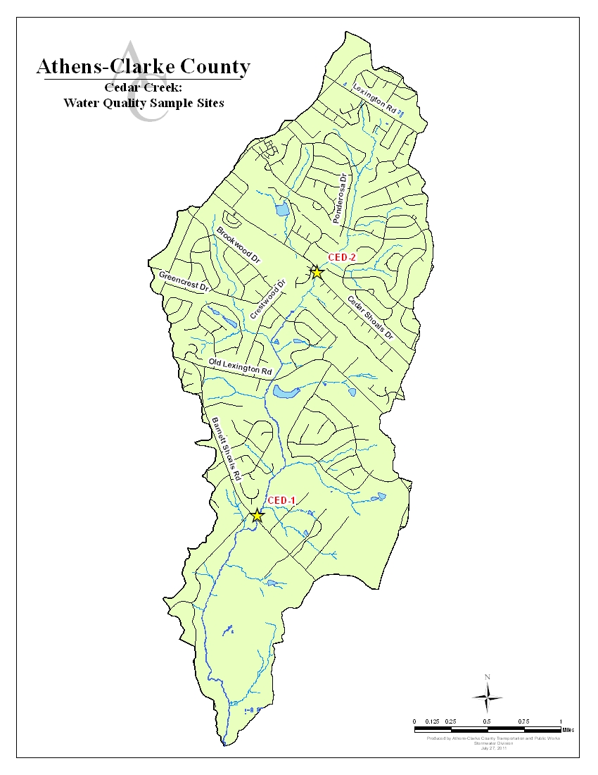

Figure 3.3.2.1: Cedar Creek Water Quality Sampling Sites

3.3.3 Water Quality Data for Cedar Creek

Georgia’s water quality standards are set by the State of Georgia Environmental Protection Division (GAEPD). According to the State, the “healthy” range for a number of criteria depends on the designated use of the stream as made by GAEPD. A stream designated for fishing has a higher water quality criterion than one that is just used for outdoor recreation since the fish might be consumed by people. For this project, water quality health is determined using a set of benchmarks defined both by the state water quality standards and previous research. Previous research included a literature review focused on instream, baseflow measurements within the Georgia piedmont. Table 3.3.3.1 shows the benchmarks and monthly averages for all water quality data used in this project, with the bolded benchmarks having regulatory implications. Cedar Creek is designated as a recreational use stream, specifically fishing. Based on available water quality data, the primary constituents of concern related to the benchmarks in Table 3.3.3.1 for Cedar Creek are Fecal Coliform and Nutrients. To view all sampling results, refer to the charts in Section II.1 in the Appendix where samples scoring outside of the designated “healthy” range are highlighted yellow.

Table 3.3.3.1: Water Quality Benchmarks and Monthly Average Values
Bold = Regulatory standard as defined by Georgia State Water Quality Standards (2009). Non-bold items are parameters that were also measured. Values in exceedance are not a violation of water quality standards, but indicate poor stream health.
*Benchmarks are for streams under normal flow conditions.

3.3.4 Potential Stressors Affecting Cedar Creek’s Water Quality Scores

If a water quality indicator is not within the acceptable range as designated by GAEPD, this means there has been a standards violation. When it exceeds a benchmark, not a standard, this means the parameter is indicating poor stream health. When we find a violation we look at what might be causing a water quality criterion to be out of range.

Fecal coliform is the most concerning issue in Cedar Creek. Average values for both sampling sites were above the benchmark value of 500 CFU/100 mL. Over the course of a 12 month sampling period, fecal coliform results exceeding the benchmark occurred 5 out of the 12 months for CE1 and 10 out of 12 months for site CE2. Figure 3.3.4.1 contains box plots of fecal coliform levels at each sampling site. It shows that while fecal coliform is a concern throughout Cedar Creek, the greatest concern lies around site CE2, where the average is more than twice the benchmark value. Site CE2 is located in the northern section of Cedar Creek, which agrees with other data indicating lower overall stream health in the northern section than the southern.

Figure 3.3.4.1: Box Plot of Fecal Coliform Sampling

Fecal coliform can come from leaking septic systems or sewer lines, businesses that have permits to put water back into a stream after an industrial process, and from animal waste. CEDB is a largely residential area, which is probably the cause for its high fecal coliform levels. Figure 3.3.4.2 shows the location of all the septic tanks in the CEDB as well as sewer lines and sewer spill events. Residential areas have increased numbers of septic tanks and sewer lines, which are significant sources of fecal coliform bacteria. Residential development also increases the amount of impervious surfaces by putting in streets, buildings, and sidewalks. Pet waste left along roads and sidewalks will be swept into the creek via stormwater runoff, which also contributes to fecal coliform levels.

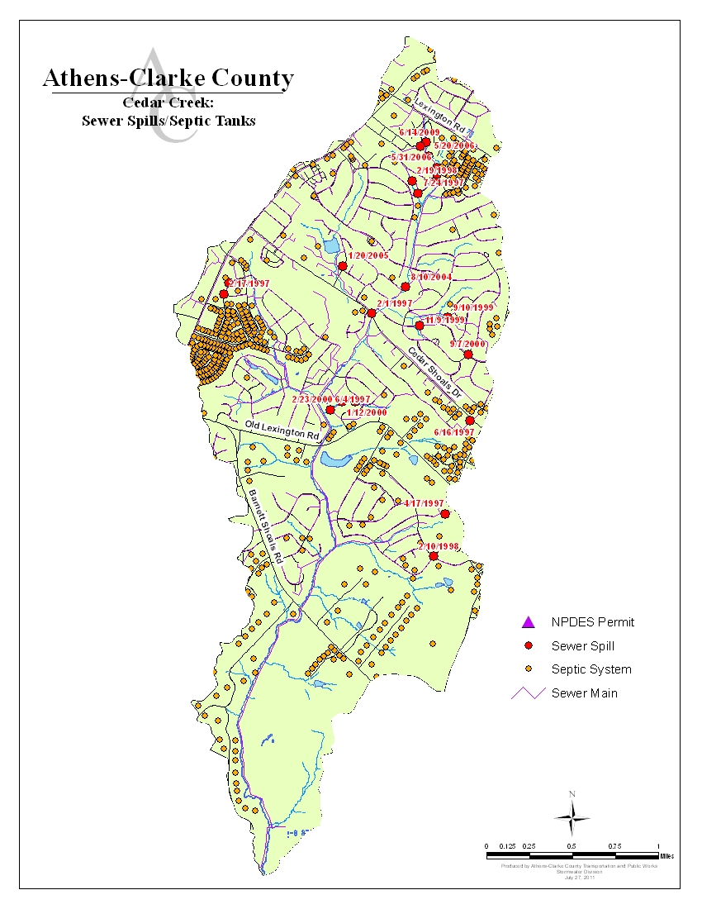
Figure 3.3.4.2 Sewer Spills and Septic Tanks in Cedar Creek Drainage Basin

Large concentrations of animal feces near streams can be a source of elevated nutrient levels. Nutrient contributions from these observed species are typically less significant than contribution by waterfowl due to their more terrestrial nature. However, feces deposited on the land surface can result in the introduction of nutrients and fecal coliform to streams during runoff events. Given the level of development within the watershed, the buffers along the stream appear to provide the most desirable habitat for wildlife, potentially concentrating wildlife sources of fecal coliform in the stream corridor. We do not have any data on how many domestic pets are in the Cedar Creek basin. The area surrounding the upstream portions of Cedar Creek are residential and may house pets, but we do not have enough data to know whether pet waste is a significant contributor to the fecal coliform levels found in the stream.

Nutrient levels are one of the most difficult water quality parameters to calibrate in flowing streams due to differences in local geology, historical land use, stream discharge, and stream size. Increased nutrient concentrations can come from a variety of sources such as: permitted discharges, fertilizers for landscaping and agriculture, and even natural sources such as decomposition of leaf and limb matter. Anthropogenic nutrients in streams can cause algal blooms, which may reduce dissolved oxygen levels and reduce water clarity. Nutrient inputs may also increase the breakdown of leaves and wood in the stream, reducing the amount of food available for macroinvertebrates and fishes. Municipal and industrial entities have permission through NPDES permits to discharge stormwater and treated wastewater into streams. Overland flow of runoff from developed watersheds contains nutrients from lawn and garden fertilizers as well as additional organic debris (leaves and lawn clippings) that are easily washed from urban surfaces. Agricultural areas can also contribute to nutrient increases through poor manure and fertilizing practices and erosion from plowed land. Our observations during stream walks indicate that fertilizers are used in landscaping by residents for their lawns. Runoff from permitted discharges and developed land uses can convey increased nutrients found in the stream.
In this study, we sampled three forms of nitrogen: nitrate (NO₃), ammonium (NH₄) and total nitrogen. Nitrate and ammonium measure forms of nitrogen that are dissolved in the water column and made available for uptake by biota, while total nitrogen includes both the dissolved ammonium and nitrate as well as organic and particulate forms of nitrogen. Two forms of phosphorus are also sampled in this study: phosphate (PO₄) and total phosphorus. Phosphate is dissolved and inorganic, meaning that it that is easily utilized by plants and microbes. Total phosphorus includes both inorganic PO₄ and organic and particulate forms of phosphorus. In this study, benchmarks for total nitrogen, nitrate, ammonium, total phosphorus and phosphate were set based on scientific literature values (Herhily et al. 2008, Dodds et al. 2002) and baseline data from this study, creating both an upper and lower boundary for nutrients (See table 6.1).
Average nitrate levels for CE2 were above the benchmark and only slightly under for CE1. Ammonium levels were consistently low. Total nitrogen averages were within the acceptable benchmark range, indicating no significant input of nitrogen into Cedar Creek. Both phosphate and total phosphorus levels are very low in Cedar Creek. Still, it is important to track inputs of phosphorus; if phosphorus were to be added to these streams and nitrogen remained at moderate levels, it would likely cause significant changes in both algal biomass and organic matter breakdown. Figure 6.5 shows the summary of nutrient samples for Total Nitrogen and Figure 6.6 shows the summary of nutrient samples for Total Phosphorous.

Figure 3.3.4.4 Box Plot of Total Nitrogen

Figure 3.3.4.5: Box Plot of Total Phosphorous
Increased nutrient concentrations can come from a variety of sources such as: permitted discharges, fertilizers for landscaping and agriculture, and even natural sources such as decomposition of leaf and limb matter. Municipal and industrial entities have permission through NPDES permits to discharge stormwater and treated wastewater into streams. Overland flow of runoff from developed watersheds contains nutrients from lawn and garden fertilizers as well as additional organic debris (leaves and lawn clippings) that is easily washed from urban surfaces. Agricultural areas can also contribute to nutrient increases through poor manure and fertilizing practices and erosion from plowed land. Our observations during stream walks indicate that residents fertilize their lawns and there was evidence of landscaping within the stream buffer. Runoff from permitted discharges and developed land uses can convey increased nutrients found in the stream. As the upstream portions of Cedar Creek are more of an urban watershed, runoff undoubtedly also contributes to nutrients found in the stream. The impacts of elevated nutrient loading can result in increased algae growth. Excessive growths of algae can cause low dissolved oxygen levels, unsightly conditions, odors, and poor habitat conditions for aquatic organisms (WA Department of Ecology, Chapter 3). While increased nutrient levels are not a regulatory violation, they can have regulatory consequences by impacting other water quality parameters.

3.4 Conceptual Model of Cedar Creek Conditions and Concerns

In order to understand the health of Cedar Creek watershed, we utilized three main methods of data collection that provide us with information on stream health: conducting a physical stream assessment, collecting biological scores, and collecting water quality data. A conceptual model (Figure 3.4.1) was created to trace these indicators back to their likely sources and identify areas of particular concern in Cedar Creek. Additional work is needed to identify and locate sources.

Indicators
The three indicators for this study are Water Quality Data, Biological Scores, and Stream Assessment Scores. Water Quality Data come from monthly grab sampling and datasonde long-term monitoring instruments. This data is then compared to water quality benchmarks created using the Georgia Water Quality Standards and comparable studies of water quality. Biological Scores were obtained by collecting and analyzing macroinvertebrate and algae data. Stream health cannot be solely defined by water quality alone. That is why it is important to conduct physical stream assessments as well. Stream walks were used to gain an understanding of Cedar Creek’s physical health from the headwaters to the confluence with the Oconee River.

Impacts

Moving up the model, we looked at the local impacts that lead to the indicators mentioned above. These are the “evidence” that a stream is suffering from some type of water pollution. These indicators include specific impacts with a direct correlation to Water Quality Data like regulatory standards violations and missed benchmarks stemming from algal growth and decreased water quality. Degraded aquatic habitat and impaired aquatic life affect biological scores. In the physical assessment of the stream, we focused on the bed, banks, and buffers and noted the particular impact of deposition, aggradation, and degraded riparian habitat in Cedar Creek.

Stressors

A variety of more broad stressors cover some of the larger issues of water quality. These stressors include nutrients, pathogens, and chemicals—all important contaminants to be mindful of in stream studies. More importantly in Cedar Creek, these stressors include Increased Peak Flow and Runoff Volumes, Riparian Disturbance, and Increased Pathogens, which upon analysis are likely the most important contributors to the declining health of the watershed.

Sources/Sub-Sources

Finally, more global sources of stream degradation include Human Activity and other Sources of Water Pollution. In this study of Cedar Creek, it is evident that a majority of the issues in this watershed stem from human sources, particularly Urban Residential Development. Natural Sources of Water Pollution also contribute to poor water quality, but the data does not suggest that the impacts are as great as Human Activity.

Summary

Overall, as mentioned, the driving factor on the condition of CEDB is human activity. We can point to two key stressors as having impacts on aquatic life, hydrologic function, and water quality. These stressors are hydromodification due to development and fecal coliform contamination. Residential development in the northern half of CEDB has led to increased impervious surface which results in increased storm flows. These increased storm flows have resulted in high flow velocities which “blew out” the stream channel in the upper reaches causing increased sedimentation, incised channels, and channels aggraded with sediment downstream. Stream bank erosion scores were extremely low (average 3.1 and 2.8 out of 10 for the left and right banks respectively) throughout Cedar Creek. The combination of sediment and increased flows also decreases the habitat for macroinvertebrates. Fecal coliform contamination has already resulted in the stream being listed on the state’s 303(d) list; however, the sources of this contamination are uncertain at this time and the data shows potential signs of a continuous source, but one has not been identified. Further source identification is needed. The lack of stormwater BMPs in urban and suburban development could be another source of fecal coliform in CEDB. However, there are methods for controlling some fecal coliform inputs, including education and outreach. Also, the lack of vegetated buffers throughout the watershed limits the filtering and treatment of runoff. Restoration of woody vegetation in riparian buffers may also provide pollutant removal benefits as well as storm flow reduction.

Chapter 4: Identification of Management Needs

4.1 Summary of Management Needs

The northern half of the Cedar Creek watershed has experienced significant suburban and commercial development over the years. An increase in imperviousness coupled with past agricultural land uses has resulted in widespread flow issues and aggraded streams. The lower half of the watershed is less developed with large riparian buffers. However, development in the upper half and past agricultural land uses have impacted the lower half through increased peak flows and choked the stream with sediment. The most important step in watershed improvement for Cedar Creek is to stabilize flow in the northern half of the watershed through the use of centralized and distributed BMPs. Wetlands combined with extended dry and/or wet ponds should be prioritized for the northern half of Cedar Creek to meet flow objectives and nutrient reductions. A reduction in peak flow in the northern half of the watershed will improve sediment loads and channel stability in the upstream reaches as well as downstream. To the extent practicable, BMPs should be designed such that they also provide water quality treatment for nutrients and fecal coliform. Stream channel restoration should be targeted in the northern portion of the watershed where smaller channel dimensions and drainage areas improve success rates. Larger channels and/or the main channel in the lower portion of the watershed are expected to improve naturally with a reduction in peak flow. Where stream restoration is performed, natural channel design principles should be used to stabilize banks, create in-stream structures, provide good aquatic habitat, and improve native riparian vegetation. The overall goal of these flow control and restoration efforts is to reduce sediment loads and degradation of the aquatic habitat. Key to this will also be ensuring that new development has adequate flow and water quality BMPs, such as LID. Citizen education efforts should target existing and new suburban and commercial areas in the watershed to help mitigate runoff from lawn, garden, and parking lot areas. Lastly, bacterial source tracking and a sanitary sewer pipeline assessment should be considered as this information is critical in selecting management options to help mitigate elevated fecal coliform levels.

4.2 Best Management Practices to Be Utilized in Cedar Creek Watershed

4.2.1 Centralized BMPs

These centralized BMPs should target the upstream reaches in order to stabilize flow in the downstream reaches, thus improving the effectiveness of downstream BMPs.

Extended detention

These devices store stormwater runoff and reduce stormwater peak flow rates. Stormwater enters the device through an inlet, which may be a grass-lined channel or stormwater pipe. An embankment detains stormwater, and an outlet riser controls the downstream release rate of the impounded water. Stormwater is detained for a longer period of time than in conventional dry detention ponds; the longer detention time allows for more removal of Total Suspended Solids (TSS) and nutrients from the stormwater.

Water quality (wet) ponds

A wet pond maintains a permanent pool of water. This device stores stormwater runoff and reduces stormwater flow. The ponding of stormwater allows excess sediment to settle out of the water and encourages bacteria to use excess nutrients. Portions of other pollutants may also be removed. Stormwater first enters a forebay, which is a small depression lined with rocks that slows the incoming stormwater flow and settles out larger particles. The outlet structure and emergency spillway control the rate of water draining out of the pond.

4.2.2 Distributed BMPs

Distributed BMPs are smaller BMPs that may be spread throughout the watershed. It should be considered implementing distributed BMP requirements as part of a Low Impact Development (LID) strategy.

Bioretention

Bioretention areas are depressions filled with 2 to 4 feet of sandy soil and planted with drought and flood tolerant plants. Stormwater drains into the surface of the bioretention area and, as the water infiltrates through the sandy soil, the soil and plants remove a portion of pollutants. In areas with sandy loam or other highly permeable soils, the water treated by the bioretention cell will infiltrate into the native soil. In areas that have soils with low permeability (typically clay-dominated soils), a gravel layer and underdrain pipe are placed below the sandy soil layer. Once the stormwater infiltrates through the treatment cell’s sandy soil, it is drained out of the device through the underdrain pipe. Most bioretention areas are designed so that up to a foot of water can pond in the cell during a rain event. A weir is included in the bioretention area to bypass excess water above the ponding depth. Since bioretention areas use mulch and a variety of shrubs and small trees, they can be easily incorporated into existing landscaping.

Rainwater harvesting

Rainwater harvesting reduces runoff during a storm event by retaining a portion of the runoff for future use. This can be accomplished by using storage tanks called cisterns or rain barrels. Cisterns are tanks that hold rainwater for irrigation and other uses. The cistern pictured to the right can hold over 200 cubic feet of water. These BMPs can be pre-manufactured or constructed onsite. They also can be incorporated inconspicuously into the side of a building. Rain barrels typically hold less water than cisterns, about 8 cubic feet per rain barrel. If these devices are designed properly and if water is reused frequently, they can be used to control stormwater runoff, reduce stormwater flow, and remove some pollutants.

Disconnect downspouts

This practice involves reducing the amount of concentrated stormwater runoff leaving a site by disconnecting roof downspouts from drainage systems. Some houses or other buildings may not be directly connected to the municipal storm sewer system, but still may have an onsite drainage system or diffused runoff that could be disconnected. The roof runoff is diffused and directed into natural areas, gardens, bioretention cells, etc.

Permeable pavement

Permeable pavement differs from conventional asphalt and concrete in that it allows for infiltration of water during a rainfall event. Permeable pavement types include porous asphalt, porous concrete and paving stones interspersed with sandy soil or other porous fill. These types of pavement vary in vehicular traffic capacity. Grass parking lots, reinforced with plastic rings, are typically used for overflow parking, while some permeable pavement can be designed to handle more frequent traffic.

Swales

A grass swale is a grass-lined channel with sloped banks. Culverts are used to pass stormwater under driveways and streets. Unlike water quality swales, grass swales do not have a sandy soil layer or gravel underdrains. Grass swales are used to convey stormwater runoff and slow stormwater flow. They are an alternative to storm sewer pipes, which produce higher stormwater flows than grass swales, especially for smaller storm events. Grass swales also remove some sediment if the stormwater flow is controlled.

4.2.3 Stream Channel Restoration

Stream channel restoration BMPs should target downstream reaches after flow has been stabilized upstream in order to ensure their lifespan and effectiveness. Stream channel restoration objectives and practices vary depending on watershed needs, goals, and site constraints. In general, restoration concepts include channel morphology, floodplain structure, hydrologic and hydraulic analysis, in-stream structures, habitats and vegetation, site and watershed conditions, monitoring, maintenance, and education. Priority 1 restorations include raising the channel to the existing valley and constructing a new meandering channel. Priority 2 restorations include excavating a lower floodplain and constructing a new meandering channel. Priority 3 restorations include the excavation of narrow floodplain benches in confined systems. Priority 2 restorations are recommended for Cedar Creek.

Characteristics may include:
- Producing more gradually sloping banks
- Reconnecting a stream to the floodplain
- Converting a stream from a
straight to a meandering channel
- Restoration of riffles (shallow areas where flow passes over a gravel bed)
- Restoration of pools (deeper,
more slow-flowing areas)
- Rock or wood structures that promote natural stream flow patterns (see above photo)
- Revegetation of banks
- Maintenance and monitoring

Instream grade control

Instream grade control is a type of restoration that alters the existing channels and adds structures to the channels that reduce velocity and downstream erosion.

4.2.4 Sewer Line Maintenance/Replacement/Study

This strategy involves replacing or repairing cracks or other sources of leaks in sewer pipes.
Closed Circuit Television (CCTV) study of sewer pipe condition

A CCTV study involves the use of video equipment to evaluate the condition of sewer pipes and identify those that require maintenance or replacement.

Enhanced CIP for sewer pipe maintenance and replacement (potential enhancement of current programs)

A capital improvement plan/program (CIP) includes an enhanced schedule for routine sewer pipe maintenance and replacement of leaking pipes.

Conduct enhanced bacteria study

A field study designed to observe indicators of bacteria loading can help identify the major sources of bacteria in a watershed and lead to more successful management efforts.

4.2.5 Streambank/Riparian Area BMPs

4.2.5.1 Priority Streambank/Riparian Area BMPs

Streambank stabilization

Streambank stabilization involves adding natural materials or structures to banks to reduce erosion and provide stability. Natural, less structural materials are preferred, but riprap and similar materials may be required along severely unstable reaches.

Streambank restoration

Streambank restoration involves the conversion of vertical banks to gradually sloping banks, which are then stabilized and vegetated.

4.2.5.1 Secondary Streambank/Riparian Area BMPs

Riparian buffer revegetation

Riparian buffer revegetation, or restoration, involves the re-establishment of natural vegetation along streams where it has previously been removed or destroyed. This activity is usually part of a stream restoration project.

Riparian buffer preservation (education and conservation easements)

This activity involves preventing the future disturbance of vegetation along streams by purchasing property rights, either through a conservation easement or fee simple purchase.

4.2.6 Citizen Education

Citizen Education Efforts

Citizen education is an extremely important method for improving stream health. Several different methods would be used for educating citizens, as outlined below. Many of these strategies would be utilized county-wide, not just in Cedar Creek. They are an important part of this WMP however. Each strategy includes:

- Program Description
- Target Audience
- Goals of Program (Broad)
- Expected Outcome (Quantitative)
Stream Clean-Ups
- Residents remove trash and tires from the stream bed, banks, and buffer. Volunteers may also be recruited using Community Connection’s network of volunteers. Partner with the Solid Waste Department in order to have access to roll-off containers for disposal of trash.
- Residents living in the target basin, residents living or owning property near streams.
- To improve stream habitat, connect residents to their local environment, and to gain resident investment in the larger Watershed Improvement Program.
- 500 feet of stream cleaned up and involvement of 15 residents per basin. Also measure the tons of garbage removed from the stream and buffer.
Fertilizer Reduction Program
- Residents are taught how to test the soil to determine how much fertilizers they need. They are taught how and when to fertilize properly, using a fertilizer with nitrogen/phosphorous/potassium ratios recommended by UGA Cooperative Extension Office. Residents can be engaged during the neighborhood meetings but will also be mailed test kits. How many kits are sent in by residents to be tested is a measure of some behavior change. Residents will be asked to create a “no fertilizer and no mowing zone” within x feet from the stream, and the change in buffer width over time can be a measurement of behavior change. The landscaping businesses currently used by basin residents will also be engaged and asked to use only what fertilizers are necessary as prescribed by UGA Cooperative Extension. Residents will be asked to show the soil testing results to their landscapers and request that only the necessary amounts of fertilizers are applied during the appropriate season. Signs may be posted that can be changed to give residents a “green” or a “red” light for fertilizing based on when the next rain event is likely to occur.
- Home owners in target basins, approach by neighborhood or even a collection of streets.
- Overarching goal is to reduce improper fertilizer application and therefore to reduce nutrient levels in the stream. The stream will be sampled before, during, and after the implementation of the program. During the program complimentary media will run on local media outlets.
- Outcomes could include:
  - Enlist at least 50% of households in a residential neighborhood to sign a pledge to eliminate or reduce fertilizer application to once per year. (Follow up periodically to confirm ongoing adoption.)
  - Have 25 number of residents send in soil testing kits per year.
  - Change in buffer width over time.
  - Fertilizer levels in water before and after program implementation.
Other Desired Behavior Change
- Reduction of soaps and detergents in runoff
  - Give residents car clings that remind them to wash their car on the lawn.
  - Offer coupons for local car washes. Can track how many coupons are redeemed.
- Reduction of pet waste in runoff
  - Give out free doggie bags
  - Have residents and their children do “poop patrol,” putting flags in pet waste left on the ground. Repeat 6 months later and measure the change in the number of flags distributed for the same area.
- Reduction of leaf and lawn litter that enter the stormwater system
  - Leave door hangers explaining the harm done by lawn debris on area houses.
    - Do a visual assessment of lawn debris and leaves in the gutters and stormdrains before and then 6 months after program implementation.
Businesses
- Engage businesses in the Stream Savers Program. This program is still in development but includes business participation in the following types of activities. An “ACC Green Business Award” program might also be effective, and would involve participating in education and behavior change activities designed by ACC Stormwater, Keep Athens-Clarke County Beautiful, ACC Water Conservation, and ACC Recycling.
- Hosting a rain barrel workshop for the general public
- Installing a rain barrel with educational signage on the business property
- Having a “Stream Saver Special” food item or product for sale
- Completing a stormwater audit of the business grounds
- Organizing a team of business employees to take part in a stream clean-up or other environmental service day
- Adopting a stream or highway
- Hosting a visit from the Stormwater mascot, Tortooga
- Completing a water conservation audit
- Watching a stormwater or water quality related DVD during a staff meeting
- Converting to non-toxic cleaners for cleaning the workplace
- Participating in a lunch-n-learn lecture hosted by ACC Stormwater
- Making stormwater education materials available for customers

Complementary Media
Complimentary media campaigns will be run on local media outlets to increase awareness of and advertise for the programs themselves, as well as to educate ACC citizens in general about ways they can protect the health of their watersheds. Advertising for localized neighborhood programs to the larger general audience will help to build awareness of the watershed improvement programs ACC Stormwater will offer and hopefully increase attendance at future public meetings and workshops. Staff should create a media campaign approach that speaks to the interests of the Athens population, but should also draw from resources that already exist from national stormwater pollution reduction campaigns.

4.2.7 Other BMPs

Preservation of beaver ponds and wetlands
This activity involves preventing the future disturbance of beaver ponds or wetlands by purchasing property rights, either through a conservation easement or fee simple purchase.

Waterfowl management

It is generally desirable to have waterfowl habitat within a watershed ecosystem. However, waterfowl can be a significant source of bacteria and nutrients in waterbodies, and a number of management strategies are available to control their populations. The following strategies can be used to discourage the overuse of waterbodies by waterfowl, particularly Canadian geese:

- Install devices that repel waterfowl from a waterbody without causing harm to the birds or other wildlife (custom windmills, eagle-shaped kites, flashing lights, etc.)
- Reduce or eliminate fertilization and irrigation near waterbodies.
- Replace lawn areas along waterbodies with shrubs, yucca plants, or other vegetation that is less attractive to waterfowl.
- Build in trees, shrubs, rocks and other natural obstructions that provide habitat for predators.

These strategies should also be used to prevent BMP retrofits, especially pond retrofits and stormwater wetlands, from being accessed by waterfowl.

4.3 Evaluation and Location of BMP Priority Areas

The BMPs above were further evaluated to select the most promising BMPs for detailed modeling and assessment by individual catchment. Tetra Tech, the environmental consultant used on this project, used available observed and simulated data to designate which catchments presented the greatest management needs, including
- Catchment Loading: estimated total loading from overland runoff in the watershed, including Total Nitrogen (TN); Total Phosphorus (TP); Total Suspended Solids (TSS). These estimates are from the LSPC watershed model results of existing conditions.
- Observed Monitoring Data: measured water quality data including TN, TP, TSS, Dissolved Oxygen (DO), Fecal Coliform (FC), Biological Oxygen Demand (BOD), and Turbidity (as discussed in Section 3.3.3).
- Flashiness Index: a measure of the peak flow of streams. These estimates are from Tetra Tech’s modeling of existing conditions using the project’s LSPC watershed model.
- Aquatic Habitat Score: indicators of overall stream health from the project characterization reports.
- Total Stream Segment Score: an indicator of overall stream condition from the project’s characterization reports.
As noted above, all of the BMPs in the previous section are recommended for the watershed improvement strategy. However, different combinations of BMPs were selected for different catchments. The BMPs were screened for their potential effectiveness and implementation feasibility based on each catchment’s (1) management needs, and (2) existing types and intensities of land cover. Each strategy included a number of distributed and centralized engineering BMPs, streambank and riparian area management, and citizen education. The BMPs selected for more detailed catchment assessment were considered the most promising BMPs; however, other BMPs options on the menu could be effective as well in a given catchment and should also be considered in the future.

Priority reaches for restoration and preservation were selected according to which reaches were rated as moderately degraded during ACC’s field assessment (Section 3.1). Sites were evaluated to ensure that selected reaches exhibited moderate bank erosion, channelization, etc., and selected reaches did not have conditions that would cause major constraints, like unusually high banks or existing structures.
The following figure (Figure 4.3.1) shows the major management needs for regions along Cedar Creek. The figure after that (Figure 4.3.2) indicates where the final BMP and stream restoration sites are located.

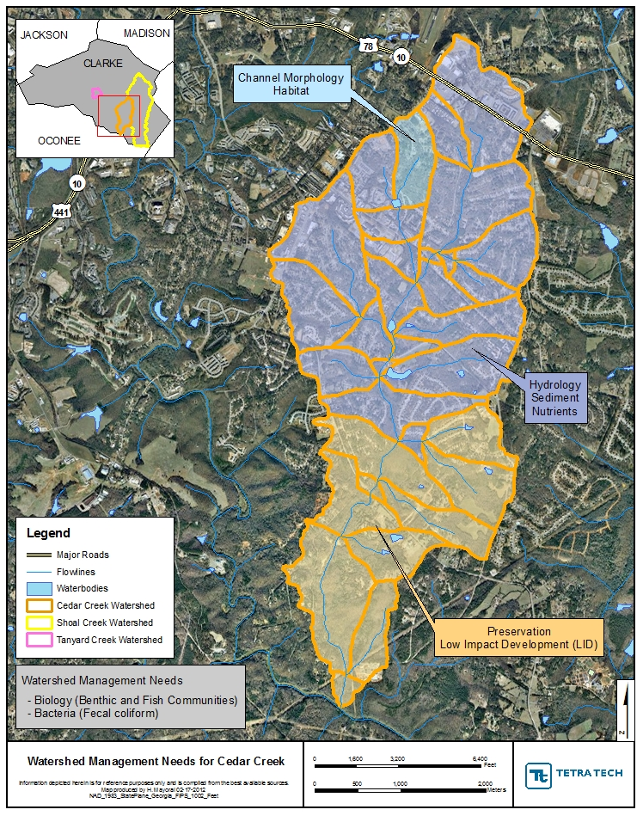

Figure 4.3.1 Cedar Creek Management Needs and Recommended BMPs
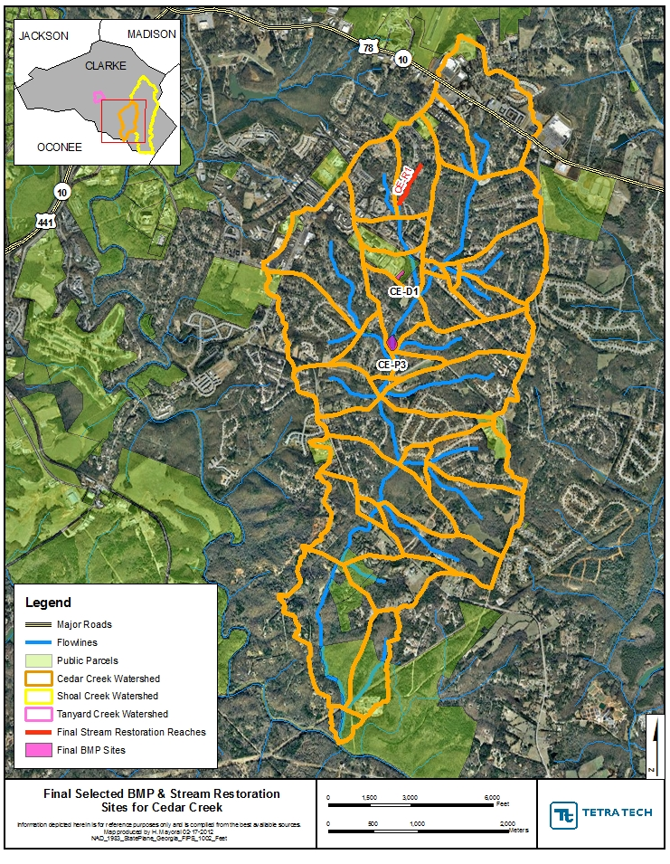

Figure 4.3.2 Final Selected BMP and Stream Restoration Sites for Cedar Creek

4.4 Estimated Load Reductions of Best Management Practices

Modeling analysis was conducted to assess the management needs and BMPs put forth in this plan. In the Cedar Creek watershed, the strategy employs BMP retrofits upstream of the priority stream restoration reaches in order to address peak flow and volume control impacts. The watershed improvement strategy recognizes that over a number of decades, the other impacted stream channels—on their own—will reach a new, stable equilibrium. Therefore, management resources would not be used to conduct stream restoration except at a limited number of stream sites.
The protection/preservation measures recommended, such as LID for future development projects, were not modeled in the assessment of watershed improvement BMPs since these measures do not address existing impairments. However, these protection measures are critical in maintaining the watershed improvements implemented and in addressing potential future impacts, and thus are included in the watershed management plan.

4.4.1 Characteristics of the Management Plan Strategy

The management plan strategy has a number of key characteristics to achieve:

- 20 percent of the impervious area is managed in the targeted catchment using the centralized and decentralized (engineering) watershed improvement BMPs.
- 75 percent of the residential area is targeted for a homeowner nutrient reduction program.
- 50 percent of the unvegetated stream buffers are restored in the targeted catchments.
- 50 percent of the good candidate streambank/channel restoration or instream grade control sites are implemented.

4.4.2 Modeling and Assessment Approach

Tetra Tech used the Best Management Practices (BMP) Evaluation Module to assess the effectiveness of management measures at the site and catchment level, and to estimate the cumulative effectiveness of the management strategy at the watershed level if implemented. The BMP evaluation module simulates BMP control of flow and water quality. The data inputs for the BMP Module were generated from the watershed model developed for the ACC study watersheds. The model used watershed hydrology and water quality data from the years 2001 to 2007 to estimate the annual pollutant load reduction and peak flow control if BMPs are implemented.
Several BMPs were not appropriate to assess in the BMP Evaluation Module: buffer and stream restoration and the homeowner nutrient reduction program. These BMPs were evaluated using the project’s watershed model and Geographic Information System (GIS) coverages of the study watersheds, and then “rolled into” the BMP Evaluation Model results to generate cumulative results for each strategy (except the stream restoration projects, which are reported separately).

4.4.3 Modeling Results

The bar graphs below compare average pollutant loading under existing conditions to those predicted using the BMPs. As the watershed improvement BMPs are implemented, it will be important to monitor stream conditions to determine how the load reductions achieved affect water quality compared to the water quality benchmarks (to be discussed in Section 4.6).

The watershed improvement strategy in Cedar Creek uses centralized BMPs (on publically owned parcels) and distributed BMPs in the most developed, top-portion of the watershed to reduce pollutant loading, as well as additional water quality BMP retrofits in the remaining watershed catchment areas. These BMPs are also designed to halt upstream and downstream flow impacts. Figures 4.4.3.1 through 4.4.3.3 display the load reductions for these constituents.

Range of Target Loading
(Not to exceed maximum of range)

Figure 4.4.3.1 Anticipated Nitrogen Concentration Reductions

Range of Target Loading
(Not to exceed maximum of range)

Figure 4.4.3.2 Anticipated Phosphorous Concentration Reductions

Figure 4.4.3.3 Anticipated Total Suspended Solids Concentration Reduction
Strategy | Land Ownership | Cedar Creek Planning Level Costs
Strategy | Land Ownership | Land Acquisition | Construction | Design | Annual O&M | 20-Year O&M | Total 20-Year Cost
Citizen Education Efforts | NA | $0 | $0 | $10,000 | $2,000 | $40,000 | $50,000
Enhanced Bacteria Study | NA | $0 | $20,000 | $0 | $0 | $0 | $20,000
Extended Dry Detention Basin | Public | $0 | $210,600 | $63,180 | $2,173 | $43,460 | $317,240
Sewer Pipe Condition Study | NA | $0 | $50,000 | $0 | $15,000 | $300,000 | $350,000
Wetland Creation / Detention | Private | $10,525 | $856,603 | $101,283 | $17,978 | $359,558 | $1,327,969
Stream Restoration | Private | $192,000 | $516,300 | $77,445 | $2,581 | $51,630 | $837,375
Total | NA | $202,525 | $1,653,503 | $251,908 | $39,732 | $794,648 | $2,902,584
4.5 Implementation Cost and Schedule

Implementing this plan will require significant amounts of funding to achieve the load reductions mentioned in the previous section. These reductions will also not occur rapidly and therefore a long-term strategy for both cost and implementation is necessary. Table 4.5.1 lists the expected cost of each BMP strategy over 20 years as well as the overall expected cost of a full WMP for Cedar Creek.

Table 4.5.1 Cedar Creek Planning Level Costs

4.6 Evaluation Methods for Measuring Success

In order to ensure the success of the management measures outlined in this plan, an adaptive management approach is necessary. Continued evaluation, both quantitative and qualitative, will help determine the effectiveness of the variety of BMPs used. All BMPs will be monitored upon implementation, but specific evaluations will take place at 5 year intervals. At this time, if necessary, revisions will be made to this plan in order to improve its effectiveness at enhancing watershed health.

4.6.1 Quantitative Evaluation Techniques

In assessing the current conditions in Cedar Creek, we have a baseline of data to compare the expected BMPs’ improvements against. In order to assess what improvements have been made, follow-up monitoring and physical assessment will be conducted 5 and 10 years after adoption of this plan. This will include the following activities and goals:

- Streamwalks
  - Activities:
    - Cedar Creek will again be walked and the same stream reaches will be scored using the same system.
  - Goals:
    - 5-year: 3 of 10 reaches score at least Sub-Optimal (currently 0 of 10)
    - 10-year: 6 of 10 reaches score at least Sub-Optimal, with at least 1 scoring Optimal
- Water Quality Sampling
  - Activities:
    - Quarterly Monitoring: Conduct quarterly grab sampling for parameters of concern including fecal coliform, nutrients (TN, NO₃, NH₄, TP, PO₄), and turbidity (for TSS).
    - Delisting Sampling: Conduct delisting sampling, four samples over a 30-day period, for fecal coliform as described in TMDL implementation plan for Cedar Creek.
  - Goals:
    - 5-year: 20 percent reduction in TN and TP, and a 10 percent reduction in TSS
    - 10-year: 40 percent reduction in TN and TP, and a 20 percent reduction in TSS
    - Delisting of Cedar Creek from the 303(d) list for fecal coliform contamination.
- Biological Monitoring
  - Activities:
    - Macroinvertebrate analysis will be conducted at the current sampling locations and scored using the same system.
  - Goals:
    - 5-year: All sites will improve to a “fair” score.
    - 10-year: All sites will score either “good” or “excellent.”

Other measures will be tracked as well, including the number of BMPs implemented, the amount of impervious surface removed or replaced, the number of cisterns or other rainwater harvesting methods put in place, etc. At 5 years after adoption of this plan, mostly lower cost BMPs such as citizen education and an enhanced bacteria study should be completed, while funding sources are identified for the more expensive BMPs and programs.

4.6.2 Qualitative Evaluation Techniques

A set of qualitative evaluation criteria can be used to determine whether pollutant loading reductions are being achieved over time and whether substantial progress is being made towards attaining water quality standards in the watershed. Conversely, the criteria can be used for determining whether this Watershed Management Plan needs to be revised at a future time in order to meet standards. A summary (Table 4.6.2.1) of the methods provides an indication of how these programs might be measured and monitored to evaluate success in both the short and the long term. By evaluating the effectiveness of these programs, communities and agencies will be better informed about public response and success of the programs, how to improve the programs and which programs to continue. Although these methods of measuring progress are not tied directly to measurements in Cedar Creek, it is fair to assume that the success of these actions and programs, collectively and over time, will impact positively on the instream conditions and measurements of the watershed.

Evaluation Method | Program/Project | What is Measured | Pros and Cons | Implementation
Public Surveys | Public Education or involvement program/project | Awareness; Knowledge; Behaviors; Attitudes; Concerns | Moderate cost.  Low response rate. | Pre- and post- surveys recommended. By mail, telephone, or group setting. Repetition on regular basis can show trends.
Written Evaluations | Public meeting or group education or involvement project | Awareness;  Knowledge | Good response rate. Low cost | Post-event participants complete brief evaluations that ask what was learned, what was missing, what could be done better. Evaluations completed on-site.
Visual Documentation | Structural and vegetative BMP installations, retrofits | Aesthetics. Pre- and post- conditions. | Easy to implement. Low cost. Good, but limited form of communication. | Provides visual evidence. Photographs can be used in public communication materials.
Phone Call/ Complaint records (Stormwater Hotline) | Education efforts, advertising of contact number for complaints/ concerns | Number and types of concerns of public. Location of problem areas. | Subjective information from limited number of people. | Answer phone, letter, emails and track nature of calls and concerns
Participation Tracking | Public involvement and education projects | Number of people participating. Geographic distribution of participants. Amount of waste collected, e.g. stream cleanup waste collection | Low cost. Easy to track and understand. | Track participation by counting people, materials collected and having sign-in/ evaluation sheets.
Focus Groups | Information and education programs | Awareness; Knowledge; Perceptions; Behaviors | Medium to high cost to do well. Instant identification of motivators and barriers to behavior change. | Select random sample of population as participants. 6-8 people per group. Plan questions, facilitate. Record and transcribe discussion.
Adapted from Lower Huron River Watershed Management Plan

Appendix of Charts and Data

Section I – Stream Reach Scores by Parameter

Section II – Water Quality Data

II.1 – Monthly Grab Sampling Results

NR = Non-recorded data (due to equipment failure or sampling methods were changed and therefore this data was not recorded)
ND = Non-detectable data (the amount was non-detectable by the sampling method)

Sample Site CE1
Date | Time | Temp (Deg. C) | pH | DO (mg/L) | Conductivity (mS/cm) | Fecal Coliform (#Col/100 mL)
6/22/2010 | 8:25 AM | 22.36 | 7.13 | 6.37 | 0.119 | 517.2
7/20/2010 | 8:37 AM | 22.74 | 6.89 | 6.31 | 0.059 | 488.4
8/17/2010 | 8:30 AM | 25.2 | 6.79 | 6.42 | 0.028 | 2420
9/14/2010 | 8:30 AM | 18 | 6.88 | 7 | 0.046 | 290.9
10/12/2010 | 8:07 AM | 16.22 | 6.71 | 6.53 | 0.058 | 344.8
11/9/2010 | 8:23 AM | 9.37 | 6.93 | 8.03 | 0.048 | 307.6
12/7/2010 | 8:19 AM | 4.31 | 6.84 | 11.18 | 0.043 | 770.1
1/4/2011 | 8:10 AM | 5.03 | 6.96 | 12.3 | 0.039 | 365.4
2/1/2011 | 8:27 AM | 8.39 | 6.6 | 9 | 0.042 | 285.1
3/1/2011 | 8:15 AM | 12.58 | 6.72 | 9.22 | 0.039 | 1413.6
3/29/2011 | 8:02 AM | 11.22 | 6.06 | 10.2 | 0.04 | 613.1
4/26/2011 | 8:12 AM | 17.7 | 7.01 | 9.91 | 0.068 | 260.3

Sample Site CE1 (cont’d)
Date | NO3-N (ppm) | NH4-N (ppm) | TN (ppm) | PO4-P (ppb) | TP (ppb)
6/22/2010 | 0.644 | 0.029244821 | 0.68908 | 5.341 | 14.205
7/20/2010 | 0.322 | 0.00893243 | 0.538763 | 4.947 | 26.143
8/17/2010 | 0.177 | 0.0048998 | 1.187868 | 2.952 | 151.098
9/14/2010 | 0.312 | 0.0033626 | 0.432767 | 2.667 | 10.400
10/12/2010 | 0.445 | 0.0060979 | 0.551443 | 2.828 | 18.333
11/9/2010 | 0.417 | 0.0071861 | 0.506963 | 1.919 | 8.809
12/7/2010 | 0.429 | 0.001024 | 0.607592 | 1.762 | 19.091
1/4/2011 | NR | 0.003 | NR | 0.000 | NR
2/1/2011 | NR | 0.006 | NR | 2.245 | NR
3/1/2011 | NR | ND | NR | 2.168 | NR
3/29/2011 | NR | ND | NR | ND | NR
4/26/2011 | Nr | ND | NR | 0.949 | NR

Sample Site CE2

Date | Time | Temp (Deg. C) | pH | DO (mg/L) | Conductivity (mS/cm) | Fecal Coliform (#Col/100 mL)
6/22/2010 | 8:45 AM | 21.72 | 7.35 | 8.85 | 0.125 | 2420
7/20/2010 | 8:20 AM | 22.57 | 6.36 | 5.84 | 0.047 | 344.8
8/17/2010 | 8:40 AM | 25.52 | 6.35 | 7.34 | 0.028 | 2420
9/14/2010 | 8:45 AM | 17.97 | 6.95 | 5.23 | 0.065 | 980.4
10/12/2010 | 8:20 AM | 16.39 | 6.71 | 6.27 | 0.061 | 980.4
11/9/2010 | 8:40 AM | 10.02 | 6.97 | 7.22 | 0.053 | 272.3
12/7/2010 | 8:31 AM | 4.79 | 6.85 | 8.29 | 0.049 | 1119.9
1/4/2011 | 8:20 AM | 6.08 | 6.86 | 10.38 | 0.51 | 1986.3
2/1/2011 | 8:40 AM | 9.06 | 6.54 | 8.34 | 0.057 | 1046.2
3/1/2011 | 8:30 AM | 12.68 | 6.4 | 8.21 | 0.056 | 1986.3
3/29/2011 | 8:15 AM | 11.12 | 6.39 | 11.52 | 0.051 | 1203.3
4/26/2011 | 8:27 AM | 17.47 | 6.72 | 8.63 | 0.067 | 1553.1

Sample Site CE2 (cont’d)

Date | NO3-N (ppm) | NH4-N (ppm) | TN (ppm) | PO4-P (ppb) | TP (ppb)
6/22/2010 | 0.9686 | 0.077279727 | 1.21184 | 12.170 | 21.222
7/20/2010 | 0.234064096 | 0.021070763 | 0.574653 | 4.620 | 25.609
8/17/2010 | 0.144514972 | 0.0243317 | 0.760276 | 2.045 | 82.446
9/14/2010 | 0.67789987 | 0.0052967 | 0.827153 | 3.447 | 16.116
10/12/2010 | 0.8478341 | 0.0059731 | 0.95173 | 2.885 | 14.426
11/9/2010 | 0.8262266 | 0.0106042 | 0.916698 | 2.104 | 13.813
12/7/2010 | 0.8739991 | 0.0209659 | 1.109226 | 2.242 | 15.892
1/4/2011 |  | 0.004 |  | 0.000
2/1/2011 |  | 0.003 |  | 0.832
3/1/2011 |  | 0 |  | 2.620
3/29/2011 |  | 0
4/26/2011 |  | 0.002 |  | 0.169

Grab Sampling Results Graphically Represented by Indicator. Spaces in the data represent either there was no data available or data was below detection limits. Shading is explained below.

= Benchmark Range = Level of Concern

II.2 In-Situ Water Sampling Using Datasondes
Gaps in data are due to equipment malfunction and subsequent repair times.

Datasonde Sample Site CE1

Datasonde Sample Site CE2

Section III – Baseline Indicators (as of 2010)

Land Cover Data for Cedar Creek
Land Cover Type | Area (acres) | %
Barren Land | 4.4 | 0.13
Deciduous Forest | 996.3 | 28.06
Developed, High Intensity | 62.7 | 1.77
Developed, Low Intensity | 637.8 | 17.96
Developed, Medium Intensity | 164.1 | 4.62
Developed, Open Space | 1134.7 | 31.95
Evergreen Forest | 195.5 | 5.51
Hay/Pasture | 153.9 | 4.33
Herbaceuous | 92.3 | 2.60
Mixed Forest | 26.5 | 0.75
Open Water | 10.9 | 0.31
Shrub/Scrub | 8.0 | 0.23
Woody Wetlands | 63.8 | 1.80
Total | 3551.0 | 100.00

Selected References

American Public Health Association (APHA) , the American Water Works Association (AWWA), and the Water Environment Federation (WEF). Standard Methods for the Examination of Water and Wastewater. http://www.standardmethods.org . December 3, 2009.
Environmental Protection Agency (EPA). Monitoring and Assessing Water Quality. http://www.epa.gov/owow/monitoring. October 20, 2009.
MacTammany, Matthew E. Recovery of Southern Appalachian Streams from Historical Agriculture. Virginia Polytechnic Institute and State University, Blacksburg, VA: 2004.
WA Department of Ecology. A Citizen’s Guide to Understanding and Monitoring Lakes and Streams. http://www.ecy.wa.gov/Programs/wq/plants/management/joysmanual/streamnutrients.html. 2009.
GA DNR/EPD. 2007. Macroinvertebrate Reference Data Piedmont Ecoregion (45), Southern Outer Piedmont -- 45b Data. GA Department of Natural Resources, Environmental Protection Division. Accessed May 2009. http://www.gaepd.org/Documents/WPB_Macroinvertebrate_SOP.html
City of Griffin. 2008. Water quality reference station in Meriwether County; data collected by City of Griffin (2005-2008).
CWP. 2003. Impacts of Impervious Cover on Aquatic Systems. Center for Watershed Protection. Watershed Protection Research Monograph No. 1. Ellicott City, MD.
CWP. 2005. Unified Stream Assessment: A Users Manual. Version 2. Center for Watershed Protection. Urban Subwatershed Restoration Manual Series. Ellicott City, MD.
Fox and Absher. 2002. The ABCs of Water-Quality Assessment in Georgia. Stormwater, March-April 2002. Accessed April 2009. http://www.stormh2o.com/march-april-2002/water-quality-assessment.aspx
GA DNR. 2007. Total Maximum Daily Load Evaluation for Two Stream Segments in the Oconee River Basin for Sediment (Biota Impacted). Submitted to the U.S. Environmental Protection Agency, Region 4, Atlanta, GA. Submitted by the GA Department of Natural Resources Environmental protection Divsions, Atlanta, GA. Accessed March 2009. http://www.gaepd.org/Files_PDF/techguide/wpb/TMDL/Oconee/EPD_Final_Oconee_Sediment_TMDL_2007.pdf
Gore, J.A., J.R. Olsen, D.L. Hughes, and P.M. Brossett. 2005. Reference conditions for wadeable stream in Georgia with a multimetric index for the bioassessment and discrimination of reference and impaired streams. Phase II. Final Report. Columbus State University, Columbus, GA.
Meyer, J. L., M. J. Paul, and W. K. Taulbee. 2005. Stream ecosystem function in urbanizing landscapes. Journal of the North American Benthological Society. Vol. 24(3):602-612.
Paul, M. J., J. L. Meyer, C. A. Couch. 2006. Leaf Breakdown in Streams Differing in Catchment Land Use. Freshwater Biology. Vol. 51:1684-1695. Blackwell Publishing Ltd.
Pitt, R. E. 2000. Water Quality Conditions in the Cahaba River and Likely Pollutant Sources. University of Alabama at Birmingham Department of Civil and Environmental Engineering. Accessed March 2009. http://unix.eng.ua.edu/~rpitt/Publications/MonitoringandStormwater/Cahaba%20problems%20and%20sources.PDF
Roy, A.H., A. D. Rosemond, M. J. Paul, D. S. Leigh, and J. B. Wallace. 2003. Stream Macroinvertebrate Response to Catchment Urbanization. Freshwater Biology 48:329-346. Blackwell Publishing Ltd.
Schoonover, J. E., B. G. Lockaby, S. Pan. 2005. Changes in chemical and physical properties of stream water across and urban-rural gradient in western Georgia. Urban Ecosystems. Vol. 8:107-124. Springer Science + Business Media, Inc.
State of Georgia. 2009. 391-3-6-.03 Water Use Classifications and Water Quality Standards. State of Georgia, Office of the Secretary of State. Accessed March 2009. http://rules.sos.state.ga.us/cgi-bin/page.cgi?g=GEORGIA_DEPARTMENT_OF_NATURAL_RESOURCES/ENVIRONMENTAL_PROTECTION/WATER_QUALITY_CONTROL/index.html&d=1
State of Georgia. 2009. 391-3-6-.03 Water Use Classifications and Water Quality Standards. State of Georgia, Office of the Secretary of State. Accessed March 2009. http://rules.sos.state.ga.us/cgi-bin/page.cgi?g=GEORGIA_DEPARTMENT_OF_NATURAL_RESOURCES/ENVIRONMENTAL_PROTECTION/WATER_QUALITY_CONTROL/index.html&d=1
Tetra Tech. 2006. Baseline Biological and Water Quality Conditions for Selected Streams in Dekalb and Fulton Counties, Georgia. Prepared by Tetra Tech, Inc. Prepared for US Army Corps of Engineers, Mobile District.
USEPA. 2000. Ambient Water Quality Criteria Recommendations: Rivers and Streams in Nutrient Ecoregion IX. US Environmental Protection Agency, Office of Water. EPA 822-B-00-019. Accessed April 2009. http://www.epa.gov/waterscience/criteria/nutrient/ecoregions/rivers/rivers_9.pdf

