EXAMPLE PROJECT NAME
Brief project description (ex: interior renovation or building expansion)
Project Address (Parcel ID #)
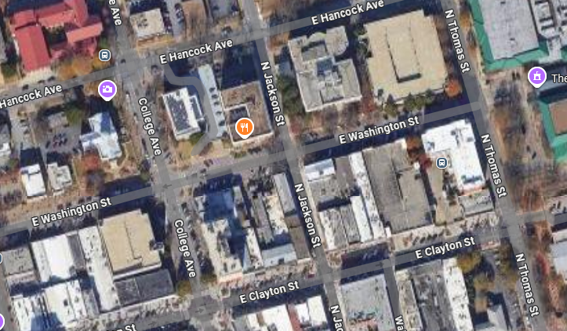
Building Design Information
Occupancy Classification:
Occupancy Load (NFPA 101 Section 7.3.1.2):
Construction Classification (NFPA 101 & IBC):
Type of Construction (Per IBC):
Square Footage of Renovation or Addition:

Fire Protection Systems:
Sprinkler System Y/N
Scope of Work
Example 4”x2” ACC Approval Stamp box. Must be in same place on every page.
Location Map
(This does not count as a required site plan this is just to get a general understanding of where the property is located – can be pulled from whatever digital mapping service is available to you)
Applicant Contact Information
Name:
Phone Number:
Email Address:
Sheet Index
1: Example Sheet
2: Example Sheet
3: Example Sheet

