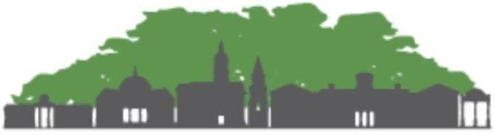
ACC Community Tree Council
ATHENS-CLARKE COUNTY
COMMUNITY TREE COUNCIL
AGENDA
Monday February 13, 20234:00 – 5:30 P.M.
____________________________________________________________________________
Meeting Location: The meeting is to be held in person at the Landscape Management office on Lexington Road in Athens and is open to the public.
Remote public access via https://youtu.be/PVJhf8GOzPA

Call to Order, Introductions, and Welcome: Patrick Perry 4:00 - 4:10
- Welcome everyone.
- Introduction
- Any other visitors?
Housekeeping (Secretary): Jeanne Connell 4:10 - 4:20
- Roll Call Sign in (3 minutes): Attending members written on the attendance list.

- Action Item: Discuss details of Arbor Day Event
- Action Item: Vote to for President-Elect and confirm 2023 work groups and committees members

Treasurer’s Report (Information – 5 minutes): Pam Knox 4:10 - 4:15

CTC Business: (Executive & Steering Committees, Work Groups): Patrick Perry 4:15 – 5:20
- Action Item: Discuss CTC Meeting and Committee Schedule for 2023

CTC Executive Committee:
Patrick (president), Vacant (president elect) Vacant (A-CC Community Forester),Pam.
Did not meet in January.

CTC Steering Committee - (Exec committee + Committee Chairs):
{ Patrick (president), Vacant (president elect) Vacant (A-CC Community Forester), Pam, Mary Attaway, Mary Songster, Holly Campbell}
Did not meet in January.

New Member Interview Work Group:
{Shawn (leader), Pam, Sarah, Mary}:
Five member terms are expiring at the end of 2023. We need to verify who wants to renew their commitment and start looking for new members if needed.

CTC Trees for Tomorrow Work Group:
{Phil (leader), Mary Attaway, Joe P., Pam, Shawn}

Grants & Fundraising Work Group:
{Mary Attaway, Patrick, Stacee Farrell }
Synovus grant opens in June for this year and CTC should reapply.

Landmark & Champion Trees Work Group:
{Shawn (leader), Joe P, Lea, Phil, , Jessie, Patrick, Mary S.}
Will re-start hunt for trees and make a goal to have list complete by end of year.

CTC Committee Reports (Information and Discussion):

Promotions Committee:
{Mary Attaway (Chair), Joe P., Phil Hale, Jessie, Tori}:
Need coordinate green life awards.

Policy Committee:
{Mary Songster (Chair), Patrick, Lauren }:
Update on recommendation ! fee in lieu of planting
1. Updates on Fee-in Lieu for plantings
2. Add Tree ordinance requirements to the C-D zoning district
3. Required Minimum tree canopy for fee in lieu.
4. Partnering with KACCB & ACC Transit for bus stop planting. Potentially plant November/December of 2023.
5. Discussion on Alternative Annual Christmas Tree

Education committee:
{Holly Campbell (chair), Stacee Farrell, , Sarah, Shawn Doonan}:
Upcoming Olli Classes on 2/24 and tree walk 2/27 from 1-3 pm. Volunteers are needed for tree walk and photos.

Parking Lot Items: 5:20 - 5:29

Meeting Wrap Up: 5:29 - 5:30

