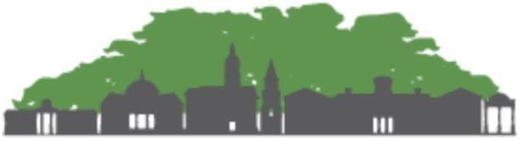
ACC Community Tree Council
ATHENS-CLARKE COUNTY
COMMUNITY TREE COUNCIL
AGENDA
Monday January 9, 2023 4:00 – 5:30 P.M.
____________________________________________________________________________
Meeting Location: The meeting is to be held in person at the Landscape Management office on Lexington Road in Athens and is open to the public.
Remote public access via https://youtu.be/PVJhf8GOzPA

Call to Order, Introductions, and Welcome: Patrick Perry 4:00 - 4:10
- Welcome everyone.
- Introduction
- Introduction from A-CC District 8 Commissioner Carol Myers
- Any other visitors?
Housekeeping (Secretary): Jeanne Connell 4:10 - 4:20
- Roll Call Sign in (3 minutes): Attending members written on the attendance list

- Action Item: Discuss details of MLK Day Planting Event
- Action Item: Vote to for President-Elect and confirm 2023 work groups and committees members

Treasurer’s Report (Information – 5 minutes): Pam Knox 4:10 - 4:15
Money Market Account
Beginning Balance as of 11/14/2022 $10,029.49
Interest 11/30/2022 0.17
Interest 12/31/2022 0.17
Ending balance as of 01/07/2023 $10,029.83
Checking Account
Starting balance 11/14/2022 $1,769.45
Deposit 1/6/2023 106.25 donation from Covenant Pres. Church
Ending balance 01/07/2023 $1,875.70

PayPal Account AccTrees@athenstreecouncil.org
Beginning balance 11/14/2022 $1,646.54
Ending balance 01/07/2023 $1,646.54

In January I plan to renew our 501(c)(3) status and transfer the PayPal balance to the checking account. I will also put together the 2022 financial summary required by ACC.

CTC Business: (Executive & Steering Committees, Work Groups): Patrick Perry 4:15 – 4:45
- Action Item: Discuss Committee Assignments for 2023
- Action Item: Discuss CTC Meeting Schedule for 2023

CTC Executive Committee:
{ Patrick (president), Vacant (president elect) Vacant (A-CC Community Forester),Pam.

CTC Steering Committee - (Exec committee + Committee Chairs):
{ Patrick (president), Vacant (president elect) Vacant (A-CC Community Forester), Pam, Mary Attaway, Mary Songster, Holly Campbell}

New Member Interview Work Group:
{Shawn (leader), Pam, Sarah, Mary}:

CTC Trees for Tomorrow Work Group:
{Phil (leader), Mary Attaway, Joe P., Pam, Shawn}

Grants & Fundraising Work Group:
{Mary Attaway, Patrick, Stacee Farrell }

Landmark & Champion Trees Work Group:
{Shawn (leader), Joe P, Lea, Phil, , Jessie, Patrick, Mary S.}
Discuss moving forward with Champion Tree List

CTC Committee Reports (Information and Discussion):

Promotions Committee:
{Mary Attaway (Chair), Joe P., Phil Hale, Jessie, Tori}:

Policy Committee:
{Mary Songster (Chair), Patrick,
Lauren }:
Discuss Policy Committee focus for 2023
-Continuing to work on a resolution/recommendation for fee in lieu standards for development, including CBD development and redevelopment, ADDA, set minimums and required minimums, -Develop language for conserving canopy tree quality point system to encourage greater tree retention in development and redevelopment -Work with Office of Sustainability, Planning, and Central Services to make sure any recommendations or language would be something that could be implemented across all ACC agencies

Education committee:
{ Holly Campbell (chair), Stacee Farrell, , Sarah, Shawn Doonan}:

Parking Lot Items: 5:20 - 5:29

Meeting Wrap Up: 5:29 - 5:30

